FACILITY TIME PUBLICATION AND STATEMENT 2022 to 2023

As part of The Trade Union (Facility Time Publication Requirements) Regulations 2017, we are required as a Public Sector employer to publish information relating to facility time on an annual basis. This report covers the period 1 April 2022 to 31 March 2023. Further information on the requirements is available on the Government Facility Time Publication.

The Library recognises the following unions: Prospect, PCS and FDA. However, there are only Prospect representatives within the Library.

The Library recognises the advantages of having a positive and productive relationship with the unions, and through the use of facility time, union members will have sufficient access to representation. It also provides confidence that union representatives are available for individual or collective representation and the representatives are confident and knowledgeable in their role.

The information required is detailed below.

Relevant Union Officials
- Number of employees who were relevant union officials during the period: 16
- Full-time equivalent employee number: 13.22

Percentage of time spent on facility time by each union official
Percentage of time | Number of Employees
0 to 0.99% | 5
1 to 50% | 11
51 to 99% | 0
100% | 0

Percentage of pay bill spent on facility time
- The total cost of facility time: £10,548.36
- The total pay bill: £13,462,000
- The percentage of the total pay bill spent on facility time: 0.08%

Paid trade union activities
Time spent on paid trade union activities as a percentage of total paid facility time hours: 0.22%

Anthony Gillespie Mike Saunders
Chief Operating Officer Prospect Co-Convener

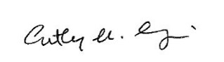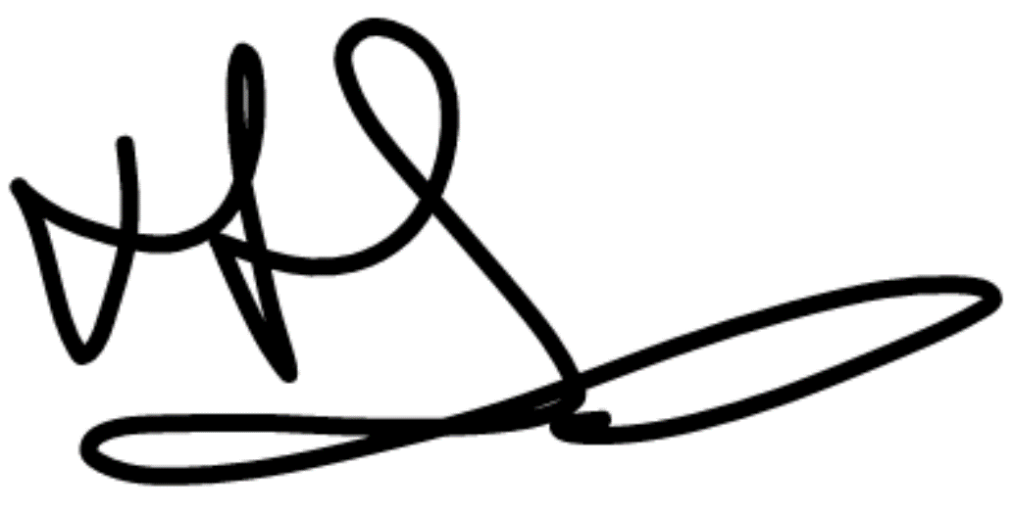
Signature Signature

