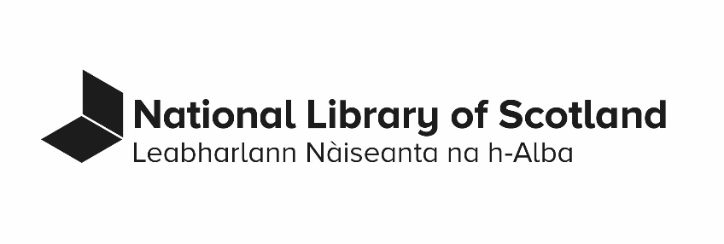

Equalities Mainstreaming Progress Report

April 2023

Table of contents
1. Executive summary 2
2. Introduction 2
3. The legal framework in relation to the Library and the duty 4
4. Mainstreaming the Equality Duty including an analysis of employee and board data and recruitment data 6
5. Equal Pay Statement 39
6. Pay by Protected Characteristics where appropriate 40
Appendix 1: Staff data 49
Appendix 2: Board data 62
Appendix 3: Recruitment data 63
Appendix 4: Chart data in tables……………………………………………………………….75

Executive summary
As a publicly funded organisation, the National Library of Scotland has a duty to eliminate discrimination and advance equality of opportunity in its everyday work. It is also required to report on how it is achieving these objectives.
This is a progress report for the two-year period from April 2021 on the progress that has been made in complying with the terms of the Equality Act of 2010 and the planned outcomes from the activities identified within the Equality Mainstreaming Report 2021 to 2025. It demonstrates that the Library continues to take steps to ensure that equality issues and improvements are identified at all stages in the development and delivery of its services and operations with actions and activity identified to address these issues and improve equality of opportunity.
The report recognises that improvement is a continuous process and there are a number of actions and associated tasks from the 2021 Report ongoing. It also recognises that Equality, Diversity and Inclusion impacts on all we do within the Library and the more we do, the more we recognise needs done. With this in mind, within the update on the planned action, additional actions and tasks which have been completed or are ongoing have been included.

Introduction
The National Library of Scotland (the Library) is one of six legal deposit libraries in the United Kingdom and Ireland. These libraries are entitled to request and receive a copy of each item published in the UK and currently the Library is the custodian of over 59 million items held in trust for the people of Scotland.
The Library was formed in 1925 by the National Library of Scotland Act largely with material from the library of the Faculty of Advocates. The Faculty had been collecting material since the early 1680s and it was much of this material that became the basis of what is now the National Library of Scotland.
The National Library of Scotland preserves the memory of the nation with collections that span the centuries, from the earliest times to the digital age. Our collections document the influence of Scots at home and abroad, while reflecting the ideas and cultures of the world. They cover all aspects of human endeavour in multiple formats, including books, manuscripts, archives, websites, maps, music, moving image and sound.
We support education, research, business and innovation and our work enhances the reputation of Scotland as a country with a rich cultural heritage and a vibrant future. We are committed to providing easy access to our physical and digital collections and delivering services that are open and available to all.
In 2015, the National Library of Scotland launched "The Way Forward: Library Strategy, 2015-2020" as the first of two five-year strategies to take the Library to its centenary in 2025. Reaching People: Library Strategy, 2020-2025 is the second strategy, concluding in the year the Library celebrates its 100th anniversary.
The first five-year journey to our centenary focused on building infrastructure, capacity and resilience, while growing partnerships, reputation and income. This second period concentrates on sharing information, knowledge and experiences with a more diverse audience in Scotland and around the globe.
Read more in the National Library of Scotland Strategy.
The Library has six buildings, four in Edinburgh with the main building at George IV Bridge and two in Glasgow. The Kelvin Hall facility in Glasgow provides the west of Scotland with access to the Library’s digital, moving image and sound collections and electronic resources.
There are around 320 staff working across the Library sites, all playing a role in supporting the delivery of the strategy. Staff have a wide mixture of skills, including those who are highly specialised in the fields of conservation, curatorial, metadata and digital development, those supporting public areas in the reading rooms and the corporate support functions such as finance and human resources.
Under the National Library Act of Scotland Act (2012), the Board of the Library was reconstituted and as of March 2023, we have eleven Board members. A newly appointed Chair took up position on 01/10/2021.
As a result of the Equality Act (Specific Duties) (Scotland) Amendment Regulations 2016 which came into force on 18 March 2016, there is a commitment to achieving greater diversity on the boards of public authorities. In light of this amendment the Library now provides information within the Report on the number of male/female members of the Board as well as a statement from the Board on their commitment to promote greater diversity of membership as part of a wider remit of succession planning.
In the April 2021 Report we published an analysis of the gender pay gap and our employee and recruitment data. This data has now been updated and included within the Progress Report.

The legal framework in relation to the Library and the duty
Under the 2012 National Library of Scotland Act we are prescribed under the general function to ‘manage the Library as a national resource for reference, study, research and bibliography, having particular regard to Scotland.’ Under the Act the Library is also specifically charged with:
- Preserving, conserving and developing its collections.
- Making the collections accessible to the public and to persons wishing to carry out study and research.
- Exhibiting and interpreting objects in the collections.
- Promoting collaboration and the sharing of good practice with and between other persons providing library and information services, and the adoption of good practice by those persons with a view to:
- encouraging education and research.
- promoting understanding and enjoyment of the collections.
- promoting the diversity of persons accessing the collections.
- contributing to the understanding of Scotland’s national culture.
Under the Equality Act 2010 the Library is specifically charged, under the public sector equality duty, to ‘exercise its functions, having due regard to the need to:
- Eliminate discrimination, harassment, victimisation and any other conduct that is prohibited by or under this Act.
- Advance equality of opportunity between persons who share a relevant protected characteristic and person who do not share it.
- Foster good relations between persons who share a relevant protected characteristic and persons who do not share it’.
Additionally, the Library has responsibilities under the Specific Duties (Scotland) Regulations 2012 to;
- report on progress towards mainstreaming the duty.
- publish equality outcomes and report on progress.
- assess and review policies and practices.
- gather and use employee information.
- publish gender pay gap information and statements on equal pay.
- consider award criteria and conditions in relation to public procurement.
- publish in a manner that is accessible.

The Protected Characteristics
There are nine listed protected characteristics under the Equality Act 2010:
- Sex
- Disability
- Race
- Sexual Orientation
- Religion or belief
- Maternity and Pregnancy
- Marital Status and Civil Partnership
- Age
- Gender Reassignment

Mainstreaming the Equality Duty including an analysis of employee and board data and recruitment data
The Library continues to take steps to ensure that equalities are mainstreamed throughout its activities. Below we have detailed some of the equality initiatives and projects which the Library has been involved with or will shortly launch since the 2021 Equality Mainstreaming Report.

The initiatives and projects are presented within the headings of the five themes:

Access
"We will actively welcome people who currently do not think of the Library as a place, service or employer that has something to offer them".
"People will be able to enjoy our collections, buildings, services and workplace without obstacle or embarrassment"
In December 2023, The Library were successful in being awarded funding for a period of 6 months from the Heritage Innovation Fund to complete a research project looking at underrepresentation within the workforce of the Heritage Sector.
Through a range of reports and statistics from across the Cultural Heritage sector it was recognised that both the Library and the wider sector workforce do not currently represent the community that we serve, There is a clear need for a more inclusive workforce and this project gives our EDI Officer an opportunity to research and investigate best practice from a wide range of organisations and sectors. The research is focused on inclusive recruitment and retention practices, and the hope is to trial and pilot a range of initiatives to increase the diversity of the Library’s workforce. This research will also be disseminated to the wider cultural heritage sector.
EqIAs – We have redesigned both the form and the process of equality impact assessments in order to review our services and projects. We have a two-step process to ensure we are rigorously considering equalities from a range of people with lived experience. This review group is made up of a range of staff from across the organisation and is a key accountability process to ensure we are doing all we can to make our services and projects as inclusive as possible.
Contemplation and Prayer Room- we have created a dedicated space to people of all faiths and religious backgrounds to observe their faith in our main library building. It is also a space where staff and the general public can have a space to reflect and think. We aim to have the functional contemplation and prayer room open to both the staff of the Library and members of the general public by the beginning of the summer.

Collections
"We work to address the silences and omissions in the collections and to revealing the diversity already within the collections, using a wider range of material and subjects to attract and serve different audiences".
In 22/23 we set a goal to acquire new collections from at least four previously under-represented communities such that a rich and representative variety of voices, views and experiences of 21st century Scotland are collected, preserved and made publicly accessible.
Examples of the works acquired in the last 12 months include:
- Acquisition by purchase, web archive and legal deposit of work by Glasgow and Scottish authors Safina Mazhar and Yasmin Hanif which centre black, Asian, and minority ethnic characters.
- Acquisition of a series of adult romance / sports romance books by American author Avery Cockburn (the pen name of Jeri Smith-Ready) that follow the exploits of fictional Glasgow LGBT football team the Warriors.
- Acquisition by purchase of evidence of nightclub culture in Scotland, and particularly the Scottish rave and electronic dance music club scene (over 300 flyers and posters that document the scene from the mid-1990s)
- A series of interviews with members of Scottish South Asian community involved in broadcasting and performance were recorded and added to the collections.
- New zine intake, by purchase and donation, is particularly connected to LGBTQ+ communities, for example, "Queer Intimacy" by Tom Hutton which is a photo essay by Tom Hutton that documents him and his flatmates during the Covid lockdowns.
- Capture and preservation of the websites of Scottish restaurants, cafes, takeaways, and other similar food and drink venues with the collection reflecting the diversity in this industry.
- Television programmes from the "Trusadh" and "Uaigneas" series on Gaelic language speaking people who have experience of Down's syndrome, biopolar disorder, or Alzheimer's.
- Short documentary from 2009 on a multi-generational Traveller family.
- The LGBT+ Youth Scotland and OurStory Scotland: HLF-funded project to create an archive of LGBT+ young people's stories at the Library, with activities tied to LGBT History Month.
- Acquisition of Workers' Stories Project archive and the ongoing Cost of Living Crisis web archive collection.
- Purchase of first edition of Jane Porter's "Thaddeus of Warsaw" - an example of recuperating the place of a very early 19th century female novelist in the history of the Scottish novel.
- Historical acquisitions also highlight working-class history including a map of Shetland showing roads constructed as part of the work of the Central Board for Relief of Highland Destitution, 1849-51.
- New e-resource the Naxos Music Library includes World and Chinese music while the separate Naxos Jazz Library offers access to seminal recordings from Black music history such as early Duke Ellington compositions and performances.
- Naxos MusicBox provides an introduction to music for children aged 4-12.
- To support the co-curated Collections in Focus display with Waverley Care we have added a number of items to the collection through purchase, including: Long Life: Positive HIV Stories, 2004 by Bambanai Women's Group; Aids in Africa: How Did it Ever Happen, 2005 by Frank Ham, African Books Collective; Let the Record Show: A Political History of Act UP, Sarah Schulman; The Body and Its Dangers, Allen Barnett, St Martins Press, 1990; and Ground Zero, Andrew Holleran, 1988.
- We also accepted very kind donations of ephemeral material relating to AIDS and HIV, including a Glasgow Bars fundraiser t-shirt, some combination therapy medicine boxes, and health education leaflets relating to PrEP.
We Undertook a 'Health Check’ of Legal Deposit from 100 selected organisations to ensure fully representative collecting is taking place. This involved investigating the deposit status of all 100 organisations and contacting them more than once, unless identified as ceased or having established that no contact was required. In 40 cases we have ensured print or digital supply of individual publications has been setup (or will continue if this was already in place). All publishers on the list are being captured by the UKWA and for 7 publishers the UKWA will be the sole appropriate collecting method. 10 publishers on the list were found to have ceased. 16 publishers failed to respond despite several attempts at contact via email and phone, although only one publisher refused outright to deposit. Although the project is now complete the Library will continue to follow up on 21 organisations where there was some successful connection made, however, the organisation was unable to supply publications by 31st March. A report evaluating the project will be produced by the end of July 2023 and shared with UK Legal Deposit groups to share the lessons learned from the EDI focused legal deposit work.
We created and released a series of videos telling some of the LGBT+ stories in the collections. External funding from CENL was secured to produce a series of short videos which highlight items in the library’s collection that capture the lives and stories of LGBT+ people throughout history. This project was be based on the previously completed work of a paid internship looking at LGBT+ History. This internship focused on pre-1950s items allowing for the discovery of lesser known items and LGBT individuals and the selected stories for the videos reflect this. These videos will be used to highlight and celebration the LGBT stories in our collections, we will be launching these in June for Pride month.
Focused cataloguing work on ten selected subsections of the Library’s Ephemera Collection were material from currently under-represented communities was known to be largely hidden from public discoverability. This resulted in improved visibility and access to 15,001 items from the ephemera collection covering areas such as "pressure groups", "women’s movement", "resident’s associations", "associations and societies" and "youth organisations".
In the next twelve months the Library will continue to actively collect material to reflect the diversity of Scottish culture, undertake work to diversify the collections material available on the open shelves in the General Collections Reading Room in Edinburgh.

Organisational Culture
"Our staff will demonstrate that they understand the different needs of individuals, and the importance of equality for all".
"We will ensure that our staff and partner communities do not face discrimination on the grounds of their protected characteristics".
All you need to know … sessions have been run for staff covering a range of EDI topics. These have included Neurodiversity; Microaggressions: Use of Pronouns; Social Class. These have been well attended and they have inspired further interest in the topics from a number of staff.
Our EDI action plan and strategy document sets out the priorities and direction of travel for the organisation around EDI over the remaining two years of our Reaching People strategy. This draft EDI strategy has undergone initial consideration by our EDI Working Group and our Leadership Team, whose feedback has been incorporated. This EDI strategy is simple and to the point, directly speaking to our values and priorities as outlined in Reaching People. We also believe it is achievable.
Our EDI action plan is fluid and responsive to change. It is a place to ensure it is accessible to everyone throughout the organisation and to ensure we can track and measure our actions under our EDI work. We have separated it into four different sections to capture the different areas of work that are being covered: Collections, Organisational Development, Access and Engagement and Co-curation.
In 2022 a number of staff were keen to set up a staff network for the LGBT members of staff at the Library. This group has been very successful and has worked with the EDI Officer to create guidance for the organisation and other staff networks about how staff networks should be supported and operate within the library. We are currently supporting the start-up of a Disability Advocacy Network. The aim is for staff to lead such work and receive advice and support from the EDI Officer and for each group to be sponsored by a senior member of staff.

Infrastructure
"We will invest resources in our collections and services to help foster good relations and a deeper understanding of complex histories and uncomfortable debates".
We established a beta Content Sensitivity Framework as a model for managing access to problematic content in collections. This includes data protection as well as culturally sensitive content. Initial applications for culturally sensitive content was proposed for moving image collections containing people in "blackface", the Helen Bannerman digitised collection from General Collections, and music records relating to minstrelsy. The Archive of Tomorrow project also consider issue of content warnings from a misinformation perspective. In the next 12 months, following NLS Board approval, the framework will be published and work to implement the technical layer required to display content advisory notices will be done.
At the Library we have a responsibility to describe, interpret, and present the collections in ways that make them useful to a wide variety of people. It is also important for us to be welcoming, inclusive and reflective of contemporary society, and language is central to this. We want to ensure that we describe and interpret material in a way that is accurate, respectful, and responsive to the people who create, use, and are represented in the collections we manage.
To do this, we review our descriptive content, including catalogue records, exhibition panels, articles, blogs and web content. While we can change the way we interpret and present the collections, we also believe all items have research value. So we are also careful not to censor or erase any part of the original material, no matter how problematic.
In 2023 we added a statement to the Library’s website articulating this position and encouraging anyone who discovers any harmful or discriminatory language in any of our descriptive content at the National Library of Scotland, to use our online enquiry service to alert us to the matter. Read more in the harmful language statement.
We are actively working with external providers of metadata and subject headings such as the Library of Congress to improve language and to update legacy terminology. The ongoing review and update of descriptive content is partly based on previous investment in the development of a Terminology Glossary which continues to be a key resource for updates to public metadata.

Partnerships
We will improve our understanding of those who use us and don’t use us by asking ourselves and others new questions, and by focussing on audience needs to help us tailor and co-produce programmes, services, collections, access and communications.
We will amplify the voices of those who have historically been under-represented in the Library’s collections and programmes, and seek out partnerships that enable us to reflect critically on our work and our history. Recent examples of work in this area include:
"Blood, Sweat and Tears: Scotland’s HIV story": exhibition co-curated with Waverley Care which is running at the Library’s Edinburgh building from June – December 2023.
In 2023 we secured funding from the SLIC Innovative Development Fund to support the Andrew Watson’s Legacies project which will run over the next 12 months. This project will
In 2023 the Library’s "Festival of Broadcasting" held to mark the 100th anniversary the first public broadcasts in Scotland included events focused on women in broadcasting, Gaelic language broadcasting, Queer culture in broadcasting and the experience of Deaf Scots.
Four members of Library staff were accepted as mentors for the University of Glasgow McCune Smith PhD programme. The Library secured SHCH funding for a collaborative PhD on refugee publishing. Community Walking co-ordinated visits to prison communities.

Resources
In the 2021 – 2025 Mainstreaming Report we highlighted the need for a specialist role with the necessary expertise in EDI best practice, knowledge and application to help advise, scope and deliver the activities which will underpin the establishment of equality diversity and inclusion principles across the Library. In January 2021, the Library appointed an EDI Officer, funded through the Library Foundation. As well as the role directly supporting those responsible for the achievement of the Mainstreaming Outcomes, the activities covered by the role is and will, bring a greater understanding and knowledge to all staff across the Library.

Board Statement: promoting diversity of Board Membership
The Board of the National Library of Scotland is committed to the promotion of diversity of Board Membership. The Board believes that it has a role to play in promoting diversity and inclusion across our workforce. The engagement and productivity of our people are positively impacted by bringing people into the organisation from a wide range of backgrounds and experiences. The Board endeavours to continuously reflect on and improve the diversity of Trustees as part of the cycle of board recruitment.

Employee Data Analysis
The tables showing the staff data are within Appendix 1. Where data is referred to, the table is referenced.
Unless otherwise stated, the information on our staff has been taken from the HR Management Information System as at 31 March 2023.

Gender and age
Within the Library there is a fairly balanced number of female and male employees with 56% female and 44% male.
Within the grades there are a proportionately larger number of male staff in Quartile 1 (Grades A,B and C) and a larger number of females in Quartile 2 (Grade D and E) and Quartile 4 (Grade H+). (Table 3). It is interesting that the predominantly female grades are within the middle and upper quartiles which goes against the general trend in organisations. Within these grades there is an element of occupational segregation, particularly in the following roles:
- Grade B and C – Porter, Security, Collection Support (Drivers)
- Grade D, E and H – Administrative roles, Reader Services, Curatorial Staff
The breakdown of the full-time and part-time staff (Table 4) shows a higher proportion of female staff working on a part-time basis. This is not uncommon and in line with national statistics. An element of this difference is that proportionately, more female staff have caring responsibilities and in a number of cases it is through choice to work on a part-time basis. It is important to support all employees with caring responsibilities and ensure flexible working requests are treated favourably where possible.
There are a larger number of males within the higher age categories (Table 8). Within the Library there are a number of areas where there are predominantly male employees with long service and very low turnover e.g. Collections Support Services.

Disability
There is a fairly even spread of staff with a disability (Table 5). This would suggest that proportionately, disability is not a barrier to being appointed or promoted to higher grades.

Age
The number of staff in the 55+ age group accounts for 34% of the staff (Table 6 & 7). One concern is in relation to the number of staff who could potentially retire and leave gaps in the levels of knowledge and skills. This is being considered through career and workforce planning and the development of staff. The other concern is the number of younger people (age 20 – 24) employed by the Library. There is an element that there are a number of roles that require experience in the Library but efforts to attract and employ young people continue through work placements, our recruitment process, Academic liaison, internships. We are working on a pilot scheme to bring at least one modern apprentice into the Library. We have also employed 2 young people who started with the Library through the Kickstart Programme.

Ethnicity and Nationality
It is evident that the staff of the Library are predominantly white, that is 84% of those that have disclosed which is a high representation (Table 9). This figure has come down slightly from 2021 (86%). The number of staff represented by different ethnic backgrounds remains low and the highest percentage sits within Quartile 1. This is an area where we are focussing our efforts which can be seen from the ongoing outcomes for 2021 – 2025.
On nationality, the staff are predominantly British, that is 87% (Table 10). This is slightly less than in 2021 (89%). The impact of Brexit may have an ongoing affect.

Sexuality
It is evident, that in the main, staff declare themselves as heterosexual, that is 63% but comparisons are difficult given that 31% of staff have not disclosed or prefer not to say (Table 12). The number of staff within the LGBT+ group has increased from 5% in 2021 to just over 6%.

Quality of Staff data

In a few areas it is difficult to provide valid conclusions due to the amount of incomplete data. The number of staff who have not disclosed or prefer not to say has reduced slightly from 2021. To continue to improve the completion of staff data, we will continue to encourage staff to update their personal record within the Self-Service system which is part of the HR System.

Board Data Analysis
The tables showing the Board data are within Appendix 2.
The publication of this data is now a requirement under the Equality Act (Specific Duties) (Scotland) Amendment Regulations 2016 which came into force on 18 March 2016 and reinforces the commitment of Scottish Ministers to achieving greater diversity on the Boards of public authorities.
Prior to the Act coming into force, The Scottish Government’s Programme for Government encouraged public, private and third sector organisations to sign up to the Partnership for Change and to set a voluntary commitment for gender balance on their Boards of 50/50 by 2020.
The Library was one of the first Scottish public organisations to achieve gender balance within its Board.
As can be seen from the data, the Board has a higher number of males. In February 2022, a number of Board members left, four of which were Female. The Scottish Government are responsible for the recruitment of Board members and three new Board members have been recently appointed.

Recruitment Data Analysis
The tables showing the staff data are within Appendix 3. Where data is referred to, the table is referenced.
The numbers from the 2021 – 2025 Mainstreaming Report figures taken at March 2021 that were recruited to the Library has now more than doubled in the March 2023 figures. The increase from 11 appointments to 24 appointments is due to the recovery from Covid-19 as during lockdown periods there was a reduction on some types of work that could be conducted and the uncertainty surrounding the impact of Covid-19, resulting in the reduction.
It is difficult to make meaningful comparisons with the data from the previous report given the small numbers.
Looking at the data at March 2023, apart from one area in the Gender category where there was a proportionately larger number of appointments made in the non-binary and self-describe groups, the other categories failed to demonstrate appointments being made to candidates from diverse backgrounds at a comparative level. There is work required to attract and engage candidates from diverse backgrounds and it is expected that the work being conducted in the current Recruitment Review will support this and improve the situation over time.

Outcome 1 – Theme: Access
We will actively welcome people who currently do not think of the Library as a place, service or employer that has something to offer them.

Relevant Protected Characteristic(s) and relationship to General Duty: Relates to all protected characteristics.

Activity | Task | Outcome | Task Owner
1.1  Make improvements so that more people can access the Library and feel that it is their library. | Deliver an audience research plan and embed new evaluation methods. | An audience development programme was launched in 2022, with a plan in place for 2023-24 focussing on a Library wide evaluation framework | Director of Engagement
 | Consider staff training for the creation of effective content, with an emphasis on plain English, support for people with cognitive/learning needs and people who don’t speak English as their first language. | To be actioned | Head of HR
 | Conduct an audit of Open Access Reading Room stock to include a broader range of representation. | Ongoing | Director of Collections, Access and Research
 | Complete an accessibility assessment of the Library’s web domains and publications to determine compliance against Accessibility Regulations. Based on the assessment, plan and commence work to make our content compliant. | Ongoing.  All new content developed for the website is designed to be compliant with the Regulation | Director of Digital and Service Transformation
 | Complete work to make content, services, publications and microsites compliant with Accessibility Regulations. | Ongoing.  All new content developed for the website is designed to be compliant with the Regulation. | Director of Digital and Service Transformation
1.2  A commitment to actively engaging with people from all ages and backgrounds (including under-represented audiences), marginalised communities and audiences from different  locations/geographical areas.  Working collaboratively with people to develop programmes and services that are relevant to them | Deliver onsite, off-site and online events, workshops and projects for under-represented groups and communities we have not previously worked with before, such as families, people from lower socio-economic backgrounds, and BAME communities. | See info added under the partnership section above. | Director of Engagement / Director of Collections and Research
 | Create and implement an Exhibitions Framework with a programme of staff training that champions inclusive and accessible design and content for all exhibitions. | Exhibitions Framework launched in April 2021 and embedded into exhibition development practice. | Director of Engagement
 | Implement the recommendations of the 2020 Kids in Museums Family-Friendly audit, ensuring the Library is accessible to families. | Recommendations under consideration as part of wider AccessAble review; family friendly elements introduced to various physical spaces in 2022. | Director of Engagement

Outcome 2 - Theme: Access
People will be able to enjoy our collections, buildings, services and workplace without obstacle or embarrassment.

Relevant Protected Characteristic(s) and relationship to General Duty: Relates to all protected characteristics.

Activity | Task | Outcome | Task Owner
2.1  Ensure access to all services (onsite, off-site or online) is welcoming to all and without obstacle. | Introduce exhibition aids to support the needs of a wide range of visitors eg. family trails, multi-language guides, and a programme of visits for people with disabilities and additional support needs. | New exhibition hub installed in 2022, containing a variety of exhibition aids for families; multi language guides in place for Treasures Gallery | Director of Engagement
 | Develop our commitment to Gaelic as outlined in the Gaelic Language Plan and consider extending this to a multi-language approach to our work, also including the main immigrant languages in Scotland (Polish, Urdu, Punjabi). | Gaelic elements installed in Treasures Gallery (opened 2022) and fully bilingual exhibition on Gaelic storytelling developed to open in June 2023 | Director of Engagement

Outcome 3 – Theme: Collections
We will work to address the silences and omissions in the collections and to revealing the diversity already within the collections, using a wider range of material and subjects to attract and serve different audiences.

Relevant Protected Characteristic(s) and relationship to General Duty: Relates to all protected characteristics.

Activity | Task | Outcome | Task Owner
3.1  We will continue to build on the ambitions outlined in our Collection Development Policy by ensuring equality, diversity, and inclusion strategies are embedded within our work of acquiring, describing, interpreting, and preserving the collections. | Carry out an audit of existing projects relating to silences and contested histories in the collections. | Completed. See info in section on collection above for details of some projects in this area. | Director of Collections, Access and Research
 | Embed equalities outcomes into a revised Research Statement. | Completed | Director of Collections, Access and Research
 | Demystify acquisitions processes using our website to enable collecting from new and diverse sources, particularly within Scotland. | Completed. The updated Collection Development Policy includes a new section on ways to contribute to collection development and a new online form was launched to make it easier for the public to suggest collections. | Director of Collections Management
 | Include EDI statement with every Collections Impact Assessment. | Completed | Director of Collections Management
 | Carry out Contemporary Collecting scoping project, in partnership with underrepresented groups, to identify specific silences and omissions across all our collections, with the aim of increasing representation in these areas of our 20th and 21st century holdings. | See info in section above for example of contemporary collections with an EDI focus | Director of Collections, Access and Research
 | Expand policies on ethical collecting and description under new Collections Management Policy Framework. | Community of interest established and well used by staff to share information and learning opportunities.  Ongoing | Director of Collections Management /  Director of Collections, Access and Research
3.2  We will address the silences and omissions in the collections, as well as the historic inequities in the ways collections have been described and promoted. We will use a wider range of collection material and subjects to attract, represent and serve different audiences. | Review and reframe summary descriptions of our collecting areas on Library website to improve the accessibility of collections. | Ongoing. See info above on cataloguing ephemera collections  Good progress.  Framework going to Library Board in June 2023. | Director of Collections Management /  Director of Collections, Access and Research
 | Coordinate collaborative work on ‘Addressing Bias in the Collections’ through the dedicated Community of Interest. | Completed | Director of Collections, Access and Research
 | Follow up on initial work on identifying slavery connections in the provenance of Special Named & Printed Collections: agree and implement next steps and broaden the scope to other collections. | Updated Information on slavery written and published. | Director of Collections, Access and Research
3.3  We will continue to be inclusive in our collections-focused digital engagement and always mindful of equalities and representation in our editorial and social media work. | Ensure Hidden Collections programme improves the discoverability of collections relating to marginalised groups and their histories. | Hidden Collections programme has prioritised work on elements of the vast Ephemera collection which are known to contain items relevant to diverse communities. 15,000 items now made accessible through retrospective cataloguing. | Director of Collections Management
 | Develop policies on content advisory notices and descriptive standards for protected characteristics and racist materials in archival collections. | Completed | Director of Collections, Access and Research
 | Dedicate a Library blog series by members of the ‘ABC’ Community of Interest to silences in the collections. | Completed | Director of Collections, Access and Research
 | Publish research guides and Collections Discovery pages focused on underrepresented narratives in our collections and tailored to the needs of different audiences. | Ongoing: new content published on Scotland and the Slave Trade https://www.nls.uk/collections/scotland-and-the-slave-trade/ | Director of Collections, Access and Research

Outcome 4 - Theme: Organisational Culture
Our staff will demonstrate that they understand the different needs of individuals, and the importance of equality for all.

Relevant Protected Characteristic(s) and relationship to General Duty: Relates to all protected characteristics.

Activity | Task | Outcome | Task Owner
4.1  Involve our staff so they are involved and that all know they have a role to play to ensure equality is embedded in our work and how we behave and treat people. | Scope and implement a mandatory training programme for all staff including e-learning modules plus supplementary targeted training for key staff. | Mandatory Training programme is well underway. It is envisaged that all current staff will have completed the training by June 2023. The mandatory EDI training is now included as part of the induction/probation process. | Head of HR
 | Review the Equality Impact Assessment policy and procedure. | Completed | Head of HR
 | Scope and implement Equality Impact Assessment training for all relevant staff | EqIA Assessment guidance is within the Policy/Procedure. Guidance and advice provided at the Management Forum and Training Sessions. The EqIA Team advise a discussion with them prior to completion and the EDI Officer is available to offer advice and feedback before being submitted. | Head of HR

Outcome 5 - Theme: Organisational Culture
We will ensure that our staff and partner communities do not face discrimination on the grounds of their protected characteristics.

Relevant Protected Characteristic(s) and relationship to General Duty: Relates to all protected characteristics.

Activity | Task | Outcome | Task Owner
5.1  Our staff will have equality of opportunity, and the knowledge and confidence to speak up and challenge where this can be improved, recognising that it is not up to someone else to improve the culture around equality, and that each individual has a responsibility in achieving this. | Review our job application process, including consideration of ‘blind’ recruitment and the inclusion of equalities principles for all posts. | A review of the recruitment process has been undertaken by the EDI Officer and is currently being reviewed by the Head of HR and the EDI Working Group. | Head of HR
 | Explore the level of interest in setting up staff networks around different protected characteristics and ensure these are adequately supported by the Library. | There is a LGBT+ staff network which was established in 2021. We are in the process of establishing a Disability Advocacy Network with the potential to set up others. There is now a budget available to the groups. | Head of HR
 | Conduct an Equal Pay Audit. | To be undertaken | Head of HR
 | Review the external presentation of the Library as an organisation to visit and work for and where possible adjust our marketing approach to include more inclusive language, imagery and content. | Ongoing; likely to form part of new marketing approach for Library Centenary in 2025 | Director of Engagement
 | Invest in a re-branding exercise to help evolve the Library into an open, inclusive and welcoming place of study, cultural engagement and employment. The new brand will make it obvious to anyone considering engaging with the Library that it is a place for them. | On hold due to budget concerns; under consideration for Library Centenary in 2025 | Director of Engagement

Outcome 6 - Theme: Infrastructure
We will invest resources in our collections and services to help foster good relations and a deeper understanding of complex histories and uncomfortable debates.

Relevant Protected Characteristic(s) and relationship to General Duty: Relates to all protected characteristics.

Activity | Task | Outcome | Task Owner
6.1  The Equalities and Inclusion work outlined in this Plan, combined with the complementary Outstanding Digital Engagement and Climate Plans, are in effect the building blocks of our Reaching People strategy. We would bring these three major areas of work together into a single Reaching People Programme. This will allow for a co-ordinated approach to delivery of a wide range of actions, many of them already inter-related, and involving many different teams across the Library. | Scope and implement a pilot ‘Reaching People’ programme incorporating actions and recommendations from the Equality and Inclusion Plan, Outstanding Digital Engagement Plan and Climate Action Plan. | The Reaching People pilot programme was established in 2022. It has been reviewed since and the focus is on advising the lead officers in this area. | LLT
 | Implement and deliver a Library-wide equalities forum and complementary series of seminars with high-profile speakers. | There is now an EDI Framework in place. The EDI Working Group are represented by a wide range of staff including the trade union and chaired by the National Librarian and Chief Executive. The Working Group are supported in their work with input from 3 Sub Groups. | Director of Engagement /Head of HR
6.2  Equality and inclusion principles are fundamental to successful audience engagement. Consideration of audience outcomes as well as specific equalities needs should be embedded in all our planning and work prioritisation processes. | Review Mainstreaming Equalities monitoring and reporting and include Mainstreaming Equalities outcomes within the FJP process. | Partly complete. | Head of HR
 | Produce an internal change communications plan to assist with shift in cultural mindset. | Culture shift referenced when relevant in internal comms. | Director of Engagement
 | Consider areas of joint equalities-based working with other cultural institutions i.e., NGS/NMS, existing partners such as BBC, universities, Glasgow Life/Hunterian, and those with recognised good practice in this area, eg. Glasgow Women’s Library. | Part of the NMDC EDI network, meeting regularly with HES, NTS, RBGE and NGS  Events held with the Glasgow Women’s Library. | Associate Director of Engagement /  Head of HR
6.3  Develop a suite of policies related to equality and inclusion is produced which will also help create a clear and practical structure for this work for the whole Library. | Produce a new suite of equality-based policies to formalise and demonstrate change. | Good examples have been gathered and next stage is to create our own.  Also researching trans policy, domestic abuse policy and menopause policy | Head of HR

Outcome 7 - Theme: Partnerships
We will improve our understanding of those who use us and don’t use us by asking ourselves and others new questions, and by focussing on audience needs to help us tailor and co-produce programmes, services, collections, access and communications.

Relevant Protected Characteristic(s) and relationship to General Duty: Relates to all protected characteristics.

Activity | Task | Outcome | Task Owner
7.1  Develop a partnership strategy to make sure that our own strategic priorities are met through any partnership. | Draft a partnerships framework for the Library as a guide for anyone starting a new partnership – encompassing formal/informal, short-term/long-term. | Partnerships framework in place from 2020. | Director of Engagement
 | Library departments to adopt partnership checklist before entering into new informal partnerships which will include a requirement for EQIA. | Partnership checklist in place. | Director of Engagement
 | Carry out an audit of all existing partnerships including membership of networks and sponsorship agreements. | Audit completed in 2021. | Director of Engagement
 | Consider partnership-related KPIs for every Library Plan. |  | Director of Engagement / Chief Operating Officer
 | Purchase a CRM database to adequately capture Library-wide activity. | This work is in our 23-24 Library Plan. | Director of Engagement / Director of Digital and Service Transformation
 | Commence an annual partnerships forum for all staff. | Further partnerships planning and comms to be allied to audience development plan and to Centenary programme. | Director of Engagement
 | Implement an internal communications plan for partnership working. | See above. | Director of Engagement

Outcome 8 - Theme: Partnerships
We will amplify the voices of those who have historically been under-represented in the Library’s collections and programmes, and seek out partnerships that enable us to reflect critically on our work and our history.

Relevant Protected Characteristic(s) and relationship to General Duty: Relates to all protected characteristics.

Activity | Task | Outcome | Task Owner
8.1  Continue to develop and deliver a multi-stranded public programme in collaboration with partners based on information and feedback from existing and new partnerships. | Develop a partnerships strategy for the Library informed by the latest audience research, with a focus on reaching the most underrepresented groups. | Partnerships strategy will be allied to audience development plan and to Centenary programme. | Director of Engagement
 | Trial new forms of partnership  working, consultation, advisory panels, and co-production to shape the content, design and delivery of our public offer. | Co-creation work via partnerships underway in 2023, including evaluation approach | Director of Engagement

Equal Pay Statement
The Library recognises that all staff should receive equal pay for doing equal work of equal value, in line with the Equality Act 2010.
We have a job evaluation system that is supported by a procedure which includes clear responsibilities, the process and a briefing section providing information on the following:
- What is Job Evaluation
- Why we use a job evaluation system
- What we use
- The factors considered within the evaluation
- What the evaluation system does not cover
- How the evaluation system works
The job evaluation system used has been ‘equality proofed’ and meets the requirements of the Equality & Human Rights Commission and is supported by the trade unions recognised by the Library.
The staff conducting the evaluations have all been trained. Every post will be evaluated by a member of the HR Team and a Trade Union representative.
We will provide guidance and support to managers where they make decisions on pay and benefits for staff.
Within this report we will cover:
- Analysis and observations of our gender, disability and ethnicity profile by grade
- Analysis of our gender profile by grade within functional business area
- Recommend actions from the analysis where appropriate.
- Analysis and observations from the gender pay gap

Pay by Protected Characteristics where appropriate
Alt Text descriptions have been added to the tables below.

Gender
Mean salary by hourly rate difference men to women by pay point 31 March 2022

Grade | Difference Men to Women £ | Difference Men to Women %
A | 0.0 | 0.00
B | 0.0 | 0.00
C | -0.07 | -0.56
D | 0.30 | 2.17
E | 0.04 | -0.29
F | 0.04 | 0.26
G | 0.18 | 1.02
H | 0.24 | 1.18
I | 0.13 | 0.58
J | 2.67 | 9.38
K | 0.0 | 0.00
L | N/A | N/A
Personal Contract | N/A | NA
Total | -0.41 | -2.55%

Minor differences at C are result of shift allowances.
Differences at D are result of shift allowances.
Minor differences at E are result of shift allowances.
Differences at G are result of on call allowances.
Differences at H are result of on-call allowances and recruitment and retention allowances.
Differences at I and J as a result of recruitment and retention allowances.

Percentage of men and women in each pay point at 31 March 2022:
Pay Point | % Male | % Female
A | 37.5 | 62.5
B | 69.2 | 30.8
C | 65.4 | 34.6
D | 30.3 | 69.7
E | 21.4 | 78.6
F | 52.1 | 47.9
G | 36.7 | 63.3
H | 34.0 | 66.0
I | 42.9 | 57.1
J | 50.0 | 50.0
K | 40.0 | 60.0
L | 100.0 | 0.0
Personal Contract | 0.0 | 100.0

Percentage of men and women by pay point quartile at 31 March 2022
Pay Point | % Male | % Female
Q1 ABC | 60 | 40
Q2 DE | 25 | 75
Q3 FG | 46 | 54
Q4 H+ | 38 | 62
Totals | 42 | 58

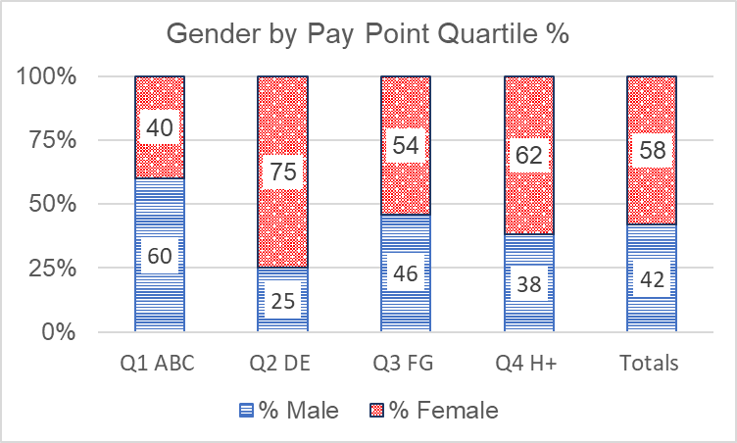

Ethnicity and Disability
Analysis of staff by pay point combined with ethnicity and disability results in all reportable categories showing fewer than 6 staff in one or more category. We therefore do not report on these combinations to prevent the identification of individuals.

Gender Pay Gap – Mean and Median Pay Gap 31 March 2022
Mean Pay Gap
Mean Pay Gap = Sum of all employees' rate of pay/Total number of employees
A= mean hourly rate of pay of male employees
B= mean hourly rate of pay of female employees

Pay Gap (A-B/Ax100)
Mean hourly rate | £16.15
Mean hourly rate of male employees | £15.92
Mean hourly rate of female employees | £16.31
Mean Pay Gap | -2.45%
Median Comparison
Median hourly rate | £14.72
Median hourly rate of male employees | £14.72
Median hourly rate of female employees | £14.72
Median Pay Gap | 0.00%
NB Hourly rate includes basic pay plus shift allowance plus on-call allowance.

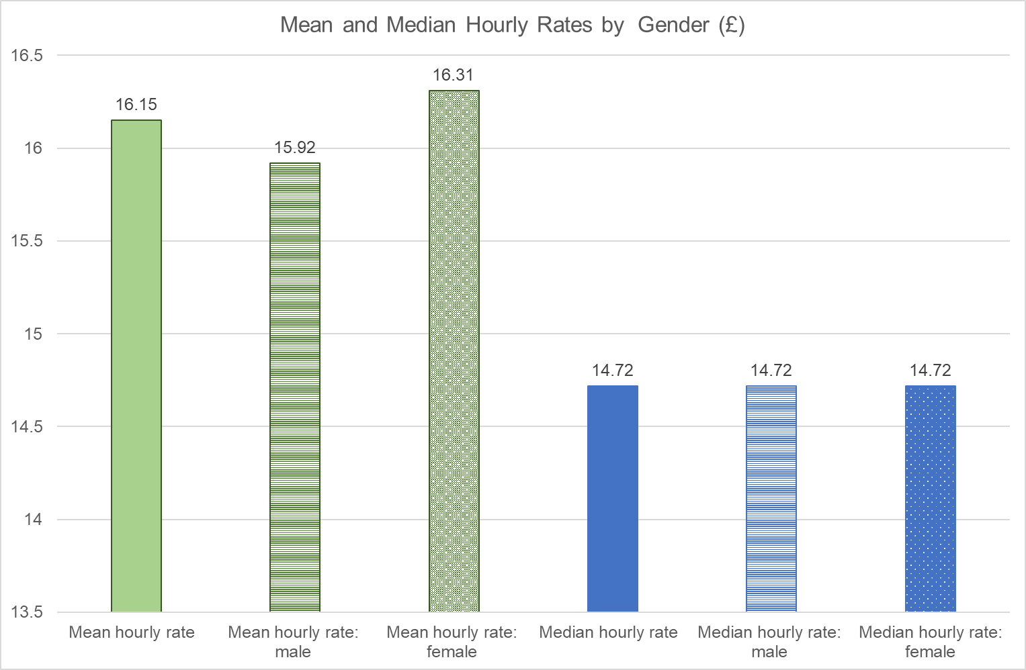

Occupational Segregation
Total number of staff in pay point broken down by gender. An asterisk signifies fewer than 6 staff in each category.
Pay Point | Female | Male
A | 10 | 6
B | * | 9
C | 18 | 35
D | 23 | 10
E | 44 | 12
F | 23 | 26
G | 19 | 11
H | 31 | 16
I | 12 | 9
J | * | *
K | * | *
L | 0 | *
Personal Contract | * | 0
Grand Total | 190 | 137

Breakdown by broad functional categories:
- Administration (38 staff)
- Library (158 staff)
- Support (87 staff)
- Technical (44 staff)

Administration: total number of staff in administration function broken down by pay point and gender. An asterisk signifies fewer than six staff in each category.
Pay Point | Female | Male
A | 0 | 0
B | 0 | *
C | * | 0
D | * | 0
E | 6 | 0
F | * | 0
G | * | *
H | 7 | *
I | * | 0
J | * | 0
K | * | 0
L | 0 | *
Personal Contract | 0 | 0
Grand Total | 31 | 7

Library: total number of staff in library function broken down by pay point and gender. An asterisk signifies fewer than six staff in each category.
Pay Point | Female | Male
A | 0 | 0
B | * | *
C | 0 | 0
D | 13 | 6
E | 33 | 9
F | 18 | 13
G | 16 | *
H | 20 | 9
I | 6 | *
J | 0 | *
K | * | *
L | 0 | 0
Personal Contract | * | 0
Grand Total | 109 | 49

Support: total number of staff in support function broken down by pay point and gender. An asterisk signifies fewer than six staff in each category.
Pay Point | Female | Male
A | 9 | 5
B | * | 6
C | 16 | 34
D | * | *
E | 0 | 0
F | * | *
G | 0 | *
H | * | *
I | 0 | *
J | 0 | 0
K | 0 | 0
L | 0 | 0
Personal Contract | 0 | 0
Grand Total | 32 | 55

Technical: total number of staff in technical function broken down by pay point and gender. An asterisk signifies fewer than six staff in each category.
Pay Point | Female | Male
A | * | *
B | * | *
C | 0 | 0
D | * | *
E | * | *
F | 0 | 7
G | 0 | 6
H | * | *
I | * | *
J | 0 | *
K | * | 0
L | 0 | 0
Personal Contract | 0 | 0
Grand Total | 18 | 26

Appendix 1: Staff data
The following section provides information on our staff. Unless otherwise stated, this information has been taken from the HR Management Information System as at 31 March 2023.
Alt Text descriptions have been added to the charts below.
Where information is described as "Unknown" no data has been provided by the staff member. "Prefer Not to Say" signifies that the staff member has indicated their desire to keep this information private.

Reporting by Quartile
We have aggregated data on staff by pay point into quartiles to balance a meaningful level of detail with safeguards on anonymity around protected characteristics.
The quartiles are as follows:
Quartile | Pay Points | Number of staff
Q1 | A (13), B (11) and C (58 staff) | 82
Q2 | D (36) and E (50 staff) | 86
Q3 | F (47) and G (28 staff) | 75
Q4 | H (44), I (20) and above (12 staff) | 76

Q1: Pay Point A is the lowest pay point in the Library. At pay points A-C roles are generally support roles where tasks are generally straight-forward and supervision readily available.
Q2: Pay Points D and E also provide support services however at this level there is an expectation that there is more freedom, e.g. to determine priorities or exercise judgement.
Q3: Pay Points F and G. These tend to be specialist or professional roles. F is the first level of formal line management.
Q4: Pay Points H+. These are senior roles within the organisation which may demand specialist knowledge, and which are carried out with greater autonomy. Role specific qualifications are usually expected at these levels.

1: Staff numbers by gender
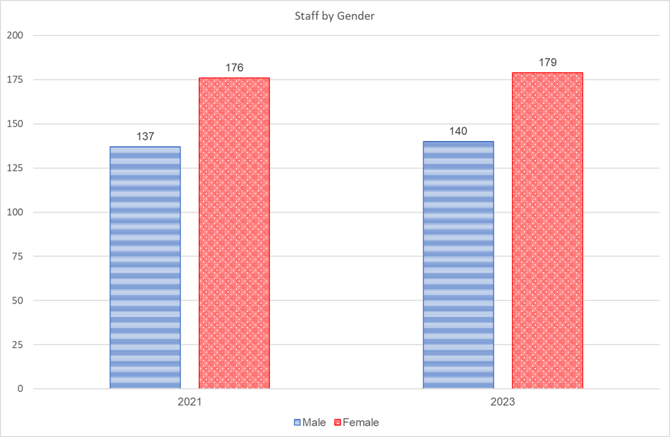

2: Staff by Gender (%)
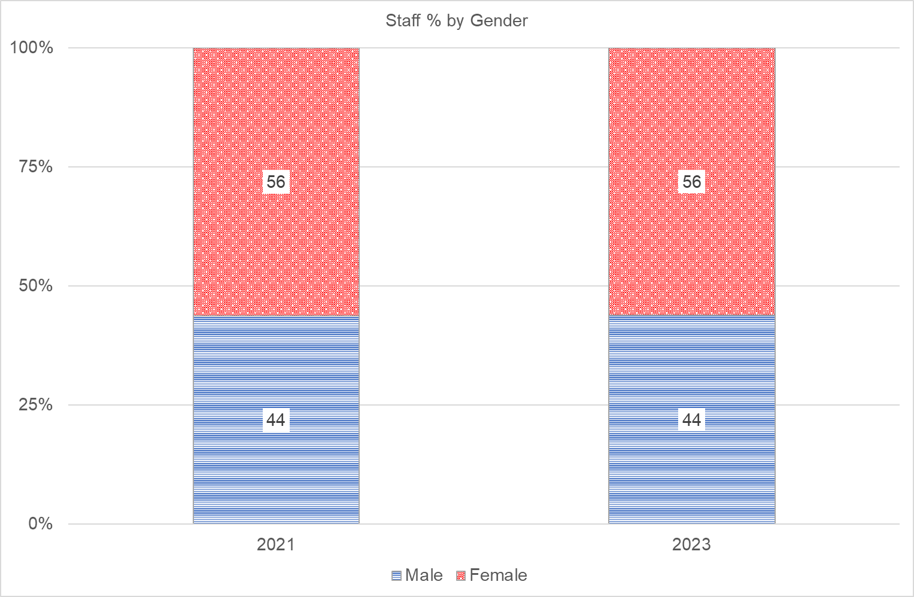

3: Pay Point by Gender
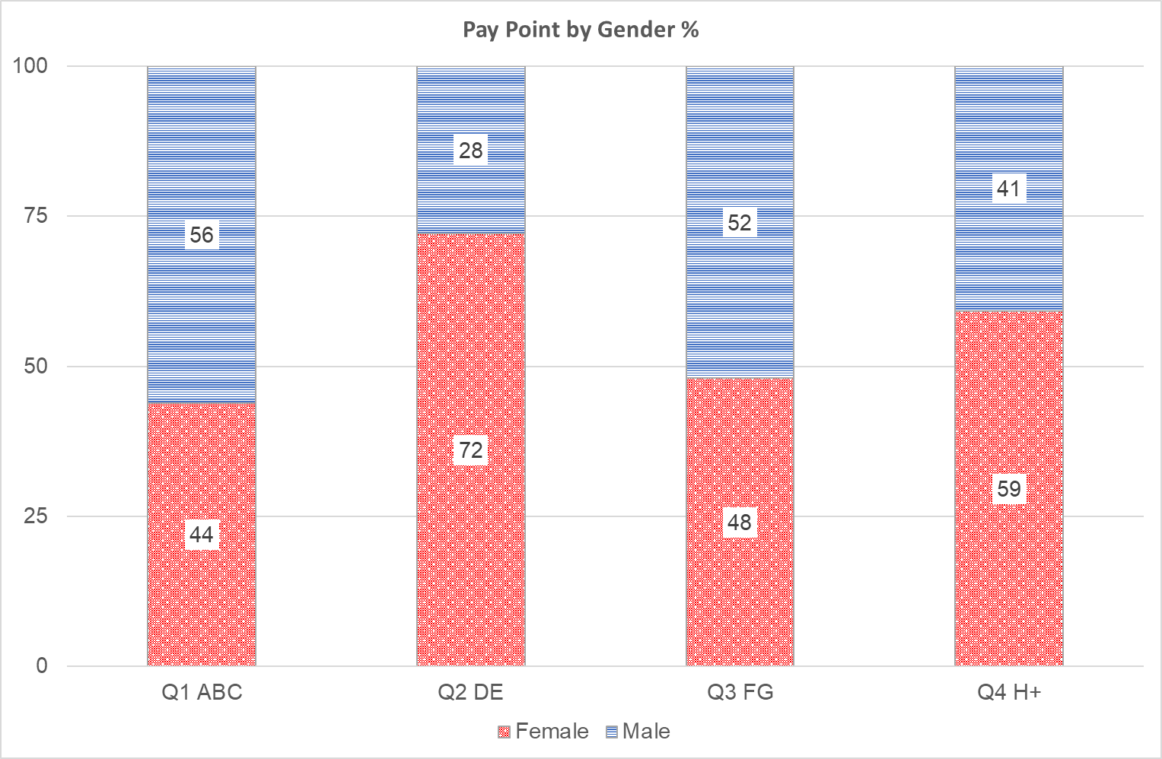

4: Full/part-time staff by gender
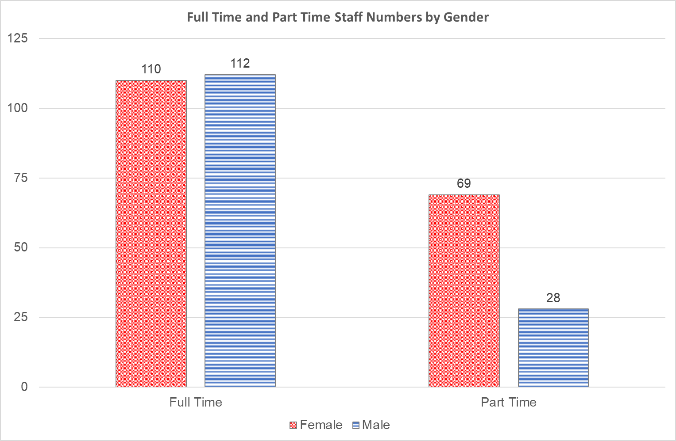

5: Disability by pay point
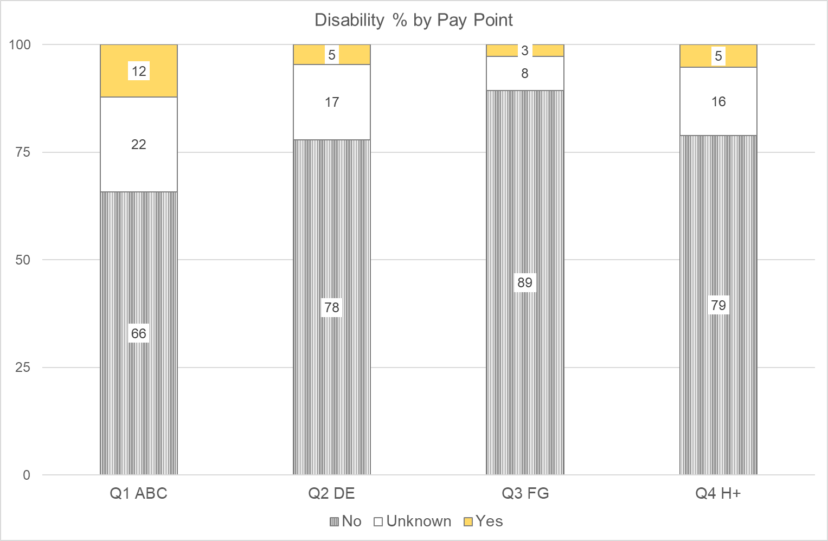

6: Staff numbers by age
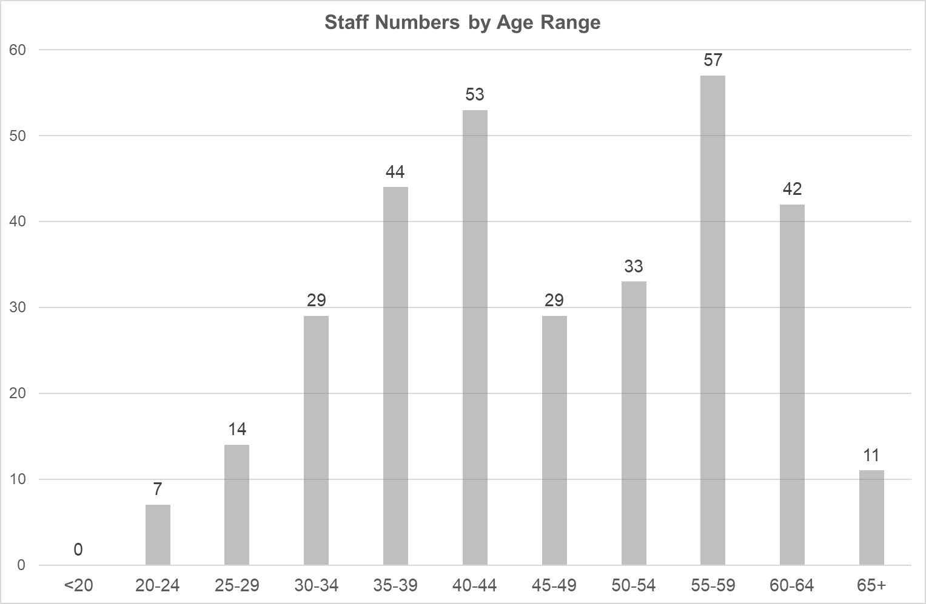

7: Staff Age and Gender Trends %
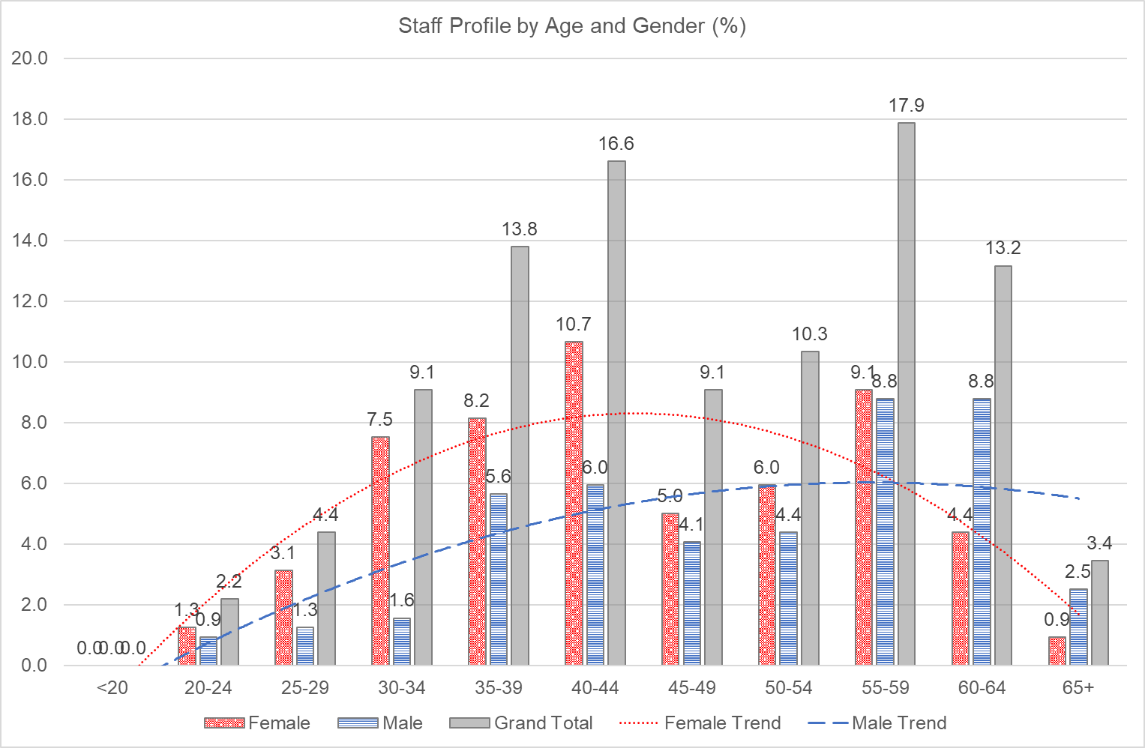

8: Staff numbers by age and gender
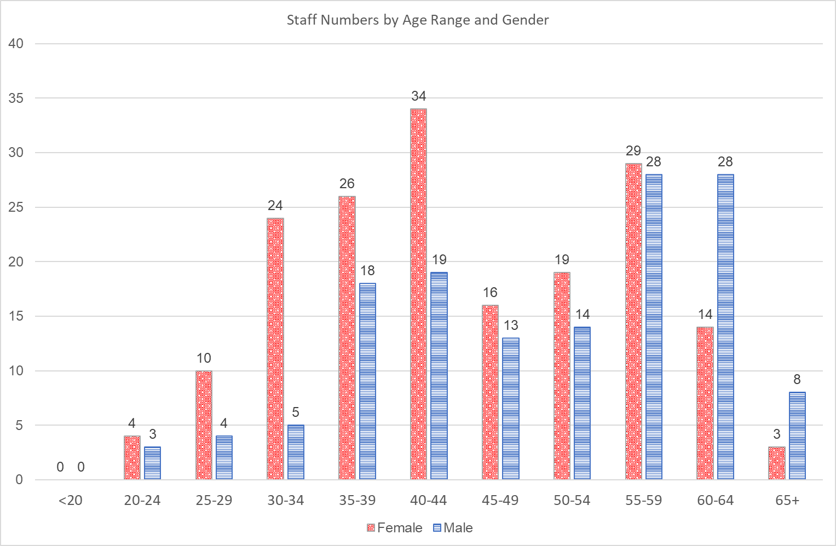

9: Ethnicity by pay point %
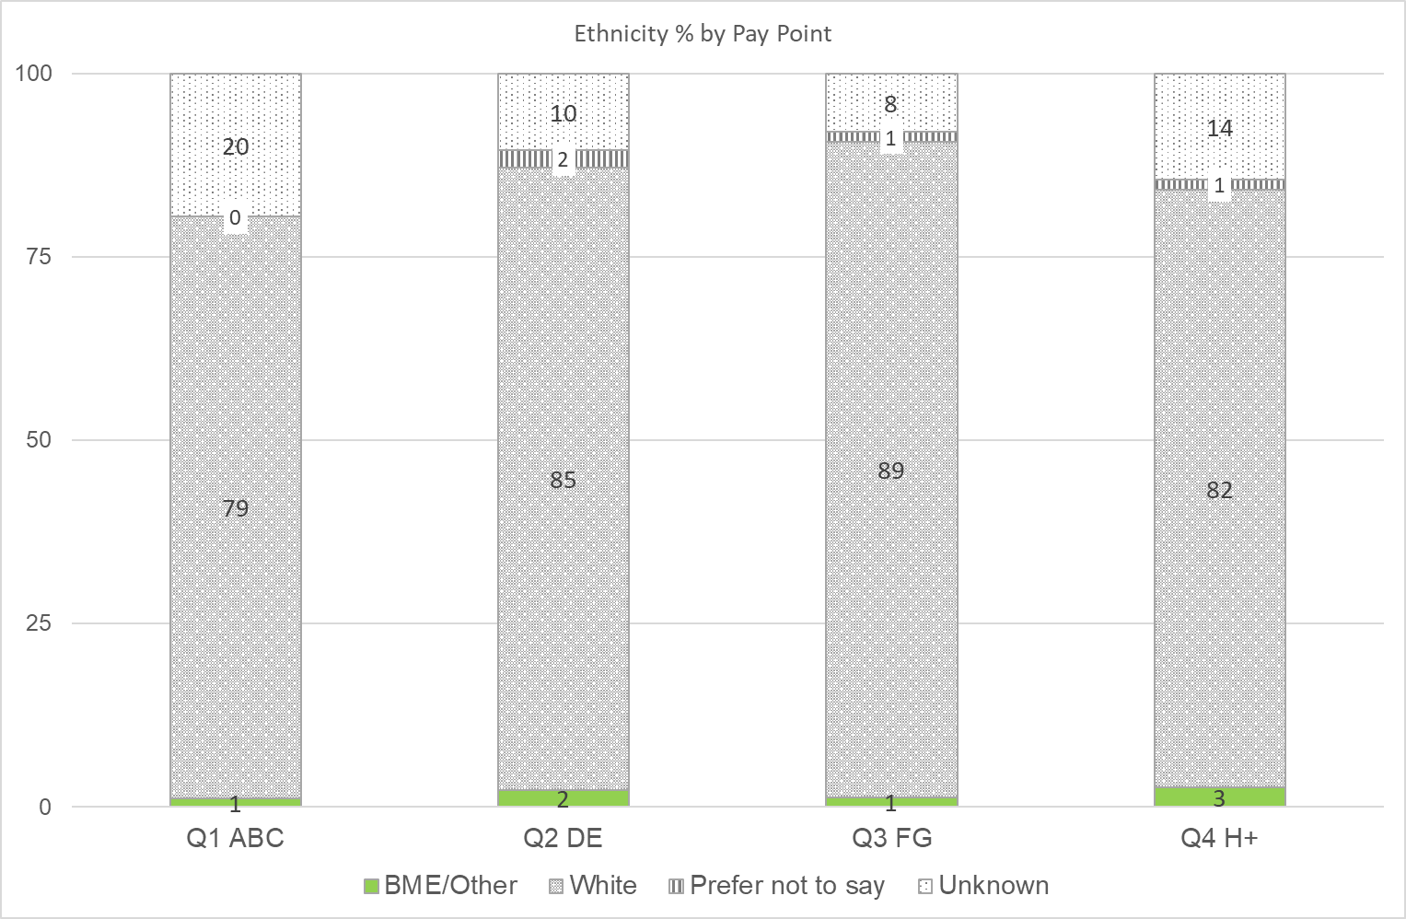

10: Nationality by pay point %
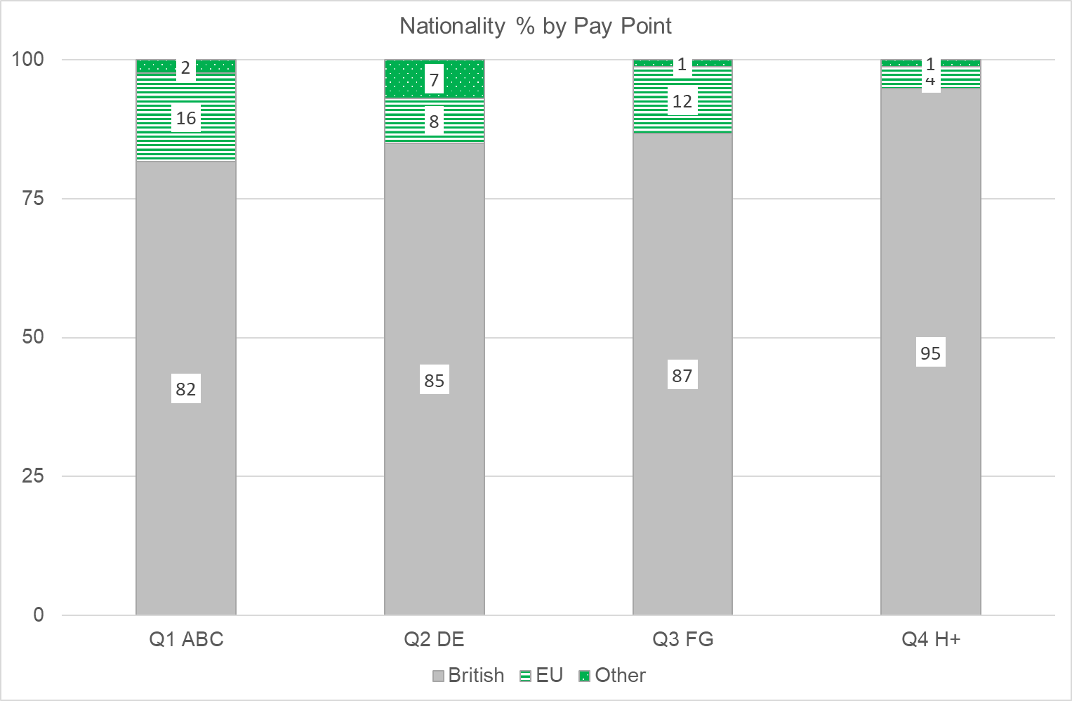

11: Belief by pay point %
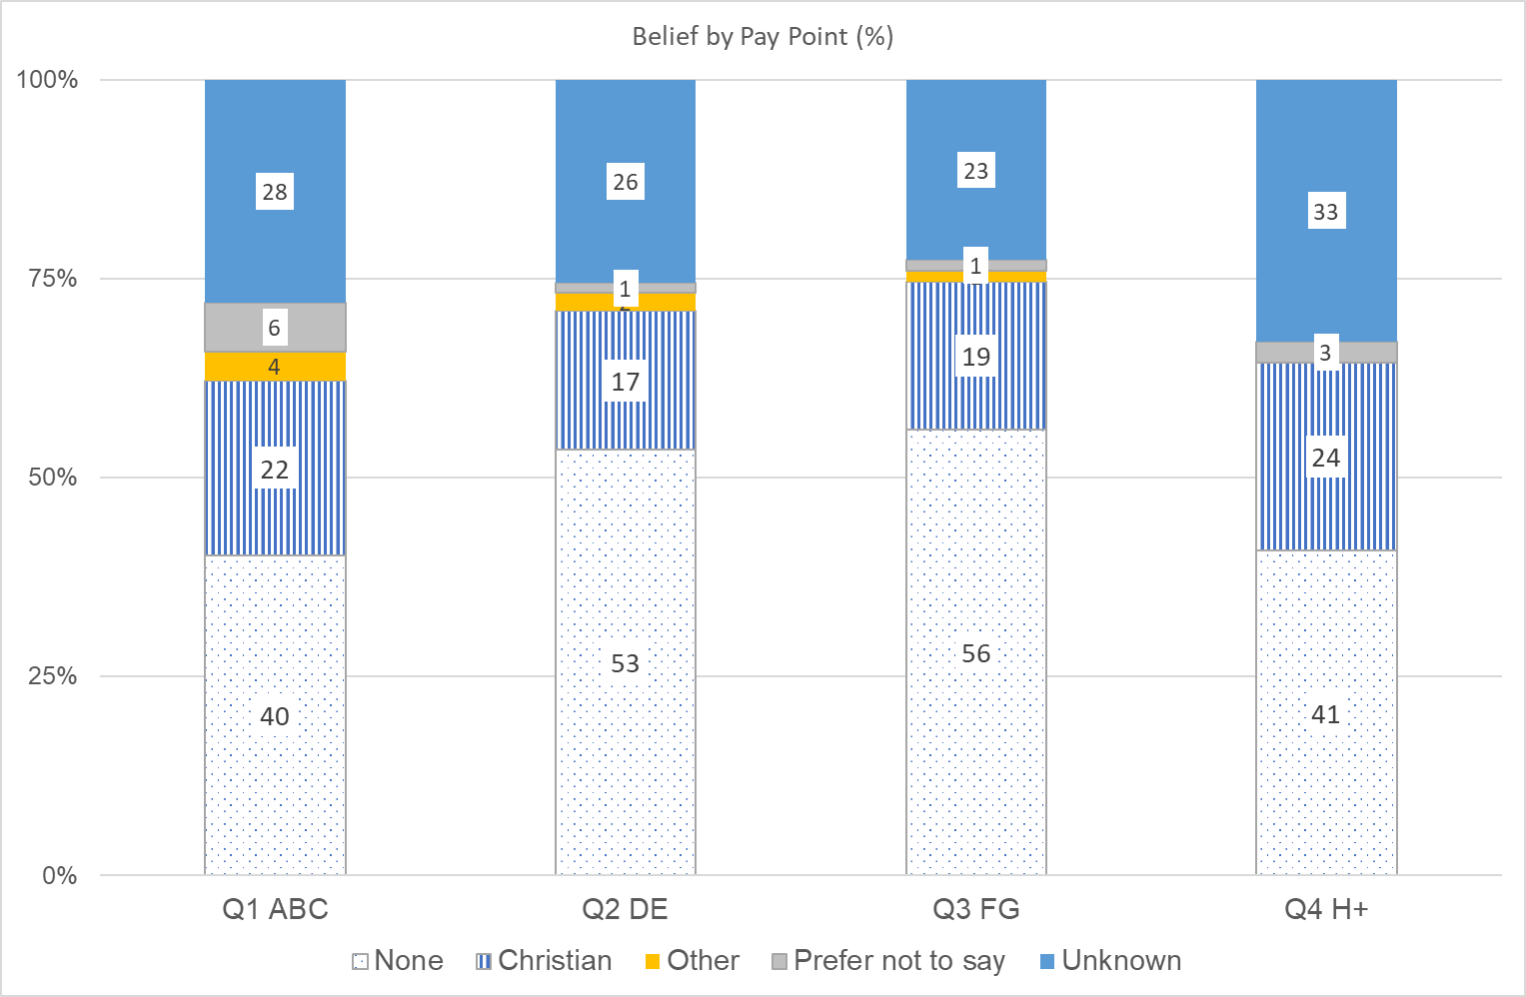

12: Sexual Orientation by pay point
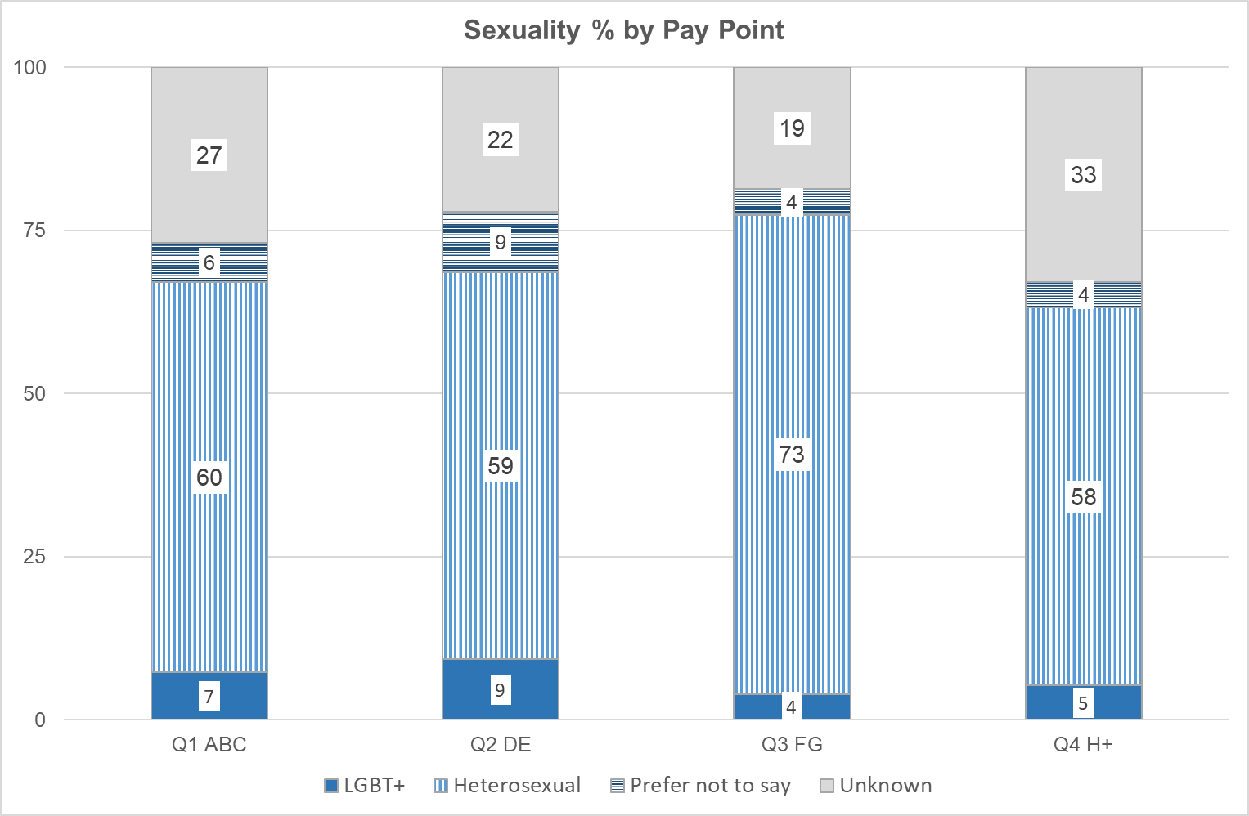

Appendix 2: Board data

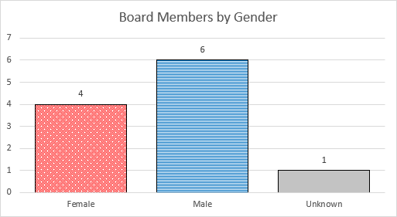
Board by Gender Data Table
Female | 4
Male | 6
Unknown | 1

Appendix 3: Recruitment data
The following charts breakdown the recruitment process by both the stages of recruitment and protected characteristics by percentage.
The stages of recruitment are:
- All Applicants: everyone who submitted an application
- Withdrawn: everyone who withdrew their application before the process was complete
- Regret after Sift: everyone excluded from the process after their application was processed and not invited to interview or who declined an invitation to interview
- Regret after Interview: everyone who was interviewed but not selected and anyone who was made an offer but declined that offer.
- Offer: everyone who was made a job offer and accepted that offer
Comparing percentages at each stage in the process for each protected characteristic reveals any patterns in the data. Please note that the small number of applicants who withdrew from the process (14 out of 1328) may skew the picture when comparing percentages across the stages of recruitment.
The dataset is made up as follows:
Stages of Recruitment | Number | %
- All Applicants | 1328 | 100
- Withdrawn | 14 | 1.1
- Regret after sift | 1218 | 91.7
- Regret after Interview | 72 | 5.4
- Offer | 24 | 1.8

The data is taken from equal opportunities data provided by applicants on the Library’s recruitment website between 1st April 2022 and 31st March 2023. Some descriptions are aggregated into larger sets to facilitate the analysis and display of information e.g. White (Scottish), White (British), White (English) will appear as White.

Protected Characteristics
The units of analysis are:
- Gender (Female, Male, Non-binary, Self-describe)
- Age (ten-year age brackets and prefer not to say – PNTS)
- Disability ("Do you consider yourself to have a disability or health condition?" yes or no)
- Ethnicity (BAME/Other, White, Not Disclosed)
- Belief (Buddhism, Christianity, Hinduism, Jewish, Muslim, None, PNTS, Other)
- Sexual Orientation (LGBT+, Heterosexual, PNTS)
- Nationality (EU, Other, UK)
- Marital Status (Divorced, Married, Separated, Single, Not Disclosed)
- Pregnancy/Maternity ("Are you pregnant or on maternity leave?" yes or no)
Charts show the relative percentages of applicants at each stage of the recruitment process for each protected characteristic. Please note that where the percentage for any category is less than 5% these will not be labelled on the chart in order to maintain clarity in the display.

Gender

Age

Disability: Do you consider yourself to have a disability or health condition?

Ethnicity

Belief and Religion

Sexual Orientation

Nationality

Marital Status
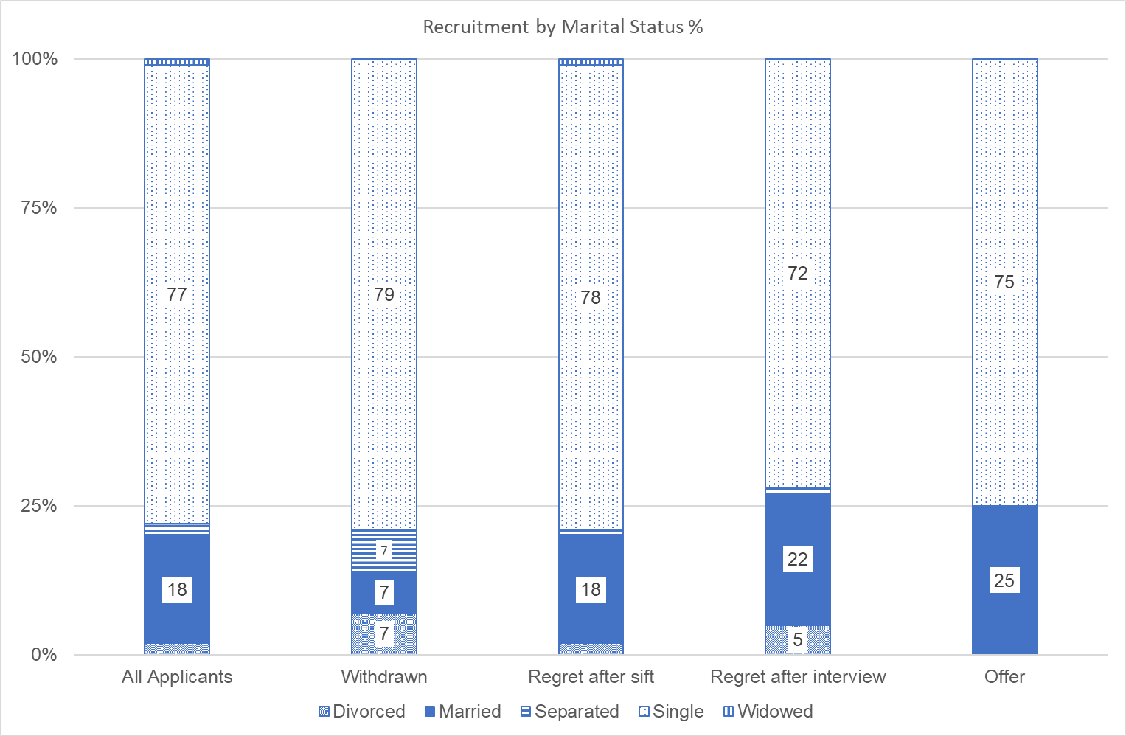

Pregnancy and Maternity Leave: Are you pregnant or on maternity leave?

Appendix 4: Chart Data Tables

A: Staff Profile

1: Staff by Gender Data Table
A: Staff Numbers
 | 2021 | 2023
Male | 137 | 140
Female | 176 | 179

B: Percentages
 | 2021 | 2023
Male % | 44 | 44
Female % | 56 | 56

2: Pay Point by Gender % Data Table
Pay Point | Female | Male
A | 69 | 31
B | 36 | 64
C | 40 | 60
D | 64 | 36
E | 78 | 22
F | 40 | 60
G | 61 | 39
H | 61 | 39
I | 55 | 45
J | 60 | 40
K | 60 | 40
L | 0 | 100
PC | 100 | 0
Grand Total | 56 | 44

3: Pay Point by Gender Numbers Data Table
 | Female | Male | total
Q1 ABC | 36 | 46 | 82
Q2 DE | 62 | 24 | 86
Q3 FG | 36 | 39 | 75
Q4 H+ | 45 | 31 | 76
 | 179 | 140 | 319

4: Full/Part time by Gender Data Table
 | Female | Male | Grand Total
Full Time | 110 | 112 | 222
Part Time | 69 | 28 | 97
Grand Total | 179 | 140 | 319

5: Disability % by Pay Point Data Table
 | No | Yes | Unknown
Q1 ABC | 66 | 12 | 22
Q2 DE | 78 | 5 | 17
Q3 FG | 89 | 3 | 8
Q4 H+ | 79 | 5 | 16

6: Staff by Age Range Data Table
Age Range | Grand Total
<20 | 0
20-24 | 7
25-29 | 14
30-34 | 29
35-39 | 44
40-44 | 53
45-49 | 29
50-54 | 33
55-59 | 57
60-64 | 42
65+ | 11
Grand Total | 319

7: Staff Age Range by Gender Data Table
Age Range | Female | Male
<20 | 0 | 0
20-24 | 4 | 3
25-29 | 10 | 4
30-34 | 24 | 5
35-39 | 26 | 18
40-44 | 34 | 19
45-49 | 16 | 13
50-54 | 19 | 14
55-59 | 29 | 28
60-64 | 14 | 28
65+ | 3 | 8
Grand Total | 179 | 140

9: Ethnicity % by Pay Point Data Table
 | BME/Other | White | Prefer not to say | Unknown
Q1 ABC | 1 | 79 | 0 | 20
Q2 DE | 2 | 85 | 2 | 10
Q3 FG | 1 | 89 | 1 | 8
Q4 H+ | 3 | 82 | 1 | 14

Nationality % by pay point Data Table
 | British | EU | Other
Q1 ABC | 82 | 16 | 2
Q2 DE | 85 | 8 | 7
Q3 FG | 87 | 12 | 1
Q4 H+ | 95 | 4 | 1

Belief % by pay point Data Table
 | None | Christian | Other | Prefer not to say | Unknown
Q1 ABC | 40 | 22 | 4 | 6 | 28
Q2 DE | 53 | 17 | 2 | 1 | 26
Q3 FG | 56 | 19 | 1 | 1 | 23
Q4 H+ | 41 | 24 | 0 | 3 | 33

Sexual Orientation by pay point Data Table
 | LGBT+ | Heterosexual | Prefer not to say | Unknown
Q1 ABC | 7 | 60 | 6 | 27
Q2 DE | 9 | 59 | 9 | 22
Q3 FG | 4 | 73 | 4 | 19
Q4 H+ | 5 | 58 | 4 | 33

B: Recruitment Data Tables

1: Recruitment Stages by Percentage Gender
Stage | Female | Male | Non-Binary | Self-describe
All Applicants | 59 | 36 | 3 | 2
Withdrawn | 50 | 50 | 0 | 0
Regret after sift | 60 | 36 | 3 | 1
Regret after interview | 60 | 35 | 2 | 3
Offer | 54 | 33 | 8 | 5

2: Recruitment by Percentage Age Range
Stage | 18-25 | 26-35 | 36-45 | 46-55 | 56-65 | 66+ | PNTS
All Applicants | 36 | 40 | 13 | 8 | 2 | 1 | 0
Withdrawn | 29 | 43 | 7 | 21 | 0 | 0 | 0
Regret after sift | 37 | 40 | 12 | 8 | 2 | 0 | 1
Regret after interview | 22 | 32 | 28 | 14 | 4 | 0 | 0
Offer | 21 | 50 | 17 | 8 | 4 | 0 | 0

3: Recruitment by Percentage Disability
Stage | Disability Yes | Disability No
All Applicants | 17 | 83
Withdrawn | 14 | 86
Regret after sift | 17 | 83
Regret after interview | 19 | 81
Offer | 8 | 92

4: Recruitment by Percentage Ethnicity
Stage | BME/Other | Not disclosed | White
All Applicants | 15 | 2 | 83
Withdrawn | 29 | 7 | 64
Regret after sift | 16 | 2 | 82
Regret after interview | 3 | 0 | 97
Offer | 4 | 0 | 96

5: Recruitment by Percentage Belief
Stage | Buddhist | Christian | Hindu | Jewish | Muslim | None | Other | PNTS
All Applicants | 1 | 20 | 1 | 1 | 2 | 57 | 5 | 13
Withdrawn | 0 | 29 | 0 | 0 | 0 | 64 | 0 | 7
Regret after sift | 1 | 20 | 1 | 1 | 3 | 56 | 5 | 13
Regret after interview | 1 | 21 | 0 | 1 | 1 | 65 | 3 | 8
Offer | 0 | 17 | 0 | 0 | 0 | 75 | 0 | 8

6: Recruitment by Percentage Sexual Orientation
Stage | Heterosexual | LGB+ | PNTS
All Applicants | 57 | 29 | 14
Withdrawn | 50 | 29 | 21
Regret after sift | 57 | 29 | 14
Regret after interview | 60 | 26 | 14
Offer | 67 | 20.5 | 12.5

7: Recruitment by Percentage Nationality
Stage | EU | Other | UK
All Applicants | 16.5 | 20.5 | 63
Withdrawn | 36 | 14 | 50
Regret after sift | 16 | 22 | 62
Regret after interview | 14 | 8 | 78
Offer | 13 | 4 | 83

8: Recruitment by Percentage Marital Status
Stage | Divorced | Married | Separated | Single | Widowed
All Applicants | 2 | 18 | 2 | 77 | 1
Withdrawn | 7 | 7 | 7 | 79 | 0
Regret after sift | 2 | 18 | 1 | 78 | 1
Regret after interview | 5 | 22 | 1 | 72 | 0
Offer | 0 | 25 | 0 | 75 | 0

9: Recruitment by Percentage Pregnancy and Maternity Leave
Stage | No | Yes | Not Disclosed
All Applicants | 99.2 | 0.8 | 0
Withdrawn | 100 | 0 | 0
Regret after sift | 99.2 | 0.4 | 0.4
Regret after interview | 98.6 | 1.4 | 0
Offer | 100 | 0 | 0

