National Library of Scotland
Sustainability report 2022 to 2023

Contents table
Contents table 1
Background 2
Executive summary 3
Climate action plan 5
Adaptation 6
Mitigation 7
Sustainable development 9
Wider influence 10
Summary of performance figures 11

Background
In 2021 the National Library of Scotland launched a four-year Climate Action Plan, running 2021 to 2025. The Climate Action Plan was created to embed sustainability into the Library's working practices, prepare for the impact of climate change, and enable us to progress towards achieving net-zero by 2045. As a national institution, with extensive collections and staff knowledge, the Library also has an important role to play in climate literacy. We can help communities and individuals be empowered to respond to the climate crisis.
During 2022 to 2023 the Climate Action Plan was reviewed and updated to ensure the continued relevance of the Action points. The Library has also reviewed the scope of the data collected for its performance indicators, to ensure that this data is as comprehensive and accurate as possible. In some cases, this may mean that the figures in this report vary from those reported in previous years, due to the expanded scope of the data captured.
The Library had successfully met several of the Scottish Government's targets on emissions in 2021 to 2022, and the Library has therefore set more challenging internal targets where appropriate.
This report marks the half-way point of the Climate Action Plan. It details successful actions undertaken in 2022 to 2023, and summarises progress in the four areas of the plan:
- Mitigation;
- Adaptation;
- Sustainable development;
- Wider influence.

Executive summary
Below you can see some of the key Library results for the 2022/23 year against key targets set by the Scottish Government and in the Climate Action Plan.
Greenhouse gas emissions
- Scottish Government target: 75% reduction in greenhouse gas emissions against 2008/9 levels by 2030.
- National Library of Scotland target: 77.5% reduction in greenhouse gas emissions against 2008/9 levels by 2025.
- Result: 72.2% reduction in greenhouse gas emissions achieved for 2022/23 year.
Energy use
- Scottish Government target: 40% reduction in energy use against 2008/9 levels by 2020.
- National Library of Scotland target: 55% reduction in energy use against 2008/9 levels by 2025.
- Result: 46% reduction in energy use achieved for 2022/23 year.
Water use
- Scottish Government target: 25% reduction in water use against 2008/9 levels by 2020.
- National Library of Scotland target: 65% reduction in water use against 2008/9 levels by 2025.
- Result: 46.5% reduction in water use achieved for 2022/23 year.
Business car travel
- Scottish Government target: 20% reduction in business car travel against 2008/9 levels by 2030.
- National Library of Scotland target: 40% reduction in business car travel against 2008/9 levels by 2025.
- Result: 74.1% reduction in business car travel achieved for 2022/23 year.
Waste arisings
- Scottish Government target: 15% reduction in waste arisings against 2011 levels by 2020.
- National Library of Scotland target: 15% reduction in waste arisings against 2011 levels by 2025.
- Result: 26.9% reduction in waste arisings against 2010/11 levels.
Waste recycled or composted
- Scottish Government target: 70% of all waste recycled by 2025.
- National Library of Scotland target: 70% of all waste recycled by 2025.
- Result: 72.1% of all waste recycled in 2022/23 year.
General waste sent to landfill
- Scottish Government target: 0% of general waste to go to landfill by 2030.
- National Library of Scotland target: 0% of general waste to go to landfill.
- Result: 0% of waste went to landfill for 2022/23 year.

Climate action plan
This Sustainability report reflects the structure of the Library's Climate action plan, which in turn is derived from the Climate Change (Scotland) Act 2009. The Act sets out three statutory duties that are required of Scottish public bodies:
To act in a way:
- best calculated to contribute to the emissions reduction targets;
- best calculated to contribute to the climate adaptation programme;
- that it considers most sustainably.
Furthermore, public bodies are encouraged to go above and beyond, considering other ways they can positively contribute towards Scotland's climate change targets.
We have translated this into four areas of focus, which we call:
- Mitigation.
- Adaption.
- Sustainable Development.
- Wider Influence.
The Climate action plan identified key desirable outcomes in each area of focus. A mixture of discrete projects and ongoing actions was then scheduled to enable the Library to achieve these outcomes by 2025.
There were 65 actions in the Plan for 2022 to 2023, of which 12 had been carried over from 2021 to 2022, 27 were ongoing actions, and 26 were new actions. During 2022 to 2023, 48% were completed, with good progress made in 31%. Only two actions were not started. Any actions not fully completed in 2022 to 2023 have been carried over to 2023 2024 for completion.

Adaptation
Our world is already seeing massive disruptions caused by our changing climate. As a Library we need to prepare for the inevitable and unavoidable effects of the climate crisis that are already present and will continue to cause disruption to our lives, our mental health, and local economies in the future.
In 2022 to 2023, the National Library of Scotland:
- Put in place an integrated pest management programme and held training sessions for staff in pest awareness.
- Developed a 'Sustainability Hub' on the staff intranet. This included information on:
  - reducing your carbon footprint;
  - eco-anxiety;
  - citizen science projects;
  - volunteering opportunities;
  - background reading on the Climate Crisis.
- Alerted Library staff to local events, training, and volunteering opportunities through regular news posts.
- Began development of a triage area for assessing incoming acquisitions.
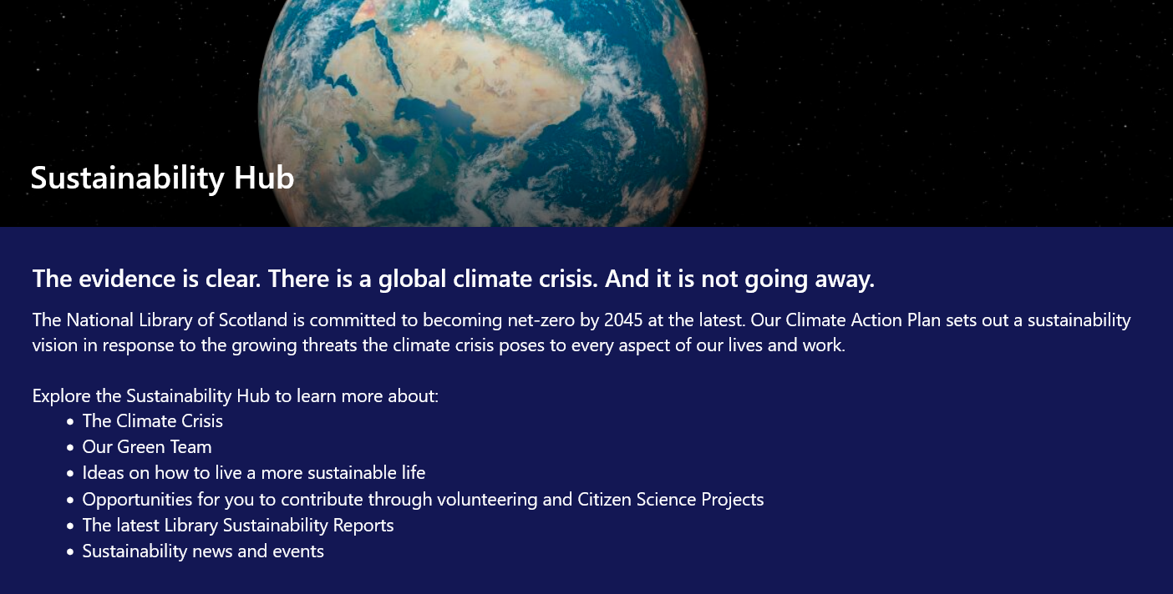
Figure 1. Screenshot of Sustainability Hub

Mitigation
Mitigation refers to the actions we take to mitigate the effects of the climate crisis. This typically means reducing or eliminating our greenhouse gas emissions. The Library is also working to reduce waste and water usage.

Figure 2. Chart showing National Library of Scotland's greenhouse gas emissions up to 2022/23.

During 2022 to 2023, the Library:
- Ensured that sustainability criteria are incorporated into the procurement process for all future IT procurements.
- Worked to decarbonise the Library fleet and roll out electric vehicle driver training to all relevant Library staff. Three electric vehicles were purchased, and 75% of the library fleet is now electric.
- Promoted low-carbon travel alternatives to staff and users.
- Made the Library's environmental data available in open-source format via the Library's Data Foundry to support research in this area.
- Installed utility water metering across the Library's buildings, to support understanding and reducing water usage.
- A 'Carbon Literacy' training session was held in for 14 staff, who obtained Carbon Literacy Certification from the Carbon Literacy Project.
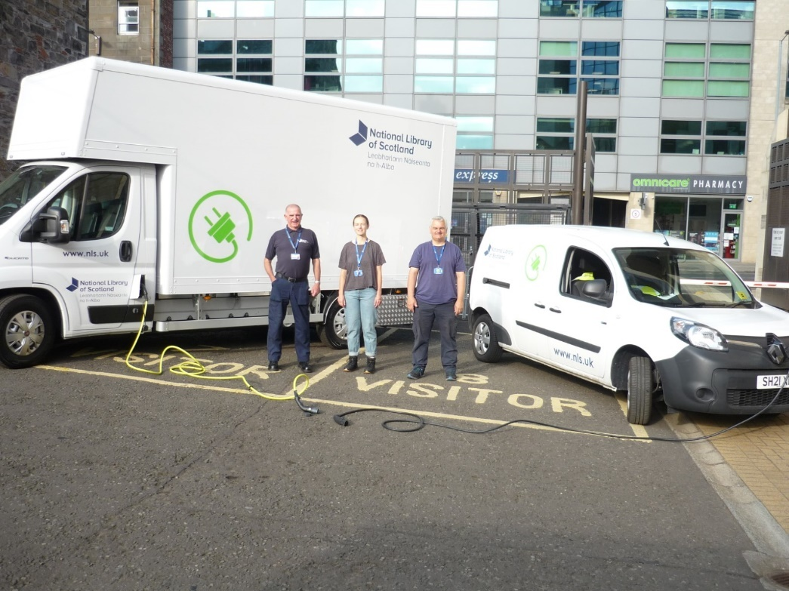
Figure 3. New electric vans for the National Library of Scotland.

Sustainable development
Sustainable development covers many areas. It is not a stand-alone concept but rather a process, something to be built into practices and operations.
The most famous definition of sustainable development comes from the Brundtland Report, also known as 'Our Common Future', a UN document published in 1987. The report defines sustainable development as development 'that meets the needs of the present without compromising the ability of future generations to meet their own needs'.
The National Library of Scotland is seeking to embed sustainable practices into all areas of the Library.
In 2022 to 2023, the Library:
- Updated the business case approval process to include meaningful sustainability requirements.
- Provided sustainable procurement training to delegated purchasing officers.
- Set up a Library Green Team to engage staff on sustainable development and climate action and develop proposals for sustainable actions. During 2022 to 2023, the Green Team organised a Sustainability Fair, and bike maintenance sessions for staff.
- Carried out an audit of general waste, to identify opportunities for increasing recycling and composting.
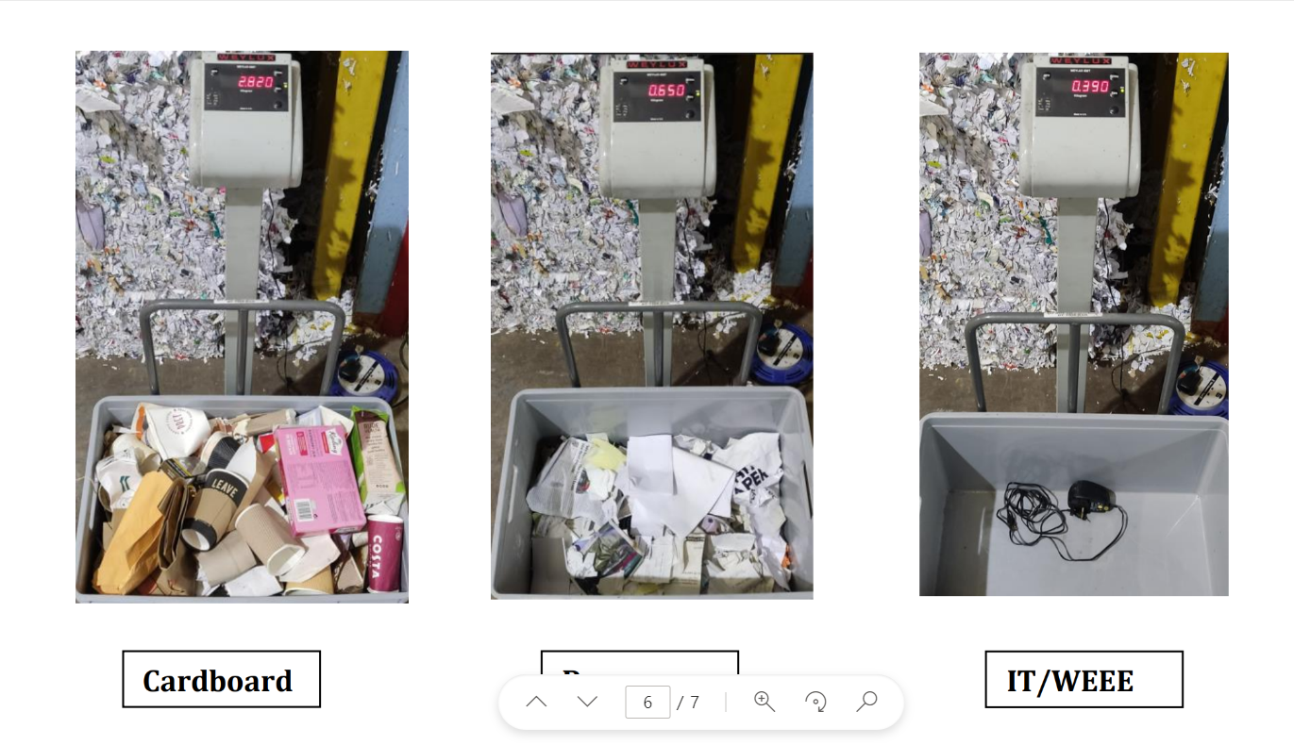
Figure 4. Waste Audit.

Wider influence
Meaningful change depends on people. It's not enough if climate information is confined to an elite few; the hearts and minds of everyone across Scotland need to change if we are to collectively meet our climate targets and work towards a greener, brighter, sustainable future.
As a national library we are in a position to use our collections to help build resilience and improve climate literacy across Scotland. Additionally, the Wider Influence section gives us the space to consider how we can improve staff and user wellbeing in the coming years.
In 2022/3 the Library:
- Held 20 public events relating to Climate and Sustainability. These included:
  - A creative writing workshop on the theme of 'Silent Spring';
  - a sustainability fair;
  - screenings of the film 'The Living Proof';
  - climate resource workshops.
- Contributed to a CILIPS panel discussion on sustainability and libraries.
- Held a staff forum dedicated to items from the collections related to the climate.
- Set up a staff community of interest group dedicated to the climate crisis.
- Participated in Scotland's Climate Week 2022 by promoting a range of online resources on climate and sustainability created by the Library.
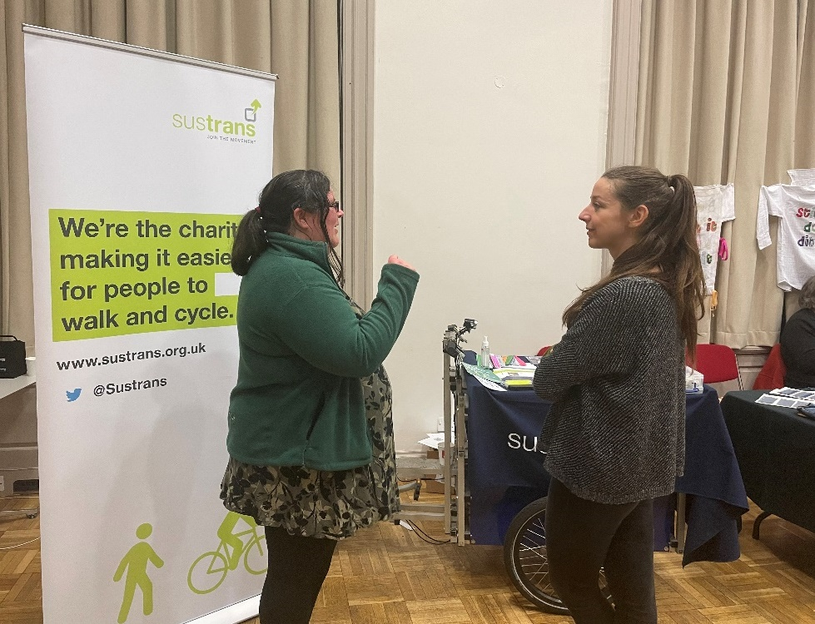
Figure 5. Sustrans stall at Sustainability Fair, February 2023

Summary of performance figures
Area | Target | Baseline year | 2021/22 | 2022/23 | Percentage change against baseline | Percentage change against previous year | Status
Greenhouse Gas emissions (GHG) (Kilotonnes CO2e) | Reduce GHG emissions from operations by 77.5% by 2025 from 2008/9 levels | 3,365,018 | 1,001,447 | 934,947 | -72.2% | -6.6% | Amber
Total energy consumed (kWh) ¹ | Reduce energy consumption by 55% by 2025 from 2008/9 levels | 7,867,983 | 4,477,012 | 4,261,278 | -45.8% | -4.8% | Amber
Total waste arisings (Tonnes) ² | Reduce waste arisings by 15% by 2025 from 2010/11 levels | 68.1 | 79.4 | 41.2 | -26.9% | -48.1% | Green
Food waste consumption (Tonnes CO2e) | Reduce food waste by 1/3 (33%) by 2025, against 2013 levels | 16.64 | 2.427 | 5.659 | -65.8% | +133.2% | Green
Percentage waste recycled or composted | Recycle or compost 70% of all waste arisings by 2025 |  | 86.0% | 72.1% |  | -14% | Green
Percentage waste to landfill | Only 5% of all waste arisings to go to landfill by 2025 and send no waste to landfill by 2030 |  | 0% | 0% |  | 0% | Green
Water consumption (m3) | Reduce water usage by 65% by 2025 from 2008/9 baseline | 18,595 | 6,804 | 9,954 | -46.5% | +46.3% | Red
Owned transport and business travel (Km) | Not to exceed the baseline year numbers 2008/9 | 1,038,859 | 65,610 | 203,997 | -80.4% | +210.9% | Green
Business Car travel (km) | Reduce business car travel by 20% by 2030 from 2008/9 baseline | 21,318 | 5,502 | 5,520 | -74.1% | +3.3% | Green

Target Status:
- Green: Target achieved or exceeded.
- Amber: Target not achieved, however, the Library is making good progress towards meeting this target in coming years.
- Red: Target not achieved, and the Library is showing limited or negative progress towards meeting this target in coming years.
In 2023 the National Library of Scotland reviewed the scope of the data collected for the performance indicators listed above. This has led to performance figures being recalculated to ensure that the Library provides as comprehensive and accurate reporting as possible. Figures for previous years given in the table above may therefore vary from figures reported in previous Sustainability Reports.

