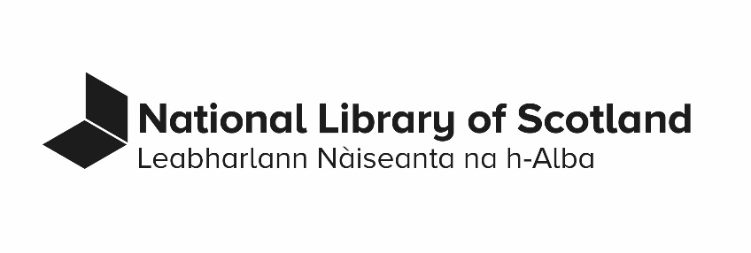
Statement of Public Task

Last revised: August 2023

Statement of Public Task
The National Library of Scotland’s (‘the Library’s’) Public Task under the Re-use of Public Sector Information Regulations 2015 (‘the Regulations’) consists of the production, maintenance, and use of documents for the purposes of:
- preserving, conserving, and developing its collections;
- making its collections accessible;
- exhibiting and interpreting its collections;
- promoting collaboration and sharing of good practice within the library and information sector; and
- satisfying its operational, legal, charitable, and statutory obligations.
The legal and organisational framework for the Library’s Public Task is set out by the functions and privileges that the Library is accountable for:
- under the National Library of Scotland Act 2012 and associated legislation, such as the Museums and Galleries Act 1992;
- as a legal deposit library and as a library in Scotland, including as laid out in relevant legislation, such as the Legal Deposit Libraries Act 2003, the Legal Deposit Libraries (Non-Print Works) Regulations 2013, and the Copyright, Designs and Patents Act 1988;
- as a non-departmental government body in Scotland, including as laid out in relevant legislation;
- as a charity registered in Scotland, including as laid out in relevant legislation; and
- as laid out in its Strategy, Corporate Plan, Annual Review, and similar documents published on the ‘About Us’ section of www.nls.uk.
The Library produces, maintains, and uses documents within its Public Task:
- in any and all formats and media;
- in physical and digital form, both online and offline; and
- on the Library’s premises and externally, for example through loan.
Information on re-use of documents available under the Regulations can be found on the Re-use Categories Register and on the PSI and Permissions pages of www.nls.uk.
Questions about this statement may be submitted through the Library’s Contact page.
Complaints about this statement may be made through the Library’s complaints procedure.
This statement is reviewed every 4 years and is due to be considered again in 2027.

Document information
- Document name: Statement of Public Task
- Document status: Approved
- Contact: Rights and Information Manager
- Approval:
  - Date of Library Leadership Team Approval: May 2015
  - Date of Whitley Approval: Not applicable
  - Date of Audit Committee Approval: Not applicable
- Equality Impact Assessment Completed: Not applicable
- Date of next review: August 2027
- Business classification: 06.08.01.01
- Retention: Retain until superseded

Document control
Date | Action
May 2015 | Document approved and published
August 2023 | Document updated

