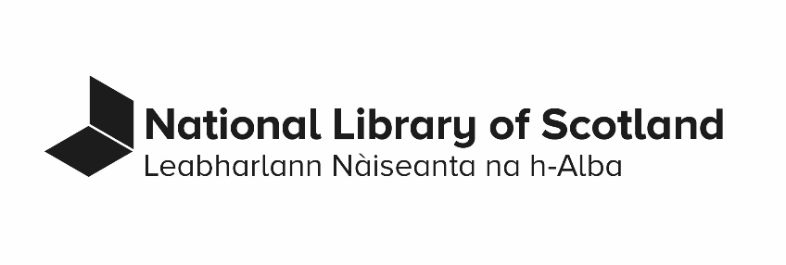

Gifts, Fees, Hospitality, Bribery and Corruption Policy

Last revised November 2023
Contents
1. Scope 3
2. Aim 3
3. Background 3
4. Principles 5
5. How to raise a concern 7
6. Related policies and procedures 7
7. Appendix A Declaration of Acceptance Of Hospitality And Gifts 9
Document control 10

Scope
This policy applies to all staff members of the National Library of Scotland including employed staff, agency staff, work placements, volunteers and all Board members.

Aim
This policy gives staff members and Board Members clear guidance on the proper receipt of gifts, fees and hospitality.
The National Library of Scotland expects high standards of behaviour from all staff members and Board Members. Any association with a conviction for a bribery or corruption related offence would have severe reputational and/or financial consequences for the Library.
The prevention, detection and reporting of bribery or corruption is the responsibility of all staff members and Board members.

Background

Ethical Standards in Public Life
The Nolan Seven Principles of Public Life outline the ethical standards those working in the public sector are expected to adhere to. These are 'the seven principles of public life'. These are selflessness, integrity, objectivity, accountability, openness, honesty and leadership.
These principles apply to staff members and Board members. The Library's Code of Conduct for Board members also applies to members of the Board.

Bribery Act 2010
- The Bribery Act 2010 makes it an offence for a UK national or person located in the UK to pay or receive a bribe, either directly or indirectly. The Bribery Act covers transactions that take place in the UK or abroad, and both in the public or private sectors. It outlines four main offences.
- Giving or offering a bribe.
- Requesting or accepting a bribe.
- Bribing a foreign official.
- A corporate offence of negligently failing to prevent bribery.
Bribes are not only cash. Gifts and hospitality can be considered bribes if they are intended to influence a decision.

Risk Areas
Key risk areas to be aware of are.
- Excessive gifts, entertainment and hospitality can be used to exert improper influence on decision makers.
- Facilitation payments should never be used to secure or expedite the performance of an action the payer is entitled to.
- Improper payments to obtain new business, retain existing business, or secure any improper advantage should never be accepted or made.
- Record keeping can be exploited to conceal bribes or corrupt practices.

The Library may be held responsible for actions by third parties such as agents, contractors and consultants. Third parties should only be engaged where there is a clear business rationale for doing so, with an appropriate contract and due diligence. Payments to third parties should be properly authorised and recorded.

Principles
You are personally responsible for all decisions relating to offers of gifts, fees or hospitality. If in doubt as to the proper course of action you should seek the advice of your line manager or the Board Support and Compliance Officer.
Where you decline a gift or hospitality you should do so courteously and tactfully, informing the giver/host of the Library's policy.

Gifts
- You must not solicit a gift or any other personal benefit from any outside individual or organisation in connection with your work for the Library.
- You should refuse any personal gifts offered in the course of your work for the Library which exceed a token value of approximately £50.
- You must reject any gift which might be seen as intended to influence you in the discharge of your duties.
- Where a gift of more than token value is received without any opportunity to refuse, or which could not be refused without causing offence, then you must declare the receipt of the gift, using the form in Appendix A. The Library will decide if you may retain the gift personally or if it should be retained by the Library. The Library will maintain a register of such gifts.

Cash gifts
- If you are given any gifts or donations of money in the course of your work at the Library you must immediately pass these to Finance.
- Under no circumstances should you keep any cash gifts.

Fees
- If you are asked by the Library to undertake outside work, e.g. lectures and publications, then any fee or commission earned must be passed to the Library. You should also note that copyright in such situations rests with the Library.
- You are free to carry out outside work in a purely personal capacity entirely within your own time, without the use of Library resources not generally available to the public. Any fee earned may be retained and copyright will generally rest with the individual.
- You should consider whether there is a potential conflict of interest with your role within the Library or whether the public or press could perceive a conflict of interest. Where there is the possibility of a conflict you should notify your line manager in writing in advance.
- If such work is carried out in a personal capacity but your line manager has given prior approval for the use of Library resources and/or time, then the work will be deemed to be on behalf of the Library. Any fee or commission earned must be passed to the Library. Copyright will rest with the Library.

Awards and prizes
- If you are approached by an outside organisation about the offer of an award or prize in any way connected with your work at the Library you should notify your line manager.
- You should only accept awards that are recognised and reputable.
- You should not accept an award that is, or could be construed as, a gift, inducement, or payment.

Hospitality
- You must not solicit hospitality from any outside individual or organisation in connection with your work for the Library.
- You must reject any hospitality which might be seen as intended to influence you in the discharge of your duties.
- You must reject any hospitality you cannot justify, or for which you think you may receive legitimate criticism.
- You must reject repeated offers of hospitality from the same source.
- You must reject any offer which appears to you, or potentially to others, as in any way excessive.
- Offers to attend social or sporting functions should only be accepted when the Library is expected to attend and should be represented.
- Offers of hospitality from organisations advertising products or services to the Library should only be accepted if there is clear, direct benefit to the Library in your attendance. Examples include.
Events where it is important the Library is represented.
Events providing useful information about the products or services supplied by the organisation.
Events providing opportunities to gain contacts or improve liaison with other groups or organisations which might be helpful to the Library.
You must declare any hospitality you accept, using the form in Appendix A.

How to raise a concern
- You must report to your line manager, or to the Board Support and Compliance Officer, any offer of a gift or hospitality which you intend to reject but which, in your view, is designed to influence you inappropriately. The Library reserves the right to take appropriate action, including launching a fraud investigation and making a report to the police and/or the Library's auditors.
- If you suspect or become aware of any form of bribery or corruption you have a duty to report this in accordance with the Library's Code of conduct and Whistleblowing Policy.

Related policies and procedures
- Code of Conduct for staff
- Whistleblowing policy
Board members should also refer to the Library's Code of Conduct for Board members.

Appendix A Declaration of Acceptance Of Hospitality And Gifts
Please use this form to declare.
- Gifts of more than nominal value you have received. Please enclose the gift.
- Hospitality you have accepted.

Your name | Input
Name of giver/host | Input
Details of gift or hospitality | Input
Approximate value | Input
Date of receipt | Input
I confirm the above declaration is complete and correct to the best of my knowledge and belief.
Signature (insert signature)

Date (insert date)

Please return the completed form to the Board Support and Compliance Officer (email: governance@nls.uk).
To be completed by the Director of Engagement
I declare I have (delete as applicable).
- Received the gift described above. It will be retained by the Library/returned to the individual.
- Noted acceptance of the hospitality described above.

Signature (insert signature)
Date (insert date)

Note. The Director of Engagement may refer any reported declaration to the National Librarian for final review.
Document information
- Document name: Gifts, Fees, Hospitality, Bribery And Corruption Policy.
- Document status: Approved policy.
- Contact: Board Support & Compliance Officer.
- Approval:
  - Date of Whitley Approval: Not applicable.
  - Date of Audit Committee Approval: November 2023.
- Equality Impact Assessment Completed: April 2015.
- Date of next review: November 2025.
- Business classification: Approved policies.
- Retention: 1 year after superseded (review for historical & business value).

Document control
Date | Action
May 2017 | Superseded
August 2019 | Superseded
November 2021 | Superseded
November 2022 | Superseded
November 2023 | Approved

