# National Library of Scotland **Sustainability report 2023 to 2024**

### **Contents table**

Background 2

Executive summary 3

Climate Action Plan 5

Adaptation 6

Mitigation 7

Sustainable development 9

Wider influence 10

Summary of performance figures 11

### **Background**

In 2021, the National Library of Scotland launched a four-year Climate Action Plan, running from 2021 to 2025. The Climate Action Plan was created to embed sustainability into the Library's working practices, prepare for the impact of climate change, and enable us to progress towards achieving net zero by 2045. As a national institution, with extensive collections and staff knowledge, the Library also has an important role to play in climate literacy. We can help communities and individuals be empowered to respond to the climate crisis.

This report reviews the National Library of Scotland's performance against climate indicators set by the Scottish Government in 2023-24. It details successful actions carried out during the reporting year and summarises progress in the four areas of the Plan:

* Mitigation
* Adaptation
* Sustainable Development
* Wider Influence

### **Executive summary**

After many years of reporting significant progress with our sustainability targets, the results for 2023/2024 are more sobering. While huge progress has been made since 2008/09, over the last year we have seen an increase in energy use and in greenhouse gas (GHG) emissions. Some of the reasons for this include the increased use of gas over a long cold winter, increases in carbon conversion factors for electricity, the increased use of our main George IV Bridge building and the inclusion of new sources of carbon emissions within the calculation.

While the GHG increases are disappointing and most likely to continue into the 2024/2025 results, we must remember that achieving net zero is a long-term goal and one that the Library remains focused upon.

Below you can see some of the key Library results for the 2023/24 year against key targets set by the Scottish Government and in the Climate Action Plan.

 **74.1% reduction in greenhouse gas emissions**

* **Scottish Government target:** 75% reduction in greenhouse gas emissions against 2008/9 levels by 2030.
* **National Library of Scotland target:** 77.5% reduction in greenhouse gas emissions against 2008/9 levels by 2025.
* **Result:** 74.1% reduction in greenhouse gas emissions achieved for 2023/24 year.

**50.6% reduction in energy use**

* **Scottish Government target:** 40% reduction in energy use against 2008/9 levels by 2020.
* **National Library of Scotland target:** 55% reduction in energy use against 2008/9 levels by 2025.
* **Result:** 50.6% reduction in energy use achieved for 2023/24 year.

**42.4% reduction in water use**

* **Scottish Government target:** 25% reduction in water use against 2008/9 levels by 2020.
* **National Library of Scotland target:** 65% reduction in water use against 2008/9 levels by 2025.
* **Result:** 42.4% reduction in water use achieved for 2023/24 year.

 **86.3% reduction in business car travel**

* **Scottish Government target:** 20% reduction in business car travel against 2008/9 levels by 2030.
* **National Library of Scotland target:** 40% reduction in business car travel against 2008/9 levels by 2025.
* **Result:** 86.3% reduction in business car travel achieved for 2023/24 year.

**31.9% reduction in waste arisings**

* **Scottish Government target:** 15% reduction in waste arisings against 2011 levels by 2020.
* **National Library of Scotland target:** 15% reduction in waste arisings against 2011 levels by 2025.
* **Result:** 31.9% reduction in waste arisings against 2010/11 levels.

 **73.7% of waste recycled or composted**

* **Scottish Government target:** 70% of all waste recycled by 2025.
* **National Library of Scotland target:** 70% of all waste recycled by 2025.
* **Result:** 73.7% of all waste recycled in 2023/24 year.

 **0% general waste sent to landfill**

* **Scottish Government target:** 0% of general waste to go to landfill by 2030.
* **National Library of Scotland target:** 0% of general waste to go to landfill.
* **Result:** 0% of waste went to landfill for 2023/24 year.

### **Climate Action Plan**

This Sustainability report reflects the structure of the Library's Climate Action Plan, which in turn is derived from the Climate Change (Scotland) Act 2009. The Act sets out three statutory duties that are required of Scottish public bodies:

To act in a way:

1. best calculated to contribute to the emissions reduction targets
2. best calculated to contribute to the climate adaptation programme
3. that it considers most sustainably.

Furthermore, public bodies are encouraged to go above and beyond, considering other ways they can positively contribute towards Scotland's climate change targets.

We have translated this into four areas of focus, which we call:

1. Mitigation
2. Adaption
3. Sustainable Development
4. Wider Influence

The Climate Action Plan identified key desirable outcomes in each area of focus. A mixture of discrete projects and ongoing actions was then scheduled to enable the Library to achieve these outcomes by 2025.

There were 54 actions in the CAP for 2023-24, of which 10 had been carried over from 2022-23, 42 were ongoing actions, and two were new actions. During 2023-24, 59% were completed, with good progress made in 20%. Only two actions were not started.

#### **Adaptation**

Our world is already seeing massive disruptions caused by our changing climate. As a Library we need to prepare for the inevitable and unavoidable effects of the climate crisis that are already present and will continue to cause disruption to our lives, our mental health, and local economies in the future.

In 2023-24, the National Library of Scotland:

* Held staff training to raise staff awareness of pest types and threats.
* Setup a triage space for incoming collections in the Causewayside Building.
* Agreed a Preservation Policy, which outlines the need for boxing across all collections.
* Installed dust monitoring devices on stack floors to provide baseline data to inform future cleaning plans.
* Increased the capacity of the gutters and outlets at the Sighthill Building in light of increased sudden heavy rainfall incidents.
* Began development of a quarantine area for incoming acquisitions.

photograph of dust monitors


Figure 1. Dust monitoring equipment

#### **Mitigation**

Mitigation refers to the actions we take to mitigate the effects of the climate crisis. This typically means reducing or eliminating our greenhouse gas emissions. The Library is also working to reduce waste and water usage.

Figure 2. Chart comparing National Library of Scotland's greenhouse gas emissions in 2023/24 to previous years.

During 2023-24, the Library:

* Promoted active travel by offering a bike maintenance course and Dr Bike sessions to staff.
* Made the Library's environmental data available in open-source format via the Library's Data Foundry to support research in this area.
* Fitted inverters to air handling units.

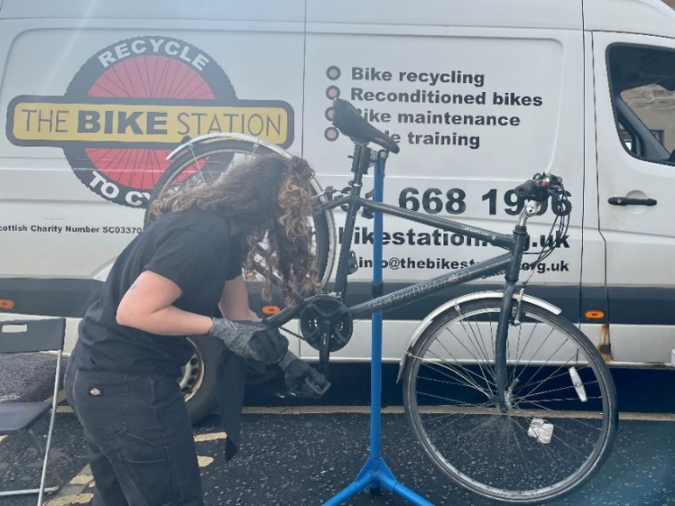

Figure 3. Bicycle being repaired during a Dr Bike session.

#### **Sustainable development**

Sustainable development covers many areas. It is not a stand-alone concept but rather a process, something to be built into practices and operations.

The most famous definition of sustainable development comes from the Brundtland Report, also known as 'Our Common Future', a United Nations document published in 1987. The report defines sustainable development as development 'that meets the needs of the present without compromising the ability of future generations to meet their own needs'.

The National Library of Scotland is seeking to embed sustainable practices into all areas of the Library.

In 2023-24, the Library:

* Provided sustainable procurement training to Delegated Purchasing Officers.
* Used sustainability criteria in appointing a new contract for the café at George IV Bridge building.
* Completed a self-assessment using the Sustainability Flexible Framework tool in October 2023, with a set of actions that will position library to complete level 1 by October 2024.
* A minimum 10% weighting for sustainability consideration in tender evaluations has become policy.
* Provided regular updates to staff via the staff intranet on Green Team news, sustainability progress, events and training opportunities.

Table showing progress against Scottish Government Flexible Framework for Procurement


Figure 4. Flexible Framework summary October 2023 for National Library of Scotland.

### **Wider influence**

Meaningful change depends on people. It's not enough if climate information is confined to an elite few; the hearts and minds of everyone across Scotland need to change if we are to collectively meet our climate targets and work towards a greener, brighter, sustainable future.

As a national library, we are in a position to use our collections to help build resilience and improve climate literacy across Scotland. Additionally, the Wider Influence section gives us the space to consider how we can improve staff and user wellbeing in the coming years.

In 2023/4 the Library:

* Held 18 public events relating to Climate and Sustainability. These included:
  + Climate resource workshops
  + Planting with Nature: A Guide to Sustainable Gardening
  + Co-lab with Glasgow School of Art
* Secured a Research Libraries UK (RLUK) Professional Practice Fellowship to fund 0.2FTE for two years to look at climate crisis resources in Library collections.
* Made a successful bid to the Chartered Institute of Library and Information Professionals in Scotland (CILIPS) Research Fund for a project to create a Carbon Literacy for Libraries shareable course and set up a project group to oversee development of the course.
* Held a staff forum dedicated to items from the collections related to the climate.
* Participated in Scotland's Climate Week 2023 by hosting a Repair What You Wear workshop, a Climate Zine workshop and a climate resources online event.
* Linda Macmillan, Head of Estates, was appointed to the International Federation of Library Associations and Institutions (IFLA) Building Committee.

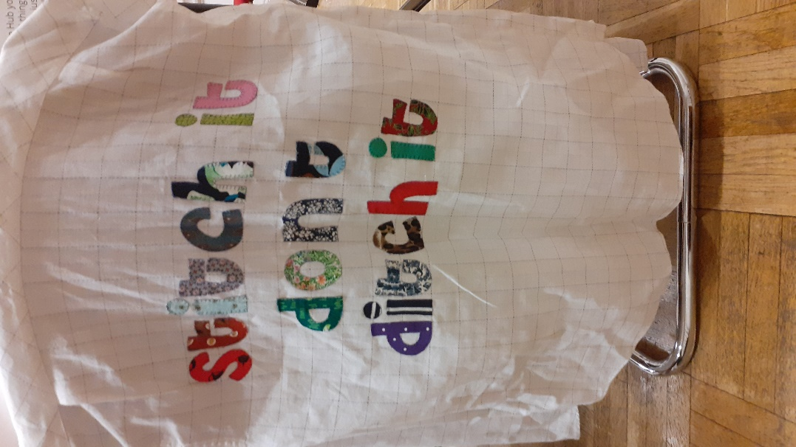

Figure 5. 'Stitch it don't ditch it' sign from Repair What You Wear Workshop.

### **Summary of performance figures**

|  |  |  |  |  |  |  |  |
| --- | --- | --- | --- | --- | --- | --- | --- |
| **Area** | **Target** | **Baseline year** | **2022/23** | **2023/24** | **% change against baseline** | **% change against previous year** | **Status** |
| Greenhouse gas emissions (GHG) (Kilotonnes CO2e) | Reduce GHG emissions from operations by 77.5% by 2025 from 2008/9 levels | 3,851,270 | 927,083 | 995,519 | 74.1% | +7.4% | Red |
| Total energy consumed (kWh) | Reduce energy consumption by 55% by 2025 from 2008/9 levels | 8,781,931 | 4,261,278 | 4,340,807 | -50.6% | +1.87% | Red |
| Total waste arisings (Tonnes) | Reduce waste arisings by 15% by 2025 from 2010/11 levels | 68.1 | 41.3 | 46.4 | -31.9% | +12.3% | Green |
| Food waste consumption (Tonnes CO2e) | Reduce food waste by 1/3 (33%) by 2025, against 2013 levels | 16.64 | 5.66 | 5.3 | -92.2% | -6.4% | Green |
| Percentage waste recycled or composted | Recycle or compost 70% of all waste arisings by 2025 | 49.3% | 72.1% | 73.7% | +24.4% | +1.6% | Green |
| Percentage waste to landfill | Only 5% of waste arisings to landfill by 2025 and send no waste to landfill by 2030 | 50.7% | 0% | 0% |  |  | Green |
| Water consumption (m3) | Reduce water usage by 65% by 2025 from 2008/9 baseline | 18,595 | 9,876 | 10,713 | -42.4% | +8.5% | Red |
| Owned transport and business travel (km) | Not to exceed the baseline year numbers 2008/9 | 1,038,859 | 152,691 | 197,397 | -81.0% | +29.3% | Green |
| Business Car travel (km) | Reduce business car travel by 20% by 2030 from 2008/9 baseline | 21,318 | 5,520 | 2,911 | -86.3% | -47.3% | Green |

#### **Target status:**

* **Green:** Target achieved or exceeded.
* **Amber:** Target not achieved, however, the Library is making good progress towards meeting this target in coming years.
* **Red:** Target not achieved, and the Library is showing limited or negative progress towards meeting this target in coming years.

In 2023, the National Library of Scotland reviewed the scope of the data collected for the performance indicators listed above. This has led to performance figures being recalculated to ensure that the Library provides as comprehensive and accurate reporting as possible. Scope 3 emissions now include emissions relating to home working. Figures for previous years given in the table above may therefore vary from figures reported in previous Sustainability Reports.