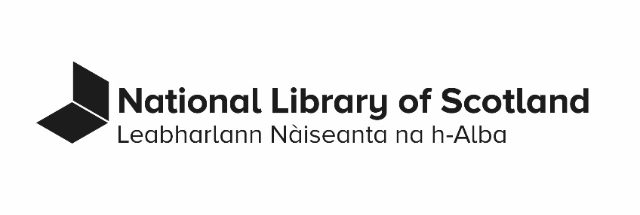

Access Policy

Last revised: 31/10/2023
Contents
1. Access is fundamental to the purpose of the Library 3
2. Access is equitable 3
3. Access is responsible 4
4. Access is free 5
5. Access is connected to engagement 6
6. The means and rights of access are clearly communicated 6
7. Access depends on discovery 6
Appendix: Means and rights of access documentation 7
Document information 8

This policy sets out a statement of principles which guides and governs access provision, and points to more detailed policies as appropriate. Access is the right, opportunity, or means of finding or using spaces, services, collections, and events and/or information about these.
This policy is part of the Collections Management framework of policies but also applies to Library spaces, services, and events. The Library works to identify areas in which access provision does not meet these guiding principles and then works towards better solutions.

Access is fundamental to the purpose of the Library
The Library’s vision is to create opportunities for people to participate in Scotland’s rich cultural life. The Library does this through the collections we hold and the spaces, services, and events we offer. People’s access to the collections is enshrined in the 2012 National Library Act.

Access is equitable
The Library aims to provide meaningful equality of access to collections, spaces, and services. It does this by delivering multiple routes to access and by being as flexible as possible to meet individual access needs within the legal, ethical, and capacity frameworks within which we work. Necessary elements of one means of access may deny or make it harder for someone to access collections or spaces or services because of a characteristic they have. For example, there are geographic barriers to access because all the Library public spaces are in Glasgow and Edinburgh and most of the collections are limited to on-site access for copyright reasons.
The Library works to mitigate the impact of this on people who do not live close to any of the public spaces. It does this through:
- digitisation of collections,
- reprographic services,
- virtual reading rooms,
- online events,
- online provision of commercial eResources,
- inter-library loans, exhibition loans and
- touring exhibitions.

Equitable access also means considering specific accessibility needs of users. For buildings this includes:
- wheelchair accessibility,
- prayer space,
- buggy storage,
- gender-neutral toilets.
For collections and services for blind, partially sighted, and deaf users this includes:
- provision of suitable tools and software,
- adherence to web accessibility standards,
- and provision of audio-description or subtitles.

The Library expects partners with whom we collaborate to deliver access to give similar regard to meaningful equality of access.

Access is responsible
Collection access balances the needs of current users with the responsibility to enable provision of access to future users. This means the Library may not provide access to specific items or parts of the collections in specific circumstances. For example:
              - The Library seeks to mitigate impact of current usage of physically fragile collections through preventative conservation work, handling guidance for users, and provision of access to digital copies as appropriate.
This is also why the National Library of Scotland does not allow physical collection items to be taken home by users. For published physical collections the Library is part of a landscape of access provided by the global library sector. This means the Library may suggest that the most suitable access to a particular item for a specific user may be through another library.
              - As per the Collection Development Policy (Word document) (139 KB; 65 pages) ( the Library aims to obtain material “that it is able to make accessible in accordance with its normal practices and in pursuit of its particular functions.” However, in the interests of enabling future public access to collections the Library may acquire material to which there is no public access until a future date. This includes archival collections which contain personal data. The Library balances the rights of those who would be harmed by public access to this personal data with the responsibility to enable access to collections materials.

              - Where providing access to specific collections would cause physical harm or put health and safety at risk. The Library seeks to provide access in ways that prevents harm to health such as through digitised copies of nitrate films and handling procedures for books with arsenic bindings.

Access is free
It is free to access collections at the point of use. But there are some services and events which have fees. Sometimes there are restrictions that impact access to collections. This includes terms of ownership, deposits, and certain contracts. When these restrictions don't apply, an open license is applied to these collections to extend access. This allows unconstrained re-use.

Access is connected to engagement
The Library works to understand the communities of users. It has effective methods in place to analyse and respond to stakeholder interests and access needs. The Library actively creates opportunities to communicate with communities and individuals about how the collections, spaces, and services can be useful in their lives.

The means and rights of access are clearly communicated
The reasons for any restrictions to access are transparent. On-site staff, online information, remote enquiry, and user support workshops exist to support users in understanding access provision. Links are given in the appendix to publicly accessible information providing more detail on access provision.

Access depends on discovery
Good cataloguing practice and metadata quality forms a fundamental part of access to collections. The development of discovery tools, systems, and services adopts a user-centred approach to design for audience needs. It aims to remove barriers to access including unreasonable expectations of prior knowledge, incompatibility with devices and screen readers, and inclusion of harmful language.

Appendix: Means and rights of access documentation
  - Service Charter
  - Accessibility of Library Buildings (includes information on specialist equipment and facilities in Reading Rooms for users with visual and hearing disabilities).
  - Website Accessibility Statement
  - Loans Policy
  - Transparent decision making on restrictions on access to collections through the Library's collections policies.
  - Membership procedures to access eResources, physical collections and Reading Rooms.
  - Access procedures for children and young people
  - Gaelic language accessibility plan (PDF) (487 KB; 25 pages)
  - Copyright and Access
  - Collections Management Policy (PDF) (211 KB; 8 pages)

Document information
- Document name: Access Policy
- Document status: approved
- Contact: Director of Collections, Access, and Research
- Approval:
  - Date of Library Leadership Team Approval: 30/10/2023
  - Date of Whitley Approval: not applicable
  - Date of Audit Committee Approval: not applicable
- Equality Impact Assessment Completed: 10/10/2023.
- Date of next review: October 2025
- Business classification: 03.01.06.00
- Retention: review 1 year after the policy superseded. All current policies are reviewed for retention after 6 years.

Document control
Date | Action
2023/10/31 | Policy template applied.
2023/11/15 | Updates made to help with accessibility.

