National Library of Scotland Sustainability report 2024 to 2025

Contents table

Background 2
Executive summary 3
Climate Action Plan 5
Adaptation 6
Mitigation 7
Sustainable development 9
Wider influence 10
Summary of performance figures 11

Background
In 2021, the National Library of Scotland launched a four-year Climate Action Plan, running from 2021 to 2025. The Climate Action Plan was created to embed sustainability into the Library's working practices, prepare for the impact of climate change, and enable us to progress towards achieving net zero by 2045. As a national institution, with extensive collections and staff knowledge, the Library also has an important role to play in climate literacy. We can help communities and individuals be empowered to respond to the climate crisis.
This report reviews the final year of this Climate Action Plan. It details the National Library of Scotland's performance against climate indicators set by the Scottish Government in 2024 to 2025. It summarises progress in the four areas of the Plan:
- Mitigation
- Adaptation
- Sustainable Development
- Wider Influence
It also summarises the overall progress achieved during the period of the Climate Action Plan 2021 to 2025.

Executive summary
Below you can see some of the key Library results for the 2024 and 2025 year against key targets set by the Scottish Government and in the Climate Action Plan.
 73.4% reduction in greenhouse gas emissions
- Scottish Government target: 75% reduction in greenhouse gas emissions against 2008 to 2009 levels by 2030.
- National Library of Scotland target: 77.5% reduction in greenhouse gas emissions against 2008 to 2009 levels by 2025.
- Result: 73.4% reduction in greenhouse gas emissions achieved for the 2024 to 2025 financial year.
49.5% reduction in energy use
- Scottish Government target: 40% reduction in energy use against 2008 to 2009 levels by 2020.
- National Library of Scotland target: 55% reduction in energy use against 2008 to 2009 levels by 2025.
- Result: 49.5% reduction in energy use achieved for the 2024 to 2025 financial year.
52.2% reduction in water use
- Scottish Government target: 25% reduction in water use against 2008 to 2009 levels by 2020.
- National Library of Scotland target: 65% reduction in water use against 2008 to 2009 levels by 2025.
- Result: 52.2% reduction in water use achieved for the 2024 to 2025 financial year.
 78.6% reduction in business car travel
- Scottish Government target: 20% reduction in business car travel against 2008 to 2009 levels by 2030.
- National Library of Scotland target: 40% reduction in business car travel against 2008 to 2009 levels by 2025.
- Result: 78.6% reduction in business car travel achieved for the 2024 to 2025 financial year.
26.6% reduction in waste arisings
- Scottish Government target: 15% reduction in waste arisings against 2011 levels by 2020.
- National Library of Scotland target: 15% reduction in waste arisings against 2011 levels by 2025.
- Result: 26.6% reduction in waste arisings against 2010 to 2011 levels.
 68% of waste recycled or composted
- Scottish Government target: 70% of all waste recycled by 2025.
- National Library of Scotland target: 70% of all waste recycled by 2025.
- Result: 68% of all waste recycled in the 2024 to 2025 financial year.
 7.2% general waste sent to landfill
- Scottish Government target: 0% of general waste to go to landfill by 2030.
- National Library of Scotland target: 0% of general waste to go to landfill.
- Result: 7.2% of waste went to landfill for the 2024 to 2025 financial year.

Climate Action Plan
This Sustainability report reflects the structure of the Library's Climate Action Plan (CAP), which in turn is derived from the Climate Change (Scotland) Act 2009. The Act sets out three statutory duties that are required of Scottish public bodies:
To act in a way:
- Best calculated to contribute to the emissions reduction targets.
- Best calculated to contribute to the climate adaptation programme.
- That it considers most sustainably.
Furthermore, public bodies are encouraged to go above and beyond, considering other ways they can positively contribute towards Scotland's climate change targets.
We have translated this into four areas of focus, which we call:
- Mitigation
- Adaption
- Sustainable development
- Wider influence
The Climate Action Plan identified key desirable outcomes in each area of focus. A mixture of discrete projects and ongoing actions was then scheduled to enable the Library to achieve these outcomes by 2025.
There were 57 actions in the CAP for 2024 to 205, of which six had been carried over from 2023 to 2024, 39 were ongoing actions, and 12 were new actions. During 2024 to 2025, 59% were completed, with good progress made in 20%. Only two actions were not started.
This was the final year of the CAP. 76 actions had been included in the CAP. It was decided not to pursue five of these actions as they no longer fitted with the Library's plans or had been superseded by new and more relevant projects. Overall, 70% of the actions in the plan were completed, with good progress being made against another 16%.
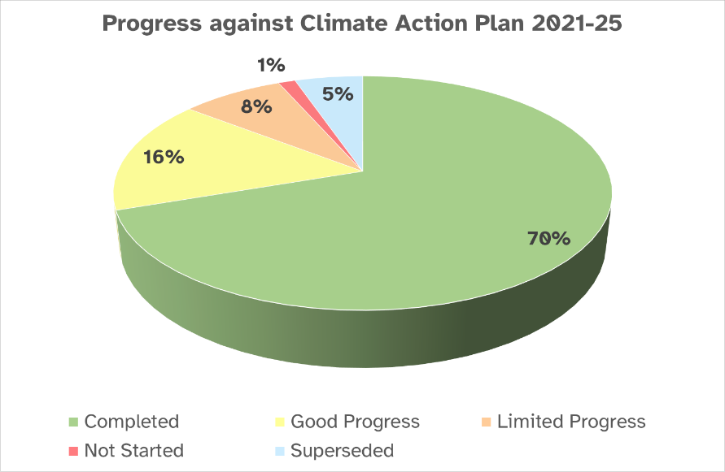
Figure 1 Piechart showing progress against actions in Climate Action Plan 2021 to 2025.

Adaptation
Our world is already seeing massive disruptions caused by our changing climate. As a Library we need to prepare for the inevitable and unavoidable effects of the climate crisis that are already present and will continue to cause disruption to our lives, our mental health, and local economies in the future.
In 2024 to 2025, the National Library of Scotland:
- Appointed Turner & Townsend to produce a Net Zero plan including adaption.
- The Quarantine area at Causewayside is now in operation and a new freezer has been installed.
- Took delivery of a new box machine and started training for staff in its use. A target of 60% of the collection to be boxed was included in the next Library strategy.
- The PhD 'Applying ANN technology to determine acceptable microclimate parameters for the National Library of Scotland's Collections to enable significant energy efficiency improvements' was completed and the results published and shared at several conferences.

Mitigation
Mitigation refers to the actions we take to mitigate the effects of the climate crisis. This typically means reducing or eliminating our greenhouse gas emissions. The Library is also working to reduce waste and water usage.
Figures for the Library's annual Greenhouse Gas emissions are detailed in Appendix 1.
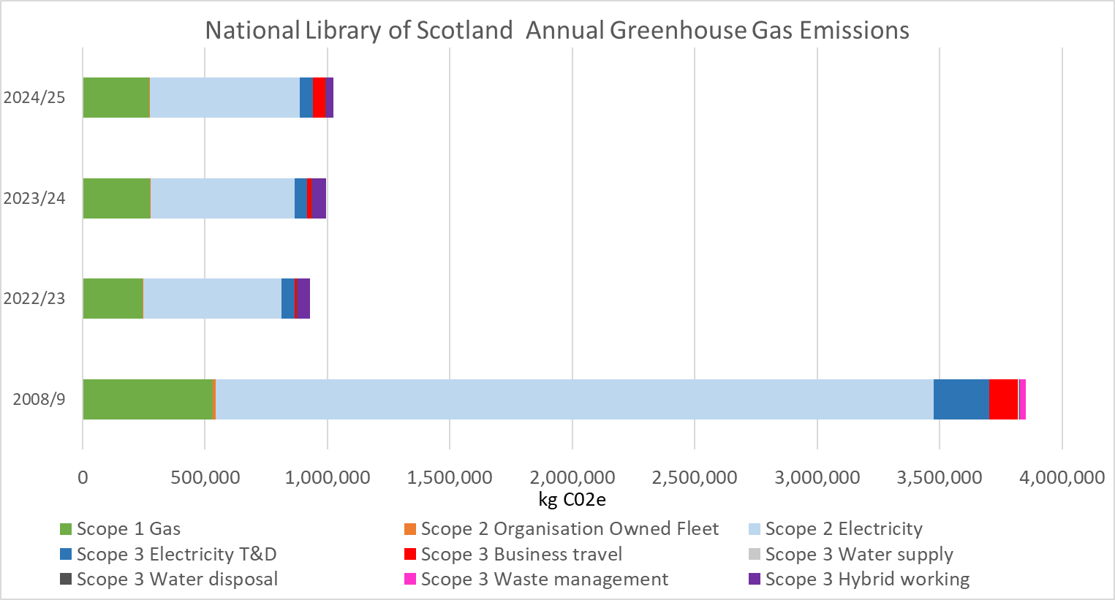
Figure 2. Chart comparing National Library of Scotland's greenhouse gas emissions in the 2024 to 2025 to previous years.
During 2024 to 2025, the Library:
- Carried out Greenhouse Gas reduction projects including:
  - Installing a new more efficient gas boiler at Sighthill.
  - Lighting at Sighthill was replaced with LEDs.
  - Inverters were fitted to some Air Handling Units.
  - Improvements to the Causewayside Data centre cooling were started.
  - Lighting at Kelvinhall was updated to LEDs
  - Project started to install solar panels at Kelvinhall.
- Video conferencing equipment in larger meeting rooms was updated and standardised.
- 'Dr Bike' free bike maintenance sessions were run for staff and a staff cycle group was setup.
- The Library's environmental data was made available in open-source format via the Library's Data Foundry to support research in this area.

Sustainable development
Sustainable development covers many areas. It is not a stand-alone concept but rather a process, something to be built into practices and operations.
The most famous definition of sustainable development comes from the Brundtland Report, also known as 'Our Common Future', a United Nations document published in 1987. The report defines sustainable development as development 'that meets the needs of the present without compromising the ability of future generations to meet their own needs'.
The National Library of Scotland is seeking to embed sustainable practices into all areas of the Library.
In 2024 and 2025, the Library:
- Provided sustainable procurement training to Delegated Purchasing Officers.
- Used sustainability criteria in appointing a new contract for the café in the George IV Bridge building.
- Completed a self-assessment using the Sustainability Flexible Framework tool.
- A minimum 10% weighting for sustainability consideration in tender evaluations has become policy.
- Provided a waste and recycling workshop for staff during Learning at Work and reviewed and updated recycling points throughout the library.
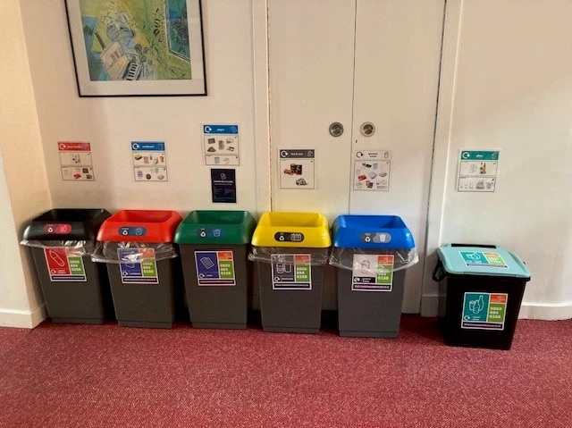
Figure 3 Recycling points with updated signage

Wider influence
Meaningful change depends on people. It's not enough if climate information is confined to an elite few; the hearts and minds of everyone across Scotland need to change if we are to collectively meet our climate targets and work towards a greener, brighter, sustainable future.
As a national library, we are in a position to use our collections to help build resilience and improve climate literacy across Scotland. Additionally, the Wider Influence section gives us the space to consider how we can improve staff and user wellbeing in the coming years.
In 2024 to 2025 the Library:
- Held eight public events relating to Climate and Sustainability. These included:
  - Climate resource workshops
  - Sustainability Fair
  - Nature Crafts for Green Libraries Week
  - Co-curated display on climate materials with community group
- Participated in Scotland's Climate Week and Green Libraries Week 2024.
- Led development of the Carbon Literacy for Libraries Shareable Course and had this validated by the Carbon Literacy Project.
- Delivered three presentations to promote this course to sector professionals and held eight training sessions to start cascading the course.
- Held a staff forum dedicated to items from the collections related to the climate.
- Started digitisation of Lloyd and Wordie collection material which can provide environmental data on polar regions.

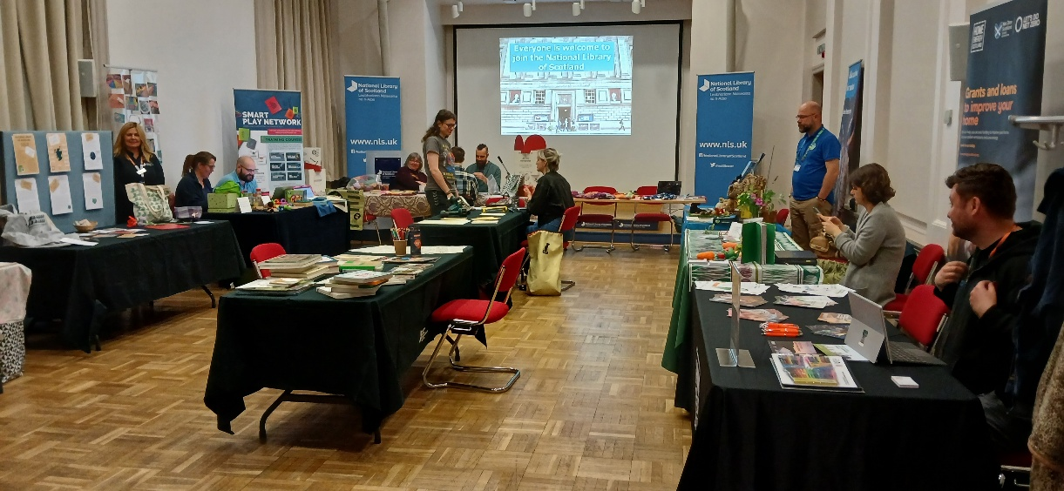
Figure 4 Photograph of Sustainability Fair in September 2024.

Appendix 1. Summary of performance figures
Area | Target | Baseline year | 2023 to 2024 | 2024 to 2025 | % change against baseline | % change against previous year
Greenhouse gas emissions (GHG) (Kilotonnes CO2e) | Reduce GHG emissions from operations by 77.5% by 2025 from 2008 to 2009 levels | 3,851,270 | 995,482 | 1,022,842 | -73.4% | +2.8%
Total energy consumed (kWh) | Reduce energy consumption by 55% by 2025 from 2008 to 2009 levels | 8,781,931 | 4,339,178 | 4,431,131 | -49.5% | +2.1%
Total waste arisings (Tonnes) | Reduce waste arisings by 15% by 2025 from 2010 to 2011 levels | 68.1 | 46.4 | 49.9 | -26.6% | +7.6%
Food waste consumption (Tonnes CO2e) | Reduce food waste by 1/3 (33%) by 2025, against 2013 levels | 16.64 | 5.30 | 5.32 | -68.0% | +0.3%
Percentage waste recycled or composted | Recycle or compost 70% of all waste arisings by 2025 | 49.3% | 73.7% | 67.7% | +18.7% | -5.7%
Percentage waste to landfill | Only 5% of waste arisings to landfill by 2025 and send no waste to landfill by 2030 | 50.7% | 0% | 7.2% | -43.3% | +7.2%
Water consumption (m3) | Reduce water usage by 65% by 2025 from 2008 to 2009 baseline | 18,595 | 10,713 | 8,881 | -52.2% | -17.1%
Owned transport and business travel (km) | Not to exceed the baseline year numbers 2008 to 2009 | 1,038,859 | 199,288 | 315,956 | -69.6% | +58.5%
Business Car travel (km) | Reduce business car travel by 40% by 2030 from 2008 to 2009 baseline | 21,318 | 2,911 | 4,566 | -78.6% | +56.9%

In 2023, the National Library of Scotland reviewed the scope of the data collected for the performance indicators listed above. This has led to performance figures being recalculated to ensure that the Library provides as comprehensive and accurate reporting as possible. Scope 3 emissions now include emissions relating to home working. Figures for previous years given in the table above may therefore vary from figures reported in previous Sustainability Reports.

