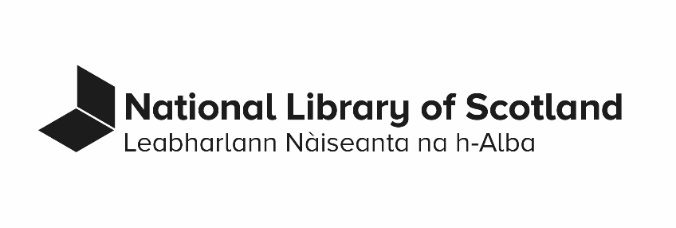

DEACCESSION AND DISPOSALS POLICY

Last revised: August 2022
Contents
1. Principles, scope and legal framework 3
2. Reasons for deaccessioning and disposal 6
3. Deaccession and disposal procedures 7
Document information 9
Document control 9

Principles, scope and legal framework

The preservation of legal deposit and of the documentary heritage of Scotland for future generations is a fundamental purpose of the National Library of Scotland. Therefore there is a strong presumption against deaccessioning: once an item has entered the Library Collections, it is extremely unlikely that it will be removed, and it will only be removed in accordance with this policy.

Scope: This policy applies to material which is part of the Library Collections through legal deposit, purchase, donation, or continuing resources, and material acquired by the Library with the intention of adding it to our collections following assessment or appraisal. Library property which is not part of the Collections is not in the scope of this policy, although in practice similar processes and practices will often be followed. Deposited collections also fall under a separate policy and procedures.

Since 1 February 2013, the Library’s disposals have been governed by the National Library of Scotland Act 2012, and in particular clause 3, Acquisitions, deposits and disposal of objects, here reproduced in full:
Clause 3 Acquisitions, deposits and disposal of objects
(1) NLS may,
(a) Acquire (by purchase, exchange or gift),
(b) Accept on deposit, any object which it considers it is desirable to add to its collections.
(2) The powers in subsection (1) are in addition to any other powers or means of acquisition or acceptance on deposit.
(3) NLS may dispose of any object from its collections if,
(a) The object is a duplicate of, or similar to, another object in the collections,
(b) NLS considers that the object is not required for the purposes of the collections,
(c) Because of damage, deterioration or infestation by destructive organisms, the object is no longer of use for the purposes of the collections,
(d) The object is hazardous,
(e) In any other case, the Scottish Ministers agree to the disposal.
(4) Disposal under subsection (3) may be by sale, exchange, gift, return or destruction.
(5) The power in subsection (3) is in addition to any other powers of disposal, in particular those conferred by,
(a) section 6 of the Museums and Galleries Act 1992 (c.44), and
(b) section 2 of the Holocaust (Return of Cultural Objects) Act 2009 (c.16).
(6) The power in subsection (3) does not apply in relation to an object which is relevant material within the meaning of section 7 of the 2003 Act.
(7) Where an object is subject to a prohibition or restriction on disposal, NLS may dispose of the object under subsection (3) in a manner inconsistent with the prohibition or restriction only,
(a) with the consent of the person having the right to enforce the prohibition or restriction, or
(b) in the circumstances mentioned in subsection (3)(c) or (d).

Clause 31 of the Legal Deposit Libraries (Non-Print Works) Regulations 2013 expands on the above 2012 Act, as well as the Legal Deposit Libraries Act 2003, permitting disposal of non-print works collected under Legal Deposit, including any surrogates we create, as follows:
31 (1) A deposit library may dispose of relevant material, or copies or adaptations of relevant material, by destroying it but must retain at least one version of any relevant material.
(2) The version or versions retained by a deposit library must be the version or versions which the deposit library considers most suitable for the preservation of the relevant material.

In addition to the 2012 Act and the legislation referenced within it, decisions relating to appraisal and assessment, deaccessioning and disposal will be taken with reference to other relevant legislation and legal agreements, including those made with co-owners and donors, ethics, data protection, respect for creators and publishers, environmental sustainability, sectoral best practice, and the Library’s fundamental mission to ensure the preservation of documentary heritage. All deaccessioning and disposal decisions relating to digital items jointly owned and managed by the Legal Deposit Libraries under the terms of the 2013 Legal Deposit Libraries (Non-Print Works) Regulations will be made collectively in discussion with co-owner Libraries and with reference to the relevant joint Notice and Takedown Policies. This includes captures made by the UK Web Archive.

The Library will be clear about who takes decisions relating to deaccession and disposal and keep a record of items deaccessioned from the collections.

Reasons for deaccessioning and disposal

The National Library of Scotland Act remits to the Library decision-making about disposal of any object in its collections on the grounds of duplication, because it is no longer required or of use for the purposes of the collections, or if the object is hazardous. In any other case, the approval of Scottish ministers is required before disposal.

Duplicates: ‘the object is a duplicate of, or similar to, another object in the collections’. As our Collection Development Policy states, ‘Exact duplicate publications may be disposed of. Appraisal and assessment usually occur before full integration into the Library’s collection to prevent duplication.’ Copy-specific details, printing discrepancies, particularly for items printed by hand press, provenance and history, and place within a collection of related items such as a Special or Named Printed Collection or an archive, are among the reasons for retaining duplicate or similar copies. Decisions about duplicates during acquisition, assessment and appraisal will be taken according to the Collection Development Policy and other guidance which sits underneath it.

Derivatives that are created or acquired to provide access to content (where one item is a copy of another, often known as ‘surrogates’) are not subject to this policy, to the extent that a preservation or master copy is held, or that they are not required for reasons of authenticity under the Digital Preservation Policy. Such ‘access’ surrogates may be disposed of without the need for further approval under this policy.

Hazard: materials identified as physically hazardous will be treated in line with the Library’s Health, Safety and Wellbeing policy and Hazardous Materials procedures. Digital materials identified as hazardous due to presenting a cybersecurity threat will be treated in line with the Library’s cybersecurity procedures. The Collection Development Policy and other acquisitions procedures provide information about items identified as hazardous at the point of acquisition.

The Library will consider all approaches made by individuals and organisations about takedown, repatriation, spoliation, or ownership claims in accordance with its Cultural Restitution and Spoliation Policy and relevant suppression and takedown policies.

Deaccession and disposal procedures

‘Accessioning’ describes the process of receiving items into the Library Collections through taking legal custody of them and documenting that receipt. ‘Deaccessioning’ is the process used to remove an accessioned item permanently from the Library Collections. An accessioned item must be deaccessioned before it is disposed of.

Deaccessioning: the Library will keep a record of items which have been deaccessioned from Library Collections. Items which have been stamped or otherwise marked with Library ownership marks will be clearly marked as deaccessioned. Where no owner can be determined, such items will be managed according to Scotland’s laws relating to moveable property and the Library’s Orphaned Collections Policy.

Disposal: disposal includes all the ways in which items may be removed from the Library custodianship and premises. These include donation to another body, return to owner, transfer of ownership to another institution, sale or recycling. Disposal of deaccessioned items and of items not selected for acquisition at the point of assessment or appraisal will take account of relevant legislation and any specific agreements with donors or depositors. Disposal methods will be appropriate to an item’s format, its significance and uniqueness, and the Library’s concern for the preservation of documentary heritage. Where there is no appropriate route to transfer an item to someone else, the Library will pursue appropriate disposal in line with Library environmental sustainability policies.

The Library may on occasion decide to re-acquire an item previously deaccessioned or to accept an item previously not taken during appraisal or assessment. This will only occur in exceptional circumstances and under the Collection Development Policy and approval processes then current.

Document information
- Document name: Deaccession and Disposals Policy.
- Document status: Approved policy.
- Contact: Joe Marshall, Associate Director of Collections Management
- Approval:
  - Date of Library Leadership Team Approval: 30 August 2022.
  - Date of Whitley Approval: Not applicable.
- Equality Impact Assessment Completed: Not applicable.
- Date of next review: August 2023.
- Business classification: Approved policies.
- Retention: 1 year after superseded (review for historical & business value).

Document control
Date | Action
30.08.2022 | New policy

