

# Equalities Mainstreaming Report

# April 2025 to 2029

**Contents**

1. Executive summary 5

2. Introduction 5

3. The legal framework in relation to the Library and the duty 7

The Protected Characteristics 8

4. Mainstreaming the Equality Duty including an analysis of employee and board data and recruitment data 9

4.1 Access 9

4.2 Collections 17

4.3 Organisational Culture 19

4.4 Staff Networks 20

4.5 Infrastructure 23

5. Partnerships 24

5.1 Sabhal Mor Ostaig Employability 26

6. Board Statement: promoting diversity of Board Membership 26

7. Employee Data Analysis 27

Gender and age 27

Disability 28

Age 28

Ethnicity and Nationality 28

Sexuality 29

Quality of Staff data 29

8. Board Data Analysis 29

9. Recruitment Data Analysis 30

10. Progress against the Planned Outcomes from the Equality Mainstreaming Progress Report 2023 32

Outcome 1 – Theme: Access 32

Outcome 2 - Theme: Access 39

Outcome 3 – Theme: Collections 41

Outcome 4 - Theme: Organisational Culture 48

Outcome 5 - Theme: Organisational Culture 50

Outcome 6 - Theme: Infrastructure 53

Outcome 7 - Theme: Partnerships 56

Outcome 8 - Theme: Partnerships 57

11. The Planned Outcomes for the Equality Mainstreaming Report 2025 – 2029 58

Outcome 1 – Theme: Access 59

Outcome 2 – Theme: Collections 62

Outcome 3 - Theme: Organisational Culture 65

Outcome 4 - Theme: Infrastructure 67

Outcome 5 - Theme: Partnerships 68

12. Equal Pay Statement 71

13. Pay by Protected Characteristics where appropriate 72

13.1 Gender 72

13.2 Ethnicity and Disability 74

13.3 Gender Pay Gap – Mean and Median Pay Gap 31 March 2025 75

13.4 Occupational Segregation 76

14. Appendix 1: Staff data 81

1: Staff Numbers by Gender 82

2: Staff by Gender in Percents 83

3: Pay Point by Gender in Percents 84

4: Contractual Status by Gender 84

5: Disability by Pay Point 85

6: Staff Numbers by Age Range 86

7: Staff Age and Gender Profile in Percents 87

8: Staff Age and Gender Profile Numbers 88

9: Ethnicity by Pay Point 89

10: Nationality by Pay Point 89

11: Religion and Belief by Pay Point 90

12: Sexuality by Pay Point 91

15. Appendix 2: Board Data 92

16. Appendix 3: Recruitment data 93

Notes on the Charts 93

1: Disability Overview 95

2: Disability detail 96

3: Gender Identity 97

4: Gender at Birth 98

5: Age Range 99

6: Ethnicity (Summary) 100

7: Religion or Belief 101

8: Sexual Orientation 102

17. Appendix 4: Chart Data Tables 103

1: Staff by Gender Data Table 103

2: Pay Point by Gender Percentage Data Table 103

3: Pay Point by Gender Numbers Data Table 103

4: Full/Part Time by Gender Data Table 104

5: Disability Percentage by Pay Point Data table 104

6: Staff by Age Range Data Table 104

7: Staff Age Range by Gender Data Table 105

8: Ethnicity Percentage by Pay Point Data Table 105

9: Nationality Percentage by Pay Point Data Table 105

10: Belief Percentage by Pay Point Data Table 106

11: Sexual Orientation Percentage by Pay Point Data Table 106

18. Appendix 5: Recruitment Data Tables 107

1: Disability 107

2: Disability Details 107

3: Gender Identity 107

4: Gender at Birth 108

5: Age 108

6: Ethnicity 108

7: Religion 110

8: Sexual Orientation 110

## Executive summary

As a publicly funded organisation, the National Library of Scotland has a duty to eliminate discrimination and advance equality of opportunity in its everyday work. It is also required to report on how it is achieving these objectives.

The Report documents the outcomes identified for the period 2025 to 2029. It demonstrates that the Library continues to take steps to ensure that equality issues and improvements are identified at all stages in the development and delivery of its services and operations with actions and activity identified to address these issues and improve equality of opportunity. It highlights the activities and initiatives that have taken place and information on the staff and Board demographic. It also reports on the progress that has been made on the outcomes from the activities identified within the Equality Mainstreaming Progress Report 2023.

The report recognises that improvement is a continuous process and there are a number of actions and associated tasks from the 2023 Report that are ongoing. It also recognises that Equality, Diversity and Inclusion impacts on all we do within the Library and efforts and evidence demonstrate the mainstreaming activity of EDI within the Library.

## Introduction

The National Library of Scotland (the Library) is one of six legal deposit libraries in the United Kingdom and Ireland. These libraries are entitled to request and receive a copy of each item published in the UK and currently the Library is the custodian of over 49 million physical and digital items held in trust for the people of Scotland.

The Library was formed in 1925 by the National Library of Scotland Act largely with material from the library of the Faculty of Advocates. The Faculty had been collecting material since the early 1680s, and it was much of this material that became the basis of what is now the National Library of Scotland.

This year the Library celebrates its centenary with a number of events planned to include people across Scotland.

The National Library of Scotland preserves the memory of the nation with collections that span centuries, from the earliest times to the digital age. Our collections document the influence of Scots at home and abroad, while reflecting the ideas and cultures of the world. They cover all aspects of human endeavour in multiple formats, including books, manuscripts, archives, websites, maps, music, moving image and sound.

We support education, research, business and innovation and our work enhances the reputation of Scotland as a country with a rich cultural heritage and a vibrant future. We are committed to providing easy access to our physical and digital collections and the delivery of services that are open and available to all.

In 2020, the National Library of Scotland launched **Reaching People**: Library Strategy, concluding in the year the Library celebrates its 100th anniversary. The strategy places emphasis on connecting with multiple audiences and enriching lives with our content and services – whether at our premises, at our touring displays, or through our growing digital presence. Read more in the [National Library of Scotland Strategy](https://www.nls.uk/about-us/what-we-do/our-strategy/).

We are now working on a new Strategy for 2025 – 2030 **The Next Chapter** which will focus on the vision of being a vibrant, inclusive, connected and creative part of Scotland's landscape. The new strategy will be published in September 2025.

The Library has six buildings, four in Edinburgh with the main building at George IV Bridge and two in Glasgow. The Kelvin Hall facility in Glasgow provides the West of Scotland with access to the Library's digital, moving image and sound collections and electronic resources.

There are around 320 staff working across the Library sites, all playing a role in supporting the delivery of the strategy. Staff have a wide mixture of skills, including those who are highly specialised in the fields of conservation, curatorial, metadata and digital development, those supporting public areas in the reading rooms and the corporate support functions such as finance and human resources.

Under the National Library Act of Scotland Act (2012), the Board of the Library was reconstituted and as of March 2025, we have eleven Board members.

As a result of the Equality Act (Specific Duties) (Scotland) Amendment Regulations 2016 which came into force on 18 March 2016, there is a commitment to achieving greater diversity on the boards of public authorities. In light of this amendment the Library now provides information within the Report on the gender representation of the Board as well as a statement from the Board on their commitment to promote greater diversity of membership as part of a wider remit of succession planning.

In the April 2023 Progress Report, we published an analysis of the gender pay gap and our employee and recruitment data. This data has now been updated and included within this Report.

## The legal framework in relation to the Library and the duty

Under the 2012 National Library of Scotland Act we are prescribed under the general function to 'manage the Library as a national resource for reference, study, research and bibliography, having particular regard to Scotland.' Under the Act the Library is also specifically charged with:

* Preserving, conserving and developing its collections.
* Making the collections accessible to the public and to persons wishing to carry out study and research.
* Exhibiting and interpreting objects in the collections.
* Promoting collaboration and the sharing of good practice with and between other persons providing library and information services, and the adoption of good practice by those persons with a view to:
* encouraging education and research.
* promoting understanding and enjoyment of the collections.
* promoting the diversity of persons accessing the collections.
* contributing to the understanding of Scotland's national culture.

Under the Equality Act 2010 the Library is specifically charged, under the public sector equality duty, to 'exercise its functions, having due regard to the need to:

* Eliminate discrimination, harassment, victimisation and any other conduct that is prohibited by or under this Act.
* Advance equality of opportunity between persons who share a relevant protected characteristic and person who do not share it.
* Foster good relations between persons who share a relevant protected characteristic and persons who do not share it'.

Additionally, the Library has responsibilities under the Specific Duties (Scotland) Regulations 2012 to;

* Report on progress towards mainstreaming the duty.
* Publish equality outcomes and report on progress.
* Assess and review policies and practices.
* Gather and use employee information.
* Publish gender pay gap information and statements on equal pay.
* Consider award criteria and conditions in relation to public procurement.
* Publish in a manner that is accessible.

### The Protected Characteristics

There are nine listed protected characteristics under the Equality Act 2010:

* Sex
* Disability
* Race
* Sexual Orientation
* Religion or belief
* Maternity and Pregnancy
* Marital Status and Civil Partnership
* Age
* Gender Reassignment

## Mainstreaming the Equality Duty including an analysis of employee and board data and recruitment data

The Library continues to take steps to ensure that equalities are mainstreamed throughout its activities. Below we have detailed some of the equality initiatives and projects which the Library has been involved with or will shortly launch since the 2023 Equality Mainstreaming Progress Report.The initiatives and projects are presented within the headings of the five strategic themes:

### Access

**"We will actively welcome people who currently do not think of the Library as a place, service or employer that has something to offer them".**

**"People will be able to enjoy our collections, buildings, services and workplace without obstacle or embarrassment".**

#### Recruitment Review

With support of Heritage Lottery funding, we completed a comprehensive review of our recruitment processes. The actions undertaken include:

* Review and redevelopment of job advert templates including inclusive language
* Redeveloped the application page which will not ask applicants to identify their name, home address or educational establishments.
* Redeveloped the recruitment job page.
* Developed guidelines for managers on inclusive recruitment.
* Set up a database of partnership organisations to share job opportunities.
* Compiled a database of photos and videos of interview spaces.
* Incorporated EDI into the interview process: diversifying the recruitment panel and making the pre interview process more inclusive including the structure of interviews.
* Provide interview questions to candidates prior to interview.
* Joining Disability Confident Employer Scheme, Level 1 – Disability Confident Committed.
* Created a recruitment video with an introduction from Amina Shah, CEO and National Librarian and from several staff talking about their role with the Library.
* The Scottish Union for Supported Employment (SUSE) have completed a digital review of our job application process. This has resulted in a few recommendations and discussions have taken place to identify what is feasible. Several changes are now in the process of being made to the online application process.

#### Youth Employability 2023-25

The Library supports efforts to help young people make the transition from formal education into the jobs market. This work falls into three broad areas:

1: Creating opportunities for individuals who have completed, or who are still engaged in, a programme of learning but who may find it difficult to translate that into the kind of experience that will help them get a suitable job.

2: Offering individuals (or groups) advice and coaching on the process of applying for jobs and the best preparation for this. This can include making the recruitment process more transparent, helping with CV preparation and offering mock interviews.

3: Working with other agencies and organisations to target our support where it might do the most good.

#### Building Work Experience

**Internships:** wherever possible we find funding to support paid internships. In 2023 this included three Edinburgh University "micro-internships" for students from disadvantaged backgrounds. In 2024 we hosted an internship for a student from Stirling University with lived experience of care as part of the Stirling Cares programme. Whenever young people come to us for experience, we include employability coaching and support to help them make the most of the experience they have gained.

**Placements:** offering experience of the workplace to young people who are still within a programme of study is also a regular part of our work. In 2023-25 this has included post-grad LIS students at Strathclyde University; students from Edinburgh College of Art; history students doing a practice-based dissertation at the University of Glasgow. We have also had a couple of school-age work experience placements though low flexibility on dates for this can make it difficult to fit placements into our schedules.

One of our Glasgow University history students gave the following update on her experience:

*"about a week ago I sent around the CV you helped me with to some acting agencies in Glasgow to ask about work experience as an assistant.*

*I had a couple of replies that said they read my email and CV with interest and yesterday I had a meeting with an agent named Sonya who rang me today. She offered me 2 days a week job until I finish University in April and then a full time position after that!*

*Being an agent is my dream plan so it's all worked out very well! I wouldn't have had a CV fit to send without your help so thank you so much."*

**Modern Apprenticeship:** in 2025 we embarked on our first Modern Apprenticeship, recruiting a school leaver to a designated post in our Visitor Services unit.

#### Direct Employability Support

Whenever we come into contact with young people at the Library we look for opportunities to give them insights into improving their own employability. This will typically take the form of raising their awareness of how recruitment works; offering tips to help them progress through the stages of a recruitment process; and building their confidence in the potential they can bring to new role.

#### Workshops

Employability workshops can be delivered online or in person and, where possible, content can be tailored to the needs of a group. This included PhD candidates at Glasgow University and participants in the Library's "Fitba" programme in 2023/4. The workshop can act as a foundation for further employability work and sometimes attendees will follow up with one-to-one employability support.

#### Coaching

The Organisational Development Partner (ODP) can offer tailored coaching around the general approach to getting a job; developing an effective CV; and preparing for specific applications. Where the individual does not have much experience to work with the coaching can focus on recognising their personal strengths and articulating their potential.

#### Young People with Additional Barriers

In 2024 – 25 we have worked with both Access to Industry and Enable Scotland to support young people with mental health issues; neurodivergence and special educational needs.

#### Raising Awareness

We have offered small scale tours of the Library to young people with special needs who come to us through agencies such as Access to Industry and Enable Scotland. The tour gives a framework to talk about the Library more generally as well as the kinds of work that underpin our services. The informality of the tour helps young people feel more comfortable asking questions and can open up opportunities for more focussed work.

Where people can't come to Edinburgh for a tour we do offer an online chat about library work in general which can clarify if it's the right direction for that individual and also give some pointers as to the best next steps to take.

#### Extended Support

Our support is not limited to the duration of an individual's direct contact with the Library. We aim to establish a relationship which encourages them to come back to us for support when they have a particular job they would like to apply for.

Other People with Additional Barriers to Employment

We have also supported people in later life as part of their efforts to secure employment or start a new career.

This has included mature students with family commitments who can struggle to articulate the relevance of previous work experience, or time out for caring, as a valid part of their life and work experience when applying for jobs in their new field

Contemplation SpaceIn September 2023, we designed and launched a new Contemplation Space in the Library that is open to the public and staff as a space for prayer, spiritual contemplation and for people experiencing sensory overwhelm or are psychologically distressed. This is a quiet private space for people to use as and when they need to.

#### Registration Process

In 2023/24 we introduced a new Fast Pass ticket system to offer short term access to our Reading Rooms at our George IV Bridge Building. This access is intended to offer underrepresented groups, amongst others, a trouble-free and easy route to seeing the reading rooms and understanding how they work, without the need for full registration. It is hoped that this 'taster' approach might encourage people with little or no experience of a large reference library, or who might otherwise be lacking in confidence in such institutions, to sign up as readers and gain access to the collections.

#### Accessibility in the buildings

Improved the layout/design of public toilets to improve disability access in our main George IV Bridge building.

Conducted a review of the hearing loop systems in our main George IV Bridge Building and identified where these could be replaced or upgraded.

#### Registration Process

**Age:** Expansion of the accepted documentation for young people joining the Library to include mobile banking statements.

**Disability:** In the registration office one of the two PCs used for filling in the registration from has an ergonomic mouse and large print keyboard. All the chairs in registration have arms.

**Religion or belief:** We have a process in place for women who wear face coverings, when we take their photo. Photos are taken behind a screen where they can take of their face covering in private. We offer to have a female member of staff take the photo.

#### Physical Environment Visitor Centre

We have included a more diverse range of children's books for sale in the shop and for reading in the café family area, for example, titles such as 'My skin, your skin', 'Grandpa's Pride', 'All about diversity', and dyslexia and autism friendly books.

Family friendly area in café –improvements to the area include new furniture, and children's ear defenders are available for use.

#### Signage

Improved signage for lifts at entrance to the George IV Bridge Building give a clearer explanation on safety reasons and need for staff supervision. Details of when new self-service lifts are to be installed is included in the signage. Louder bells for notifying staff of person wanting to use lift have been installed and have reduced waiting time.

Improved information on assisted emergency evacuation (PEEPS) is now displayed in lockers and in registration.

#### Staff uniforms

All team members are shown the types of uniform available and given a choice based on their own preference, with no presumption of gender related blouses/ shirts or trousers in place. Similarly, we can provide different uniform items based on sensory sensitivity, material type, or loose/lightweight garments, with age, disability and sex related preferences in mind, for example menopause.

#### Public Programmes

In 2023 the Library worked with Scotland's leading HIV and Hepatitis C charity [Waverley Care](https://www.waverleycare.org/) to co-curate a new exhibition as part of a National Heritage Lottery Fund project.

Staff from across the Library's Public Programmes, General Collections, Collections Care, and External Relations & Media Teams worked closely with Waverley Care's team of community researchers. Together the project team undertook research of the Library's collections and have contributed to all aspects of the upcoming exhibition including object selection, text writing, and marketing design.

The exhibition 'Blood, Sweat and Tears: Scotland's HIV Story' opened in May 2023 and explored the experience of HIV and AIDS in Scotland from the 1980s to the present day. It told how the charity Waverley Care established the UK's first purpose-built AIDS hospice Milestone House and how community action across Scotland saved lives.

Recent exhibitions on a variety of themes, for example, Renaissance Scotland, Author Pen Names and Pseudonyms, Gaelic Storytelling in Scotland have all included content which highlights the role of under-represented groups, including those with protected characteristics, in these stories. In our Treasures exhibition, selection of material (on a twice yearly basis) is carried out with representation in mind, to avoid promoting a narrative which excludes those with protected characteristics. In 2023/24, one case in the Treasures exhibition was curated by our LGBT+ Staff Network and featured a variety of LGBT+ material from our collections, accompanied by a booklet featuring the personal stories behind the selections.

We introduced an EDI anniversaries initiative designed to create content in a variety of formats, for example, displays, events, digital and social media content to celebrate a range of equalities events or initiatives. These include LGBT History Month, Pride, Black History Month, International Women's Day, Disability History Month and South Asian Heritage Month.

In 2023 we joined the Bookbug programme, which aims to bring a love of reading and books to children from an early age. Bookbug, a Scottish Book Trust initiative, offers free book bags and sessions at libraries across the country, and emphasises inclusivity and accessibility for all children and families. These have been popular, and we have been trialling Bookbug sessions in Scots and Gaelic to broaden the languages used in the sessions.

The introduction of our audience development programme from 2022 to 2024 has helped to introduce a more structured set of events in support of equalities, with events assessed and evaluated through a series of audience segments, including those with protected characteristics. This programme is continuing into 2025 and beyond with a focus on Centenary activity: this encourages us to programme new and different styles of events which might appeal to under-represented groups.

#### Online accessibility

An online accessibility audit was conducted by external agency, Nexer Digital, in October to December 2024 across the Library's web presence, including the main website, collections-focused web platforms and microsites. The review identified accessibility issues against WCAG 2.2 Level AA guidelines. A programme of work to fix known accessibility issues is underway, with platform owners working through a prioritised list of fixes. The Library's online accessibility statement has been updated to reflect this programme of work.

The redevelopment of the main Library website ([www.nls.uk](http://www.nls.uk)) will include designs and content layouts meeting WCAG 2.2 Level AA guidelines.

A staff guide to creating accessible documents is available as an online resource on SharePoint.

IT Support respond to staff requests for assistive equipment and software to meet additional accessibility needs, including ergonomic peripherals, laptop stands/risers, wrist rests, headsets, larger displays, Text-to-Speech and Magnifier software applications and one-to-one training/induction (as requested).

A range of assistive equipment and software for users with additional accessibility needs is provided in the Reading Rooms, including headsets, large text keyboard, Kurzweil 3000, Dolphin Supernova and the Read Aloud add-on on some selected devices.  Each public device has three web-browsers installed (Edge, Chrome and FireFox) providing their own in-built accessibility features.

### Collections

**"We work to address the silences and omissions in the collections and to revealing the diversity already within the collections, using a wider range of material and subjects to attract and serve different audiences".**

We have worked to acquire a wider range of material created by and relevant to diverse groups and communities, and to make available relevant content through our Hidden Collections programme. See Section 5.2 for more details. Collections are acquired through purchase, donation and legal deposit. Recent acquisitions include:

Further archival records from LGBT Youth Scotland, John Ainslie (CND activist), Ladies Scottish Climbing Club, Hope Maclean (WRNS during WWII), the Glasgow Emancipation Society. The archive of Jackie Kay whose writing explores and interrogates intersecting characteristics of race, sexuality, and nationality in her work. Two letters from Keir Hardie to Christabel Pankhurst. A parchment containing detailed lists of enslaved workers on a plantation in Trinidad. The document is an indenture of release between William Lushington (1747-1823) and the Scotsmen John Stewart (1754/5-1826) and Alexander Fraser of Inchcoulter (1759-1837).

Tape Letters Scotland: digitisation to enable acquisition of initial message on cassette tape sent to and from Pakistani families who migrated to and settled in Scotland 1960-1980. A 1971 home movie of the first Sikh Wedding in Glasgow to follow all the traditions of a Punjabi Heritage ceremony and a series of TikTok videos created to promote Deaf Awareness.

Contemporary publications on Black, African and Latin American music purchased as well as titles such as The Economics of Emancipation – Jamaica and Barbados 1823-1843, and Documenting Rebellions – A study of four lesbian and gay archives in queer times, Of Effacement – Blackness and non-being, and The Queerness of Water – troubled ecologies in the 18th century.

Older published material including firstly an Edinburgh 1742 broadside reporting on the finances and progress in construction of the Edinburgh Charity Workhouse, first proposed in 1739 and finally opened 1743 at Bristo Port, partly financed by charity subscription.

Secondly, the life and description of Alexander M'Innes, a native of the Isle of Skye printed at Penryn, Cornwall around 1820. Due to his condition, he was unable to attend the local schoolhouse, and in consequence became his "own instructor" and within a few months was able to read "extremely well". He then set himself the challenge of learning to write, electing to use his left hand, and "within the course of a year or two" could read or write a letter in both Gaelic and English. M'Innes lost his father at the age of twenty-two and in consequence was left bereft of support. He laments that there is "no regular state of supplies for the poor" in the Isle of Skye.

Thirdly the annual report of the Edinburgh Ladies' Emancipation Society for the year 1865. An acquisition adding to the five reports already held from the 1850s and 1860s. The Society was a leading abolitionist group and in this issue contributions to education and resettlement of the formerly enslaved are noted and fears of idleness and pauperism among them are dispelled.

### Organisational Culture

**"Our staff will demonstrate that they understand the different needs of individuals, and the importance of equality for all".**

**"We will ensure that our staff and partner communities do not face discrimination on the grounds of their protected characteristics".**

Our EDI action plan and strategy document sets out the priorities and direction of travel for the organisation around EDI. The EDI strategy was approved by the Board in 2023 following consideration by our EDI Working Group and our Leadership Team. The EDI strategy is simple and to the point, directly speaking to our values and priorities as outlined in Reaching People.

The Library EDI Policy was approved in November 2024. The EDI Policy was developed to provide information and a source of reference, and points to relevant policies and procedures where further information can be obtained. It underpins the Library's commitment to promoting EDI for visitors and staff and describes how and who will be responsible for supporting and progressing this work.

Our EDI Action Plan is fluid and responsive to change. It is a place to ensure it is accessible to everyone throughout the organisation and to ensure we can track and measure our actions under our EDI work. We have separated it into five different sections to capture the different areas of work that are being covered within the themes: Access: Collections; Organisational Culture; Infrastructure; Partnerships. The Plan is monitored at the EDI Working Group meetings held every 6 weeks.

As part of a move to a new governance structure for EDI at the Library, the membership of the EDI Working Group has recently been expanded to include more staff in a greater variety of departments. The new group will sit within a new 'Connections' strategic theme which will include consideration of EDI principles alongside other relevant processes and initiatives, including Programme Planning, Membership and Partnerships and Stakeholders.

### Staff Networks

We have a LGBT+ Staff Network, which was set up in 2022. This group has been very successful and provides guidance for the organisation and other staff networks about how staff networks should be supported and operate within the library.

The Disability Advocacy Network provides advice and guidance to staff and have been included in the consultation of the Workbased Assessment Form and the Absence Management review.

The Parent and Carers group is a newer group and have been establishing their scope and actions from the two established groups above.

Representatives from the Staff Networks attend the EDI Working Group and each Network has a sponsor from the Library Leadership Team to offer support and advice as required.

Each Network has a dedicated page on the Library Sharepoint. A budget has been made available to the Networks to assist with the costs of activities and networking.

#### Values and Behaviour Workshops and The Code of Conduct

From October 2023 to December 2023, we ran Values and Behaviours workshops which were mandatory for all staff. A total of 27 workshops were held. The workshops were to highlight behaviours at the Library in an open and confidential space which would help inform a new code of conduct as well as reflect on our current organisational values.

The feedback from the workshops was reviewed and incorporated into the new Code of Conduct, setting a standard of acceptable behaviour for the whole Library and highlights the connection to the proposed Values for the new Strategy.

The Code of Conduct was approved in November 2024 and now launched using various mediums. Posters will be situated throughout the Library to publicise and reinforce the Code of Conduct.

Managers will have a discussion around the Code with their staff at team meetings and it will be included in this year's appraisal discussion to ensure staff have read and understand the Code. The Code will continue to be included as part of the induction process.

We are in the process of arranging Bystander Training which will be mandatory for our public facing staff and teams where behaviours have raised concerns. All other staff will be encouraged to attend. The bystander training will be useful in raising the confidence of staff in speaking out when they witness behaviour that departs from the Code, or any colleague being treated in a disrespectful manner.

#### Menopause Policy

In October 2023 we launched the Library Menopause Policy to coincide with World Menopause Day. To enhance the launch and to improve understanding of menopause, we offered a learning session 'Everything you want to know about menopause'.

#### Workplace Adjustment Plan

In October 2024 we launched the use of a Workplace Adjustment Plan. This allows staff and their manager to work together to discuss any adjustments which could be made to the member of staff's work, equipment or working environment on a permanent or temporary basis to support any health issues they may be experiencing. The plan is completed by all new starts within the induction process and completed annually by all staff during the appraisal process. Is a live document and can be amended at any time if a member of staff's circumstances change. It is confidential but can be shared with those involved in actioning any reasonable adjustments and, with the member of staff's permission, others who can provide support.

#### EDI Related Learning and Training

'All you need to know' sessions continued to be offered to staff covering a range of EDI topics. These have included Heteronormativity, Menopause, Humour and Banter and EDI, Microaggressions, and Neurodiversity. The sessions are recorded and available on the Library SharePoint for all staff to view.

In 2022 we began mandatory EDI training for all staff and since October 2023 we have run a mandatory EDI training course every 6 months to include new staff. We delivered a special version of the training for staff with specific work patterns and part-time staff where attending a full morning or afternoon was difficult. An evaluation of the training was conducted early 2024 where 96% of staff who completed the evaluation agreed that their knowledge and understanding of EDI had improved.

Going forward EDI training is included in the induction for new staff. Mandatory general EDI refresher training for all staff is being run from April 2025.

With support from the National Lottery Heritage Fund, we delivered development sessions in the following areas:

#### Library Leadership Team development

Each LLT member participated in three 1 to1 sessions, as well as two strategy development workshops and one reflection session ensuring that EDI is embedded in the new Strategy.

#### Specialist EDI development for managers

Focused EDI training sessions in LGBT, disability, race and gender were delivered for managers. By July 2024, we had delivered eight training sessions for 80% of Library managers.

Four reflective sessions and coaching were organised for staff involved in recruitment.

#### Specialist EDI development for HR professionals in the heritage sector

Specialist EDI training to increase expertise and enable HR staff to offer advice and act as mentors embedding good practice in the organisation. EDI training sessions were in LGBT, disability, race and gender. By the end of October 2024, four training events were delivered for 44 HR staff from the Library and seven other heritage organisations in Scotland.

The funding also allowed us to organise an HR EDI conference – "Affecting Change: Transforming Organisational Culture". This took place in September 2024 for EDI, HR and senior manager professionals working in the Heritage sector across the UK. It offered an opportunity to share innovative and inclusive ways organisations have incorporated equalities into their HR practices and processes. We had four speakers, HR professionals from different heritage organisations (British Film Institute, British Library, National Museums Liverpool and National Theatre of Scotland) where they have recently undertaken transformational change to their HR inclusive practice. There were 29 attendees from more than 11 different organisations in Scotland.

### Infrastructure

**"We will invest resources in our collections and services to help foster good relations and a deeper understanding of complex histories and uncomfortable debates".**

At the Library we have a responsibility to describe, interpret, and present the collections in ways that make them useful to a wide variety of people. It is also important for us to be welcoming, inclusive and reflective of contemporary society, and language is central to this.  We want to ensure that we describe and interpret material in a way that is accurate, respectful, and responsive to the people who create, use, and are represented in the collections we manage.

To do this, we review our descriptive content, including catalogue records, exhibition panels, articles, blogs and web content. While we can change the way we interpret and present the collections, we also believe all items have research value. So we are also careful not to censor or erase any part of the original material, no matter how problematic.

In 2023 we added a statement to the Library's website articulating this position and encouraging anyone who discovers any harmful or discriminatory language in any of our descriptive content at the National Library of Scotland, to use [our online enquiry service](https://auth.nls.uk/contact/ask-a-question/) to alert us to the matter. Read more in the [harmful language statement](https://www.nls.uk/about-us/equalities/harmful-language-statement/).

We are actively working with external providers of metadata and subject headings such as the Library of Congress to improve language and to update legacy terminology. The ongoing review and update of descriptive content is partly based on previous investment in the development of a [Terminology Glossary](https://docs.google.com/document/d/17W4hstjFFlWRdD5gWjx0WDKuqzUHMqat9zyIAjgW_X8/edit) which continues to be a key resource for updates to public metadata.

Other initiatives, including the extending access to physical books on EDI topics via the Open Shelves Display is provided in table in section 5.

## Partnerships

**We will improve our understanding of those who use us and don't use us by asking ourselves and others new questions, and by focussing on audience needs to help us tailor and co-produce programmes, services, collections, access and communications.**

We will amplify the voices of those who have historically been under-represented in the Library's collections and programmes and seek out partnerships that enable us to reflect critically on our work and our history. Recent examples of work in this area include:

In 2023 we secured funding from the SLIC Innovative Development Fund to support the Fitba Research Club: Andrew Watson's Legacies project. The innovative project brought together a team of young community curators aged 18-25 from under-represented and minoritised communities across Glasgow to celebrate the rich history of sporting achievement by Black people and people of colour in Scotland.

Working with curators, facilitators and other experts through a series of 11 workshops and events from July 2023 to January 2024, the team explored the life and career of Andrew Watson, Scotland's – and the world's – first Black international football captain. Engaging with collections in the National Library and beyond, the community curators also researched other largely forgotten, hidden and untold footballing histories from the 1870s to the present.

The project was based at Kelvin Hall but also included workshops at the Scottish Football Museum and at the National Library's George IV Bridge building in Edinburgh. Several additional social activities also took place, including visits to Hampden Park to watch two UEFA Women's Nations League international fixtures and to the premiere of Cassius X: Becoming Ali at Glasgow Film Theatre.

A key feature of the Library's programme, which was remarked upon in feedback from the "Fitba" programme participants, is that our support is not limited to the time of participation in Library projects. We use projects to establish a relationship in the hope that young people will come back to us whenever we can be of help to them. We recognise that it's much more effective to focus our support on a particular job application – a much more concrete and practical approach which is also highly motivating for the young person.

One participant in the Fitba programme was keen to work in cultural heritage but was having no luck with applications. We helped with a series of applications over an 14-month period which, firstly, helped them achieve a part-time post and eventually progress into a full-time post in their chosen field. In doing this they also overcame an additional barrier of dyslexia. The project went on to win the 2024 SLIC Project Excellence Award.

A formal partnership with Sabhal Mor Ostaig, the Gaelic College on Skye, was signed in 2024, and an Edinburgh wide Capital Gaelic partnership was instigated by the Library and Edinburgh Council in 2023. These partnerships are intended to help amplify and promote the Gaelic language and the communities for which it is a crucial part of their heritage.

### Sabhal Mor Ostaig Employability

In 2025 we supported a mature student at Sabhal Mor Ostaig, Skye, who had almost no work experience but a long history of mental health issues and addictions. This student described the workshop and CV-building coaching that followed, as being "streets ahead of that I've received from careers advisers at high school, from the job centre, and other work schemes."

Our partnership with BBC Scotland continues to provide a shared focus for working together to engage groups which are currently underrepresented for both organisations, including young people.

We have embarked on a project-based partnership with National Theatre Scotland and Who Cares? Scotland. Called Caring Scotland, the three-year project will gather oral histories from at least 100 care experienced people. The oral histories will inform a touring offer in a few years' time, and the oral histories will be held by the Library into perpetuity.

## Board Statement: promoting diversity of Board Membership

The Board of the National Library of Scotland is committed to the promotion of diversity of Board Membership. The Board believes that it has a role to play in promoting diversity and inclusion across our workforce. The engagement and productivity of our people are positively impacted by bringing people into the organisation from a wide range of backgrounds and experiences. The Board endeavours to continuously reflect on and improve the diversity of Trustees as part of the cycle of board recruitment.

## Employee Data Analysis

The tables showing the staff data are within Appendix 1. Where data is referred to, the table is referenced.

Unless otherwise stated, the information on our staff has been taken from the HRManagement Information System on 31 March 2025.

### Gender and age

Within the Library there remains a fairly balanced number of female and male employees with 59% female and 41% male although the number of female employees has been gradually increasing (Table 1 and 2).

 Within the grades there are a proportionately larger number of male staff in Quartile 1 (Grades A, B and C) and a larger number of females in Quartile 2 (Grade D and E). The other grades have a more even distribution. (Table 3). Within these grades there is an element of occupational segregation, particularly in the following roles:

* Grade B and C – Porter, Security, Collection Support (Drivers)
* Grade D, E – Administrative roles, Reader Services

The breakdown of the full-time and part-time staff (Table 4) shows a higher proportion of female staff working on a part-time basis. This is not uncommon and in line with national statistics. An element of this difference is that proportionately, more female staff have caring responsibilities and in several cases it is through choice to work on a part-time basis. It is important to support all employees with caring responsibilities and ensure flexible working requests are treated favourably where possible.

There are a larger number of females within the lower age brackets which reverses at the 50 to 54 age range with more males in the higher age ranges (Table 8). Within the Library there are a few areas where there are predominantly male employees with long service and very low turnover.

### Disability

There is a fairly even spread of staff with a disability (Table 5). This would suggest that proportionately, disability is not a barrier to being appointed or promoted to higher grades.

### Age

The number of staff in the 55+ age group accounts for 30% of the staff (Table 6 & 7). One concern is in relation to the number of staff who could potentially retire and leave gaps in the levels of knowledge and skills. This is being considered through workforce planning and as part of this, age profiles are discussed with Directors as part of the annual planning cycle to consider how to mitigate the risk. The other concern is the number of younger people employed by the Library. There is an element that there are several roles that require experience in the Library but efforts to attract and employ young people continue through work placements, our recruitment process, Academic liaison and internships. We have recently recruited our first modern apprentice into the Library.

### Ethnicity and Nationality

It is evident that the staff of the Library are predominantly white, that is 83% of those that have disclosed which is a high representation (Table 9). The figure from the data in 2023 was 84%. The number of staff represented by different ethnic backgrounds remains low and the highest percentage sits within Quartile 2, although there is representation in each quartile. We have done significant work within our recruitment processes, and it is expected that with time the number of staff with different ethnic backgrounds will increase.

On nationality, the staff are predominantly British, that is 88% (Table 10). This is marginally higher than in 2023 (87%). The impact of Brexit may have an ongoing effect with specific and complex rules and regulations on Immigration.

### Sexuality

It is evident, that in the main, staff declare themselves as heterosexual, that is 62% but comparisons are difficult given that 31% of staff have not disclosed or prefer not to say (Table 12).  The number of staff within the LGBT+ group and other has increased from 6% in 2023 to just over 7%.

### Quality of Staff data

In a few areas it is difficult to provide valid conclusions due to the amount of incomplete data. One of the planned actions within this Report is to improve the validity of the data (see Section 6 (6.3)

## Board Data Analysis

The table showing the Board data is within Appendix 2.

The publication of this data is now a requirement under the Equality Act (Specific Duties) (Scotland) Amendment Regulations 2016 which came into force on 18 March 2016 and reinforces the commitment of Scottish Ministers to achieving greater diversity on the Boards of public authorities.

Prior to the Act coming into force, The Scottish Government's Programme for Government encouraged public, private and third sector organisations to sign up to the Partnership for Change and to set a voluntary commitment for gender balance on their Boards of 50/50 by 2020.

The Library was one of the first Scottish public organisations to achieve gender balance within its Board.

The Scottish Government are responsible for the recruitment of Board members.

## Recruitment Data Analysis

The tables showing the staff data are within Appendix 3. Where data is referred to, the table is referenced.

The notes are based on the data displayed in the 'Offered' column (please see the Introduction in Appendix 3 – Recruitment Data).

Table 1 – Disability Overview shows a variation of c. 20-25% across all stages suggests, broadly, no specific issues around disability.

Table 2 – Disability Detail numbers are small and potential patterns should be treated with caution but there may be an indication that people with mental health issues are not progressing through the stages as well as we might expect.

Table 3 – Gender Identity. The Library is attracting nearly twice as many females as male applicants and only one in four appointees is male. This follows a wider trend in the library sector and a tendency in this Library which has become more pronounced over the past two decades.

Table 4 – Gender at Birth. Numbers in this area are very small, and it is difficult to justify any conclusions based on the data.

Table 5 – Age Range. People in their late 20s and early 30s make up more than half of all appointees. Two people in their 60s were also appointed.

The youngest age group (16-24) accounts for 25% of applications but only 5% of appointees.

Table 6 – Ethnicity. People of colour make up nearly 20% of applications but just under 10% of appointees.

Table 7 – Religion or Belief. Percentage scores are broadly consistent across the stages suggesting no particular issues around religion and recruitment.

Table 8 – Sexual Orientation. Percentage scores are broadly consistent across the stages, allowing for small sample size, which suggests sexual orientation is not an issue in Library recruitment.

The data shows that further investigation is required in a number of the protected characteristics. It is also hoped that the number of applications being received by the underrepresented groups will gradually increase following the changes made to the recruitment system and processes.

## Progress against the Planned Outcomes from the Equality Mainstreaming Progress Report 2023

Listed below are the five outcomes based on the themes with the progress against the Activities.

### Outcome 1 – Theme: Access

**We will actively welcome people who currently do not think of the Library as a place, service or employer that has something to offer them.**

**Relevant Protected Characteristic(s) and relationship to General Duty:** Relates to all protected characteristics.

| **Activity** | **Task** | **Outcome** | **Task Owner** |
| --- | --- | --- | --- |
| 1.1  Make improvements so that more people can access the Library and feel that it is **their library**. | Deliver an audience research plan and embed new evaluation methods. | The audience development programme continued from 2022 to 2024, with a focus on underrepresented groups including those with protected characteristics. Library wide consultation and training, and the production of an evaluation toolkit, has helped embed a wider and more representative approach to audience when developing our services and programmes. Audience evaluation remains a focus through 2025 and beyond. | Director of Engagement |
|  | Consider staff training for the creation of effective content, with an emphasis on plain English, support for people with cognitive/learning needs and people who don't speak English as their first language. | A number of support and guidance documents have been produced including a Style Guide which includes information on the use of gender neutral language and the use of plain English.  Support is also available on creating accessible documents in the form of web accessibility and web writing guides.  Internal support has been provided on a number of occasions to translate and attend formal meetings for staff who don't speak English as their first language. | Head of HR |
|  | Conduct an audit of Open Access Reading Room stock to include a broader range of representation. | Ongoing  The existing section on Family History has been updated and existing sections on Biographies, Dictionaries, Family History, Scottish History, Literature, Art and Music will be updated as part of the rolling programme. A new section on Nature & Climate has been added and further new sections on Politics & Activism, and Geography & Travel will be completed in 2025. Further new sections on Gaelic & Scots, Popular Fiction, Performing Art, Religion, Folklore, Lifestyle, Film & TV are planned. In addition the regularly changing open shelves displays highlight books on particular topics have often showcase collections related to equality and diversity including Queer Horror and Famous Migrants. | Director of Collections, Access and Research |
|  | Complete an accessibility assessment of the Library's web domains and publications to determine compliance against [Accessibility Regulations](https://www.gov.uk/guidance/accessibility-requirements-for-public-sector-websites-and-apps). Based on the assessment, plan and commence work to make our content compliant. | External accessibility audit across Library web domains undertaken in Q3 FY24/25.  The main website ([www.nls.uk](http://www.nls.uk)) is designed to be compliant with the Accessibility guidelines (WCAG 2.2 Level AA). See section 4.2 above. | Director of Digital and Service Transformation |
|  | Complete work to make online content, services, publications and microsites compliant with Accessibility Regulations. | Programme of accessibility fixes across Library web domains ongoing following external audit.  The main website ([www.nls.uk](http://www.nls.uk)) is designed to be compliant with the Accessibility guidelines (WCAG 2.2 Level AA). See section 4.2 above. | Director of Digital and Service Transformation |
| 1.2  A commitment to actively engaging with people from all ages and backgrounds (including under-represented audiences), marginalised communities and audiences from different  locations/geographical areas.  Working collaboratively with people to develop programmes and services that are relevant to them | Deliver onsite, off-site and online events, workshops and projects for under-represented groups and communities we have not previously worked with before, such as families, people from lower socio-economic backgrounds, and BAME communities. | Ongoing, in tandem with the audience development programme. Our programming teams actively aim to offer a programme to appeal to a wide range of audiences, including those with protected characteristics. Recent examples include: | Director of Engagement / Director of Collections and Research |
|  | Create and implement an Exhibitions Framework with a programme of staff training that champions inclusive and accessible design and content for all exhibitions. | Exhibitions Framework launched in April 2021 and embedded into exhibition development practice. Remains a focus for exhibition development from 2023 to the present. | Director of Engagement |
|  | Implement the recommendations of the 2020 Kids in Museums Family-Friendly audit, ensuring the Library is accessible to families. | Not taken forward due to COVID/lockdown related priorities and a lack of resource. Likely to be picked up again as part of a new accessibility and refurbishment project at our George IV Bridge Building. | Director of Engagement |

### Outcome 2 - Theme: Access

**People will be able to enjoy our collections, buildings, services and workplace without obstacle or embarrassment.**

**Relevant Protected Characteristic(s) and relationship to General Duty:** Relates to all protected characteristics.

| **Activity** | **Task** | **Outcome** | **Task Owner** |
| --- | --- | --- | --- |
| 2.1  Ensure access to all services (onsite, off-site or online) is welcoming to all and without obstacle. | Introduce exhibition aids to support the needs of a wide range of visitors e.g. family trails, multi-language guides, and a programme of visits for people with disabilities and additional support needs. | New exhibition hub installed in 2022, containing a variety of exhibition aids for families; multi language guides in place for Treasures Gallery; tours developed aimed at people with additional support needs. | Director of Engagement |
|  | Develop our commitment to Gaelic as outlined in the Gaelic Language Plan and consider extending this to a multi-language approach to our work, also including the main immigrant languages in Scotland (Polish, Urdu, Punjabi). | Gaelic elements installed in Treasures Gallery (opened 2022) and fully bilingual exhibition on Gaelic storytelling opened in June 2023. Partnerships with Sabhal Mor Ostaig and Capital Gaelic to further promote the Gaelic language and Gaelic speakers. | Director of Engagement |

### Outcome 3 – Theme: Collections

**We will work to address the silences and omissions in the collections and to revealing the diversity already within the collections, using a wider range of material and subjects to attract and serve different audiences.**

**Relevant Protected Characteristic(s) and relationship to General Duty:** Relates to all protected characteristics.

| **Activity** | **Task** | **Outcome** | **Task Owner** |
| --- | --- | --- | --- |
| 3.1  We will continue to build on the ambitions outlined in our Collection Development Policy by ensuring equality, diversity, and inclusion strategies are embedded within our work of acquiring, describing, interpreting, and preserving the collections. | Carry out an audit of existing projects relating to silences and contested histories in the collections. | Completed. See info in section on collection above for details of some projects in this area. | Director of Collections, Access and Research |
|  | Embed equalities outcomes into a revised Research Statement. | Completed | Director of Collections, Access and Research |
|  | Demystify acquisitions processes using our website to enable collecting from new and diverse sources, particularly within Scotland. | Completed. The updated Collection Development Policy (2023) includes a new section on ways to contribute to collection development and a new online form was launched to make it easier for the public to suggest collections. | Director of Collections Management |
|  | Include EDI statement with every Collections Impact Assessment. | Completed | Director of Collections Management |
|  | Work in partnership with underrepresented groups with the aim of increasing representation of under represented groups in our 20th and 21st century holdings. | Partnership working, for example in co-curated exhibitions like "Blood Sweat and Tears", community research projects like the Fitba Research Club, and collaborative public events like the Trans Collecting Day have been valuable ways of working with communities which have also resulted in new acquisitions. Targeting of staff time towards claiming legal deposit copies of publications from community groups, charities and advocacy groups focused around protected characteristics has also resulted in increased collecting of contemporary collections from otherwise underrepresented groups. | Director of Collections, Access and Research |
|  | Expand policies on ethical collecting and description under new Collections Management Policy Framework. | Community of interest established and well used by staff to share information and learning opportunities.  Ongoing – this will now fall under the remit of the new Responsible Stewardship Board which supports ethical collecting and collections management as part of the new Strategy. | Director of Collections Management /  Director of Collections, Access and Research |
| 3.2  We will address the silences and omissions in the collections, as well as the historic inequities in the ways collections have been described and promoted. We will use a wider range of collection material and subjects to attract, represent and serve different audiences. | Review and reframe summary descriptions of our collecting areas on Library website to improve the accessibility of collections. | Ongoing. See info below on cataloguing ephemera collections (see 3.3)  Good progress. | Director of Collections Management /  Director of Collections, Access and Research |
|  | Coordinate collaborative work on 'Addressing Bias in the Collections' through the dedicated Community of Interest. | Completed | Director of Collections, Access and Research |
|  | Follow up on initial work on identifying slavery connections in the provenance of Special Named & Printed Collections: agree and implement next steps and broaden the scope to other collections. | Completed. Updated Information on slavery written and published. | Director of Collections, Access and Research |
| 3.3  We will continue to be inclusive in our collections-focused digital engagement and always mindful of equalities and representation in our editorial and social media work. | Ensure Hidden Collections programme improves the discoverability of collections relating to marginalised groups and their histories. | Hidden Collections programme has prioritised work on elements of the vast Ephemera collection which are known to contain items relevant to diverse communities. Work on this collection is now complete with 71,000 items now made accessible through retrospective cataloguing. We are also prioritising other uncatalogued collections with relevance to diverse communities such as paperbacks from a wide range of publishers. | Director of Collections Management |
|  | Develop policies on content advisory notices and descriptive standards for protected characteristics and racist materials in archival collections. | Completed | Director of Collections, Access and Research |
|  | Dedicate a Library blog series by members of the 'ABC' Community of Interest to silences in the collections. | Completed | Director of Collections, Access and Research |
|  | Publish research guides and Collections Discovery pages focused on underrepresented narratives in our collections and tailored to the needs of different audiences. | Ongoing: new content published on Scotland and the Slave Trade https://www.nls.uk/collections/scotland-and-the-slave-trade/ | Director of Collections, Access and Research |

### Outcome 4 - Theme: Organisational Culture

**Our staff will demonstrate that they understand the different needs of individuals, and the importance of equality for all.**

**Relevant Protected Characteristic(s) and relationship to General Duty:** Relates to all protected characteristics.

| **Activity** | **Task** | **Outcome** | **Task Owner** |
| --- | --- | --- | --- |
| 4.1  Involve our staff so they are involved and that all know they have a role to play to ensure equality is embedded in our work and how we behave and treat people. | Scope and implement a mandatory training programme for all staff including e-learning modules plus supplementary targeted training for key staff. | Mandatory Training programme for all staff undertaken. Last session held in October 2024. The mandatory EDI training is now included as part of the induction/probation process. | Head of HR |
|  | Review the Equality Impact Assessment policy and procedure. | Completed | Head of HR |
|  | Scope and implement Equality Impact Assessment training for all relevant staff | Completed. EqIA Assessment guidance is within the Policy/Procedure. Guidance has been provided at the Management Forum and Training Sessions. | Head of HR |

### Outcome 5 - Theme: Organisational Culture

**We will ensure that our staff and partner communities do not face discrimination on the grounds of their protected characteristics.**

**Relevant Protected Characteristic(s) and relationship to General Duty:** Relates to all protected characteristics.

| **Activity** | **Task** | **Outcome** | **Task Owner** |
| --- | --- | --- | --- |
| 5.1  Our staff will have equality of opportunity, and the knowledge and confidence to speak up and challenge where this can be improved, recognising that it is not up to someone else to improve the culture around equality, and that each individual has a responsibility in achieving this. | Review our job application process, including consideration of 'blind' recruitment and the inclusion of equalities principles for all posts. | A review of the recruitment process was undertaken by the EDI Officer and HR Team. A number of changes have been made, and these are highlighted in 4.1 Access. | Head of HR |
|  | Explore the level of interest in setting up staff networks around different protected characteristics and ensure these are adequately supported by the Library. | There is a LGBT+ staff network which was established in 2021. A Disability Advocacy Network is now established and a Parent and Carers Network. These are highlighted in 4.1 Access. There is now a budget available to the groups. | Head of HR |
|  | Conduct an Equal Pay Audit. | To be undertaken | Head of HR |
|  | Review the external presentation of the Library as an organisation to visit and work for and where possible adjust our marketing approach to include more inclusive language, imagery and content. | Reviewed as part of brand refresh in 2024, with the brief to create a more open and welcoming introduction to the Library through a range of marketing materials; new photography commissioned in 2024 to present a wider and younger user demographic. | Director of Engagement |
|  | Invest in a re-branding exercise to help evolve the Library into an open, inclusive and welcoming place of study, cultural engagement and employment. The new brand will make it obvious to anyone considering engaging with the Library that it is a place for them. | New brand launched in 2025 as part of Centenary activity, all intended to present the Library as an open and inclusive space for all. | Director of Engagement |

### Outcome 6 - Theme: Infrastructure

**We will invest resources in our collections and services to help foster good relations and a deeper understanding of complex histories and uncomfortable debates.**

**Relevant Protected Characteristic(s) and relationship to General Duty:** Relates to all protected characteristics.

| **Activity** | **Task** | **Outcome** | **Task Owner** |
| --- | --- | --- | --- |
| 6.1  The Equalities and Inclusion work outlined in this Plan, combined with the complementary Outstanding Digital Engagement and Climate Plans, are in effect the building blocks of our Reaching People strategy. We would bring these three major areas of work together into a single Reaching People Programme. This will allow for a co-ordinated approach to delivery of a wide range of actions, many of them already inter-related, and involving many different teams across the Library. | Scope and implement a pilot 'Reaching People' programme incorporating actions and recommendations from the Equality and Inclusion Plan, Outstanding Digital Engagement Plan and Climate Action Plan. | The Reaching People pilot programme was established in 2022. It has been reviewed since and the focus is on advising the lead officers in this area. | LLT |
|  | Implement and deliver a Library-wide equalities forum and complementary series of seminars with high-profile speakers. | There is now an EDI Framework in place. The EDI Working Group are represented by a wide range of staff including the trade union and chaired by the National Librarian and Chief Executive. This group will have a new and more visible governance focus as part of planning for the new Library strategy 2025-30 | Director of Engagement /Head of HR |
| 6.2  Equality and inclusion principles are fundamental to successful audience engagement. Consideration of audience outcomes as well as specific equalities needs should be embedded in all our planning and work prioritisation processes. | Review Mainstreaming Equalities monitoring and reporting and include Mainstreaming Equalities outcomes within the FJP process. | Partly complete. | Head of HR |
|  | Produce an internal change communications plan to assist with shift in cultural mindset. | Not progressed – however internal communications remains a priority for culture change and steps have been taken to provide a more structured internal comms process, involving the Library Leadership Team. | Director of Engagement |
|  | Consider areas of joint equalities-based working with other cultural institutions i.e., NGS/NMS, existing partners such as BBC, universities, Glasgow Life/Hunterian, and those with recognised good practice in this area, eg. Glasgow Women's Library. | Part of the NMDC EDI network, meeting regularly with HES, NTS, RBGE and NGS  Events held with the Glasgow Women's Library.  EDI Training and an HR Conference arranged for HR / EDI Staff from cultural organisations across the UK.  Since 2023 the Library is represented on the Conference of European National Libraries EEDI Netowrk alongside 10 other national libraries, giving a new European focus to our EDI work. | Director of Engagement /  Head of HR |
| 6.3  Develop a suite of policies related to equality and inclusion is produced which will also help create a clear and practical structure for this work for the whole Library. | Produce a new suite of equality-based policies to formalise and demonstrate change. | EDI Policy developed and approved.  Menopause policy developed and approved.  Draft trans policy in draft. | Head of HR |

### Outcome 7 - Theme: Partnerships

**We will improve our understanding of those who use us and don't use us by asking ourselves and others new questions, and by focussing on audience needs to help us tailor and co-produce programmes, services, collections, access and communications.**

### Outcome 8 - Theme: Partnerships

**We will amplify the voices of those who have historically been under-represented in the Library's collections and programmes and seek out partnerships that enable us to reflect critically on our work and our history.**

**Relevant Protected Characteristic(s) and relationship to General Duty:** Relates to all protected characteristics.

| **Activity** | **Task** | **Outcome** | **Task Owner** |
| --- | --- | --- | --- |
| 8.1  Continue to develop and deliver a multi-stranded public programme in collaboration with partners based on information and feedback from existing and new partnerships. | Develop a partnerships strategy for the Library informed by the latest audience research, with a focus on reaching the most underrepresented groups. | Partnerships strategy continues to be allied to our audience development plan and to Centenary programme planning. | Director of Engagement |
|  | Trial new forms of partnership  working, consultation, advisory panels, and co-production to shape the content, design and delivery of our public offer. | Co-creation work via partnerships underway from 2023, including evaluation and review. Co-creation with partners is a key element of our 2025 summer exhibition. | Director of Engagement |

## The Planned Outcomes for the Equality Mainstreaming Report 2025 – 2029

As with our previous reports we have selected the outcomes on the following Key Themes:

* Access
* Collections
* Organisational Culture
* Infrastructure
* Partnerships

### Outcome 1 – Theme: Access

**We will actively welcome people who currently do not think of the Library as a place, service or employer that has something to offer them.**

**People will be able to enjoy our collections, buildings, services and workplace without obstacle or embarrassment.**

**Relevant Protected Characteristic(s) and relationship to General Duty: Relates to all protected characteristics.**

|  | **Activity** | **Task** | **Outcome** | **Task Owner** |
| --- | --- | --- | --- | --- |
| 1.1 | Improve access for users with a physical disability, | Subject to funding from the Scottish Government, undertake work on GIVB building to improved accessibility to collections. |  | Chief Operating Officer |
| 1.2 | As above. | Improve the disabled lifts/hoists in the GIVB main entrance. |  | Chief Operating Officer |
| 1.3 | Continue implementing the suggestions identified in the Access Able report | To be defined subject to funding. |  | Chief Operating Officer |
| 1.4 | Emotional Support Animal Policy | Create and implement |  | Director of Collections, Access and Research / Director of Engagement. |
| 1.5 | Online accessibility standards | Continue implementation of fixes from previous accessibility audit across Library web presence.   Conduct regular audits of online platforms and content against WCAG 2.2 Level AA guidelines.   Ensure Library's online accessibility statement is up to date and reflects the above. |  | Director of Digital and Service Transformation |
| 1.6 | Assistive tools for public services | Improve provision of assistance technology in public spaces meeting users needs. |  | Head of Reader Services |
| 1.7 | Assistive tools for Library Staff | Supply required assistive technology in response to staff requests and survey. |  | Director of Digital and Service Transformation / IT Support |
| 1.8 | Improve access to the Library's e-recruitment portal. | Implement the recommendations from the Scottish Union for Supported Employment (SUSE). |  | Head of HR |
| 1.9 | Put users at the heart of creating accessible, welcoming and inspiring online and physical spaces to engage with collections and services | Continue Audience Development work, inc. in reference to GB Building Refurbishment |  | Director of Engagement |
| 1.10 | Attract new members to the Library through clear articulation of the benefits, targeted communication and outreach to under-represented audience groups, and the removal of actual and perceived barriers to membership |  |  | Director of Engagement  Director of Collections Access and Research |
| 1.11 | Provide experience of working at the Library to an individual from an underrepresented group. | Recruit an intern through Inclusion Scotland |  | Head of HR |

### Outcome 2 – Theme: Collections

**We will work to address the silences and omissions in the collections and to revealing the diversity already within the collections, using a wider range of material and subjects to attract and serve different audiences.**

**Relevant Protected Characteristic(s) and relationship to General Duty:** Relates to all protected characteristics.

|  | **Activity** | **Task** | **Outcome** | **Task Owner** |
| --- | --- | --- | --- | --- |
| 2.1 | Increase discoverability and access to existing collections which are related to protected characteristics. | Described and made discoverable over 90% of hidden collections.  Improved access, management and preservation of our digital collections including the launch of new services to enable access to born-digital archives, sound and collections on obsolete disk formats.  Re-established full management of electronic legal deposit and the UK Web Archive in partnership with the British Library and other legal deposit libraries. | Increased visibility and use of collections related to protected characteristics | Director of Collections, Access and Research  Director of Collections Management |
| 2.2 | Acquire new collections from under-represented  communities and undertake processing, cataloguing, digitisation  and engagement work on these to promote connections with audiences. | Fully leveraging the Library's rights as a legal deposit library to collect all UK & Ireland publications without discrimination.  Acquire additional collections through purchase and donation. |  | Director of Collections, Access and Research |
| 2.3 | Created new knowledge through independent research, research collaborations, and PhDs. |  |  | Director of Collections, Access and Research |
| 2.4 |  |  |  |  |

### Outcome 3 - Theme: Organisational Culture

**Our staff will demonstrate that they understand the different needs of individuals, and the importance of equality for all.**

**We will ensure that our staff and partner communities do not face discrimination on the grounds of their protected characteristics.**

**Relevant Protected Characteristic(s) and relationship to General Duty:** Relates to all protected characteristics.

|  | **Activity** | **Task** | **Outcome** | **Task Owner** |
| --- | --- | --- | --- | --- |
| 3.1 | To ensure that staff can address inappropriate behaviours from both visitors or colleagues by raising the confidence of staff in speaking out when they witness behaviour that departs from the Library Code of Conduct, or any colleague being treated in a disrespectful manner. | Deliver Bystander Training |  | Head of HR |
| 3.2 | Support and guidance for staff and managers in supporting trans people through recruitment and employment by ensuring that they are treated with dignity and respect. Ensuring that they have a working environment that is free from discrimination, harassment, victimisation, or other unacceptable behaviours. | Finalise the Trans Inclusion Policy.  Deliver training on the policy for managers. |  | Head of HR |
| 3.3 | Have a clear plan for EDI Activity in the Library | Review and finalise the EDI Plan for 2025. |  | EDI Working Group |
| 3.4 | Reinforce understanding of EDI for current and new staff. | Mandatory training for all current staff in 2025. Training for new staff within the induction process. |  | Head of HR |
| 3.5 | Improve the validity of the EDI Data held in the HR System. | Encourage staff to complete their information within the HR System to reduce the number of 'unknown' entries about EDI information. |  | Head of HR |

### Outcome 4 - Theme: Infrastructure

**We will invest resources in our collections and services to help foster good relations and a deeper understanding of complex histories and uncomfortable debates.**

|  | **Activity** | **Task** | **Outcome** | **Task Owner** |
| --- | --- | --- | --- | --- |
| 4.1 | Uncover and tell diverse stories through our exhibitions, outreach, events and programmes | Develop and produce a public programme which makes space for untold stories from the collections and highlights experiences from those with protected characteristics |  | Director of Engagement |

### Outcome 5 - Theme: Partnerships

**We will improve our understanding of those who use us and don't use us by asking ourselves and others new questions, and by focussing on audience needs to help us tailor and co-produce programmes, services, collections, access and communications.**

**We will amplify the voices of those who have historically been under-represented in the Library's collections and programmes and seek out partnerships that enable us to reflect critically on our work and our history.**

**Relevant Protected Characteristic(s) and relationship to General Duty:** Relates to all protected characteristics.

|  | **Activity** | **Task** | **Outcome** | **Task Owner** |
| --- | --- | --- | --- | --- |
| 5.1 | Create meaningful partnerships with a diverse and wide group of stakeholders across the country to deliver services for all of Scotland, including supporting Scotland's languages | Increase engagement and collection development in support of Scotland's languages, in partnership with Sabhal Mor Ostaig, Bord na Gaidhlig, Capital Gaelic and Creative Scotland |  | Director of Engagement  Director of Collections Access and Research |
| 5.2 | Build on work of Centenary year (2025) to continue collaboration with library and culture sectors and the co-production of exhibitions, event and outreach activities in support of communities across Scotland |  |  | Director of Engagement |
| 5.3 | Connect with future and existing audiences, seeking their views and empowering them through access to knowledge. | Continue Audience Development work, building in audience consultation and evaluation to our programmes and services to break down barriers and encourage engagement from under-represented groups |  | Director of Engagement |

## Equal Pay Statement

The Library recognises that all staff should receive equal pay for doing equal work of equal value, in line with the Equality Act 2010.

We have a job evaluation system that is supported by a procedure which includes clear responsibilities, the process and a briefing section providing information on the following:

* What is Job Evaluation
* Why we use a job evaluation system
* What we use
* The factors considered within the evaluation
* What the evaluation system does not cover
* How the evaluation system works

The job evaluation system used has been 'equality proofed' and meets the requirements of the Equality & Human Rights Commission and is supported by the trade unions recognised by the Library.

The staff conducting the evaluations have all been trained. Every post will be evaluated by a member of the HR Team and a Trade Union representative.

We will provide guidance and support to managers where they make decisions on pay and benefits for staff.

Within this report we will cover:

* Analysis and observations of our gender, disability and ethnicity profile by grade
* Analysis of our gender profile by grade within functional business area
* Recommend actions from the analysis where appropriate.
* Analysis and observations from the gender pay gap

Pay by Protected Characteristics where appropriate

Alt Text descriptions have been added to the tables below.

### Gender

Mean salary by hourly rate difference men to women by pay point 31 March 2025

|  |  |  |
| --- | --- | --- |
| **Grade** | **Difference Men to Women £** | **Difference Men to Women %** |
| A | 0.0 | 0.00 |
| B | 0.0 | 0.00 |
| C | **-1.29** | **-8.57** |
| D | 0.01 | 0.06 |
| E | 0.01 | **-0.06** |
| F | **-0.05** | **-0.28** |
| G | 0.35 | 1.69 |
| H | 0.27 | 1.14 |
| I | 0.33 | 1.25 |
| J | 0.0 | 0.0 |
| K | 1.88 | 4.76 |
| L | N/A | N/A |
| Personal Contract | N/A | NA |
| Total | 1.51 | 0.12% |

Difference at C are a result of shift allowances and more male C pay points who don't attract a shift allowance

Differences at D and E are a result of shift allowances

Differences at F are result of shift allowances where no male employees attract a shift allowance at this pay point.

Difference at G is a result of on-call/recruitment and retention and shift allowances where more female employees at this pay grade don't receive allowances.

Difference at H is as a result of recruitment and retention allowance where more female employees at this pay point don't receive allowances

Differences at I & K are as a result of recruitment and retention allowances.

Percentage of men and women in each pay point at 31 March 2025:

|  |  |  |
| --- | --- | --- |
| **Pay Point** | **% Male** | **% Female** |
| **A** | 31 | 69 |
| **B** | 75 | 25 |
| **C** | 58 | 42 |
| **D** | 29 | 71 |
| **E** | 23 | 77 |
| **F** | 52 | 48 |
| **G** | 36 | 64 |
| **H** | 40 | 60 |
| **I** | 44 | 56 |
| **J** | 25 | 75 |
| **K** | 50 | 50 |
| **L** | 100.0 | 0.0 |
| **Personal Contract** | 0.0 | 100.0 |

Percentage of men and women by pay point quartile at 31 March 2025

|  |  |  |
| --- | --- | --- |
| Pay Point | % Male | % Female |
| Q1 ABC | 56 | 44 |
| Q2 DE | 25 | 75 |
| Q3 FG | 45 | 55 |
| Q4 H+ | 41 | 59 |
| Totals | 42 | 58 |

### Ethnicity and Disability

Analysis of staff by pay point combined with ethnicity and disability results in all reportable categories showing fewer than 6 staff in one or more category. We therefore do not report on these combinations to prevent the identification of individuals.

### Gender Pay Gap – Mean and Median Pay Gap 31 March 2025

#### Mean Pay Gap

Mean Pay Gap = Sum of all employees' rate of pay/Total number of employees

A= mean hourly rate of pay of male employees

B= mean hourly rate of pay of female employees

|  |  |
| --- | --- |
| Pay Gap (A-B/Ax100) |  |
| Mean hourly rate | £18.79 |
| Mean hourly rate of male employees | £18.63 |
| Mean hourly rate of female employees | £18.95 |
| **Mean Pay Gap** | **-1.72%** |
|  |  |
| Median Comparison |  |
| Median hourly rate | £14.72 |
| Median hourly rate of male employees | £14.72 |
| Median hourly rate of female employees | £14.72 |
| **Median Pay Gap** | **0.00%** |

NB Hourly rate includes basic pay plus shift allowance plus on-call allowance.

### Occupational Segregation

Total number of staff in pay point broken down by gender. An asterisk signifies fewer than 6 staff in each category.

|  |  |  |
| --- | --- | --- |
| **Pay Point** | **Female** | **Male** |
| A | 9 | * |
| B | * | 9 |
| C | 23 | 32 |
| D | 22 | 9 |
| E | 44 | 13 |
| F | 21 | 23 |
| G | 21 | 12 |
| H | 26 | 17 |
| I | 10 | 8 |
| J | * | * |
| K | * | * |
| L | 0 | * |
| Personal Contract | * | 0 |
| Grand Total | 185 | 131 |

#### Breakdown by broad functional categories:

* Administration (39 staff)
* Library (150 staff)
* Support (84 staff)
* Technical (43 staff)

##### **Administration**

Total number of staff in administration function broken down by pay point and gender.An asterisk signifies fewer than six staff in each category.

| **Pay Point** | **Female** | **Male** |
| --- | --- | --- |
| A | 0 | 0 |
| B | 0 | * |
| C | * | 0 |
| D | * | 0 |
| E | 7 | 0 |
| F | * | * |
| G | * | * |
| H | 7 | * |
| I | 0 | 0 |
| J | * | 0 |
| K | 0 | 0 |
| L | 0 | * |
| Personal Contract | 0 | 0 |
| Grand Total | 31 | 8 |

##### **Library**

Total number of staff in library function broken down by pay point and gender. An asterisk signifies fewer than six staff in each category.

|  |  |  |
| --- | --- | --- |
| **Pay Point** | **Female** | **Male** |
| A | 0 | 0 |
| B | 0 | * |
| C | * | 0 |
| D | 13 | * |
| E | 34 | 10 |
| F | 16 | 10 |
| G | 15 | * |
| H | 17 | 9 |
| I | * | 6 |
| J | 0 | * |
| K | * | * |
| L | 0 | 0 |
| Personal Contract | * | 0 |
| Grand Total | 104 | 46 |

##### **Support**

Total number of staff in support function broken down by pay point and gender.An asterisk signifies fewer than six staff in each category.

| **Pay Point** | **Female** | **Male** |
| --- | --- | --- |
| A | 9 | * |
| B | * | 6 |
| C | 18 | 32 |
| D | * | * |
| E | 0 | 0 |
| F | * | * |
| G | 0 | 0 |
| H | * | * |
| I | 0 | 0 |
| J | 0 | 0 |
| K | 0 | 0 |
| L | 0 | 0 |
| Personal Contract | 0 | 0 |
| Grand Total | 35 | 49 |

##### **Technical**

Total number of staff in technical function broken down by pay point and gender.An asterisk signifies fewer than six staff in each category.

| **Pay Point** | **Female** | **Male** |
| --- | --- | --- |
| A | 0 | 0 |
| B | * | * |
| C | * | 0 |
| D | * | * |
| E | * | * |
| F | 0 | 7 |
| G | * | 8 |
| H | * | * |
| I | * | * |
| J | 0 | 0 |
| K | 0 | * |
| L | 0 | 0 |
| Personal Contract | 0 | 0 |
| Grand Total | 15 | 28 |

## Appendix 1: Staff data

The following section provides information on our staff. Unless otherwise stated, this information has been taken from the HR Management Information System as at 31 March 2025.

Alt Text descriptions have been added to the charts below.

Where information is described as "**Unknown"** no data has been provided by the staff member. "**Prefer Not to Say"** signifies that the staff member has indicated their desire to keep this information private.

We have aggregated data on staff by pay point into quartiles to balance a meaningful level of detail with safeguards on anonymity.

The quartiles are as follows:

|  |  |  |
| --- | --- | --- |
| Q1 | Pay points A (13), B (11) and C (58 staff) | 80 staff |
| Q2 | Pay points D (36) and E (50 staff) | 88 staff |
| Q3 | Pay points F (47) and G (28 staff) | 77 staff |
| Q4 | Pay points H (44), I (20) and above (12 staff) | 71 staff |

Q1: Pay Point A is the lowest pay point in the Library.  At pay points A-C roles are generally support roles where tasks are generally straight-forward and supervision readily available.

Q2: Pay Points D and E also provide support services however at this level there is an expectation that there is more freedom, e.g. to determine priorities or exercise judgement

Q3: Pay Points F and G.  These tend to be specialist or professional roles.  F is the first level of formal line management.

Q4: Pay Points H+. These are senior roles within the organisation which may demand specialist knowledge, and which are carried out with greater autonomy.  Role specific qualifications are usually expected at these levels.

### 1: Staff Numbers by Gender

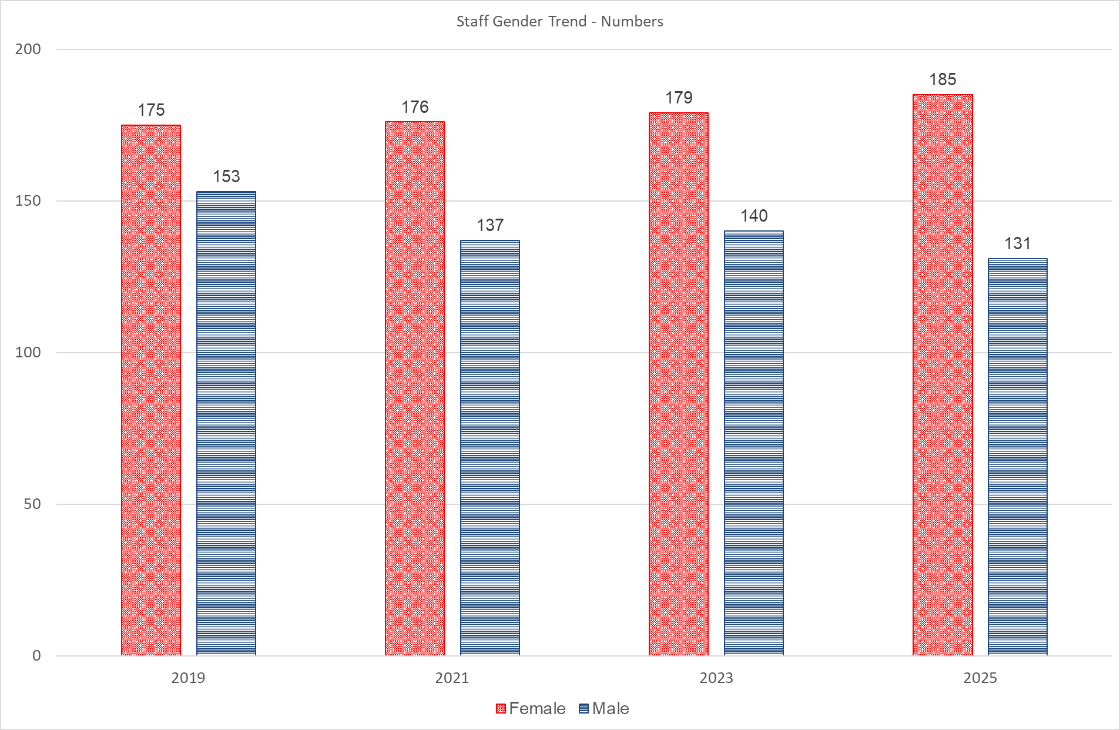

### **2: Staff by Gender in Percents**

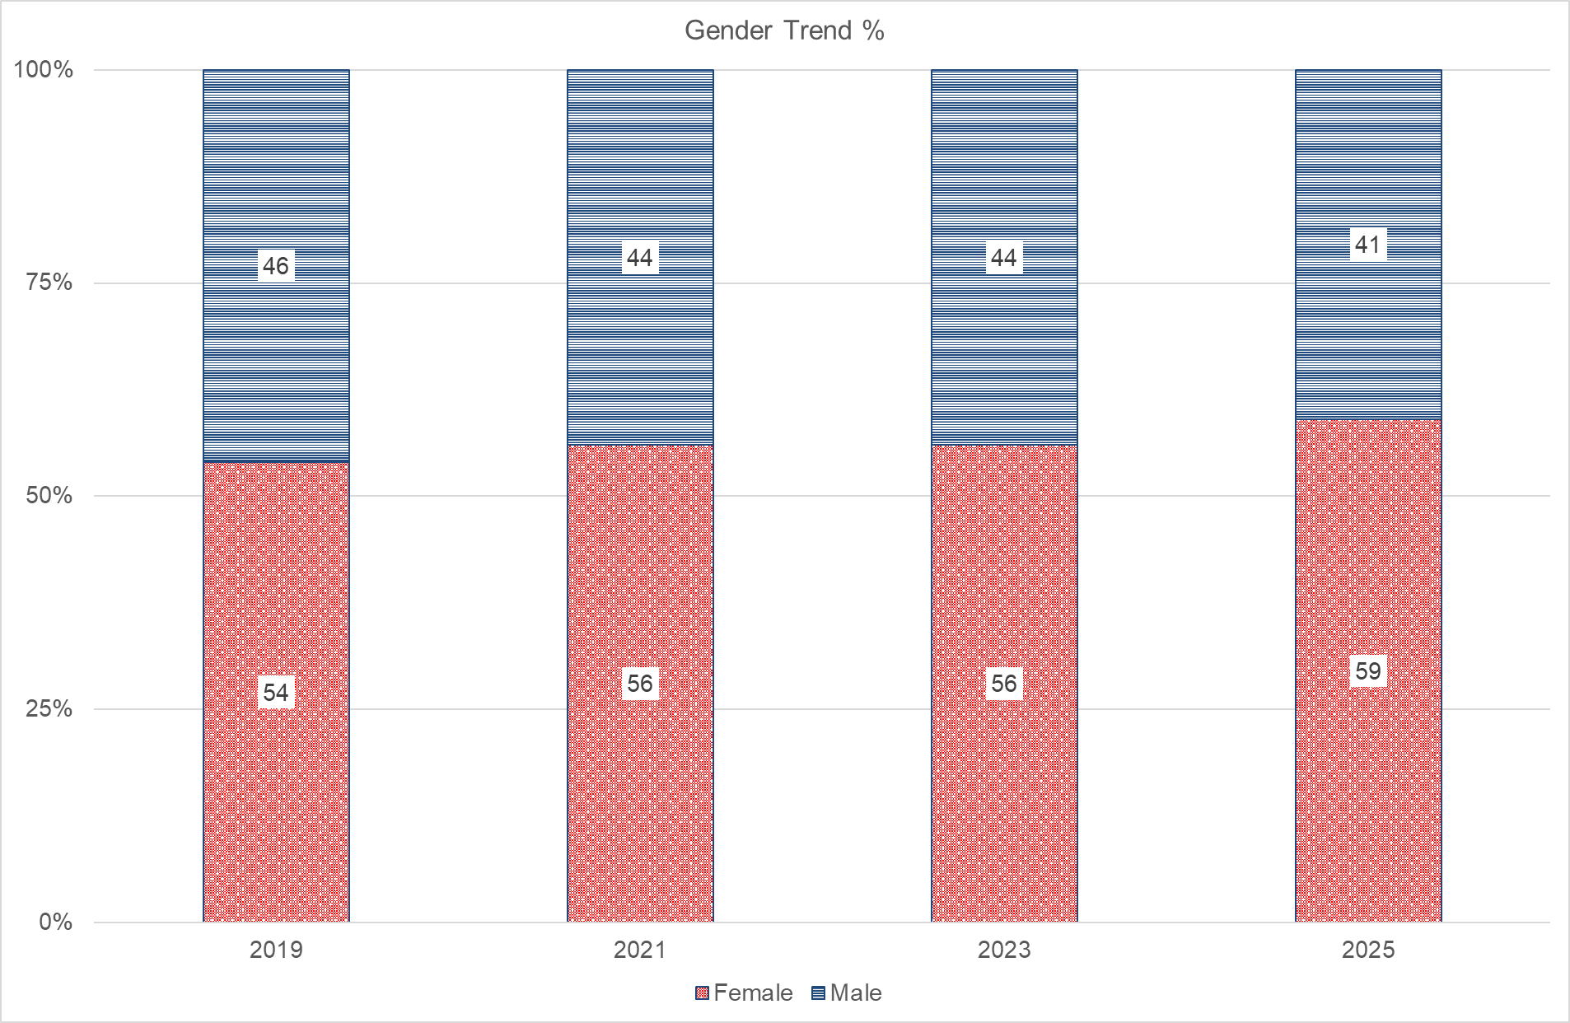

### 3: Pay Point by Gender in Percents

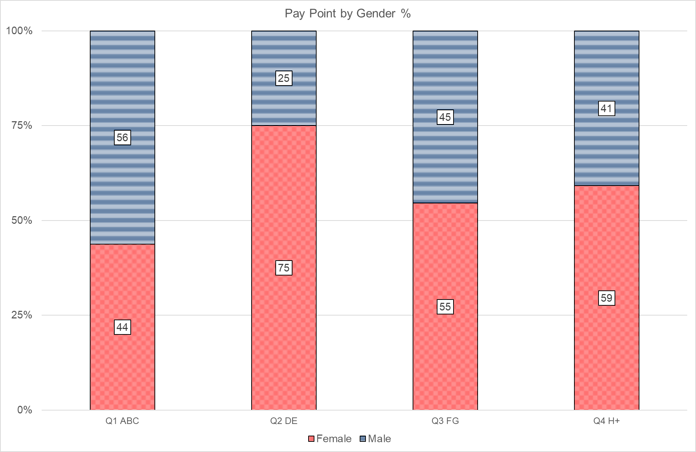

### 4: Contractual Status by Gender

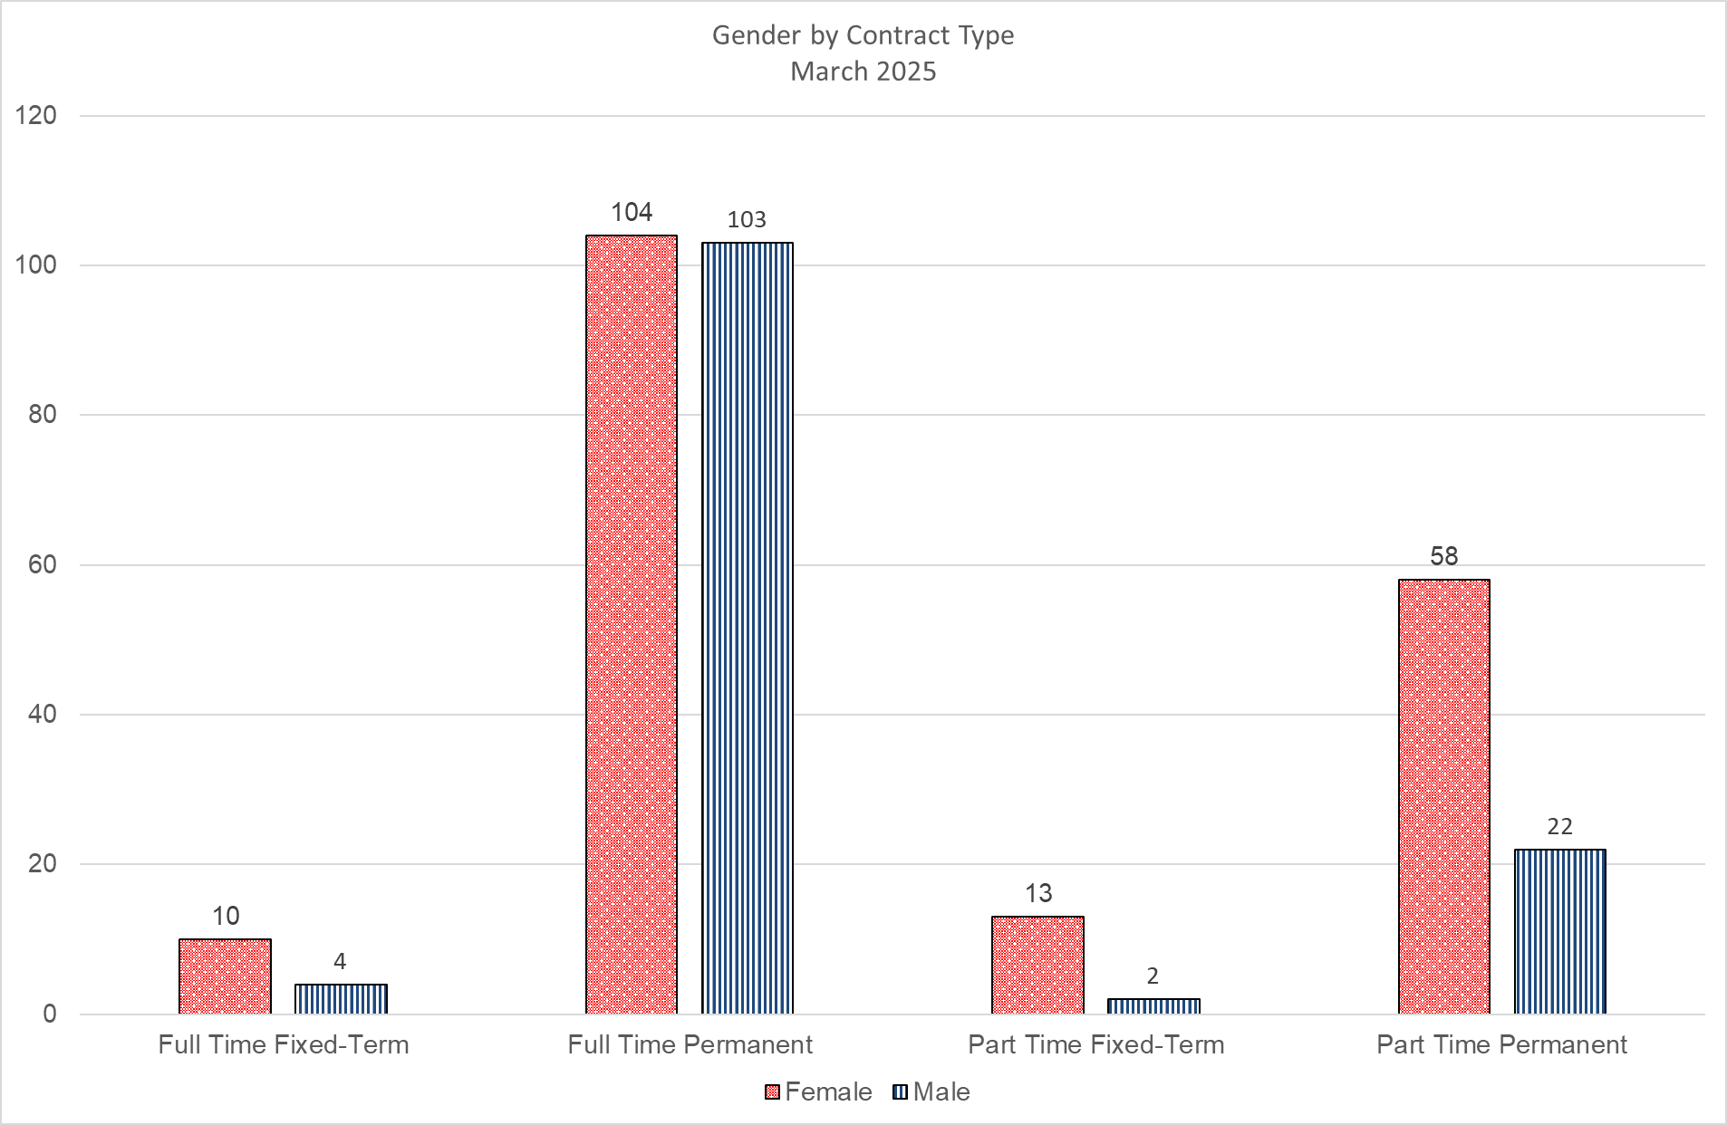

### 5: Disability by Pay Point

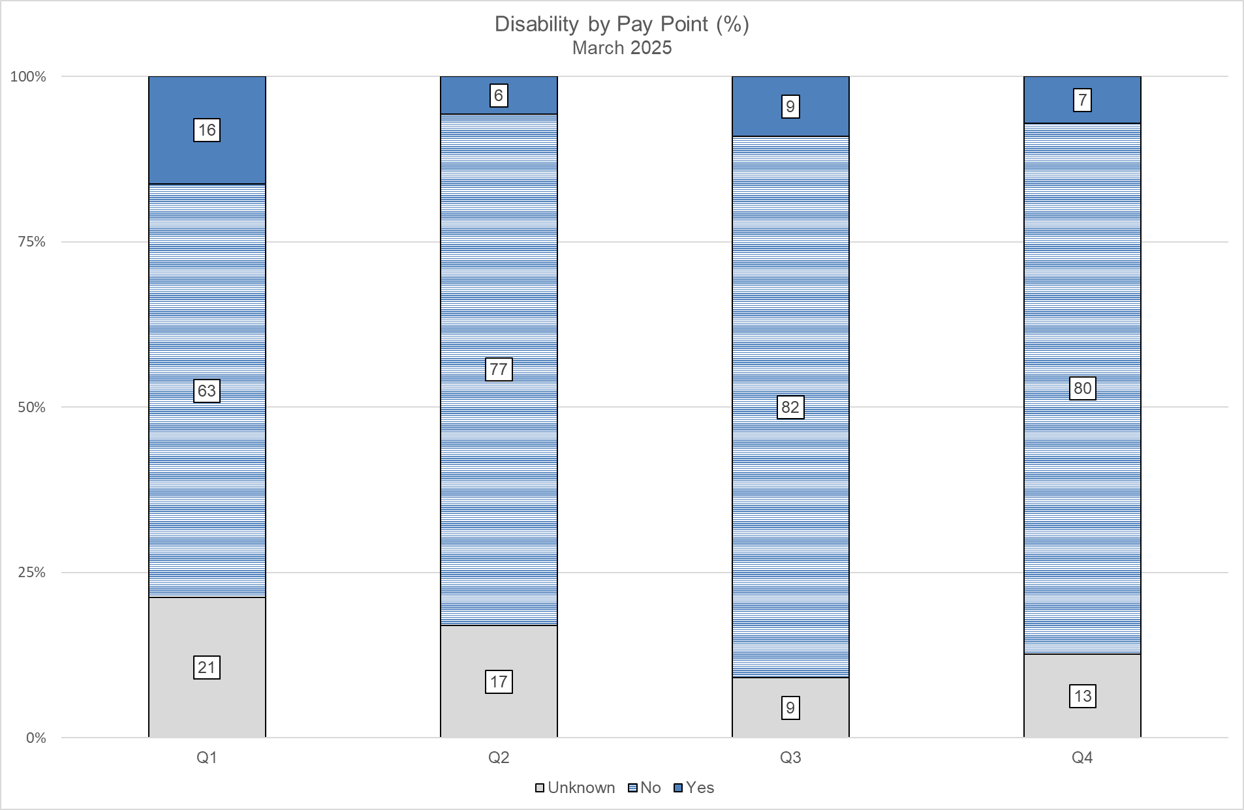

### 6: Staff Numbers by Age Range

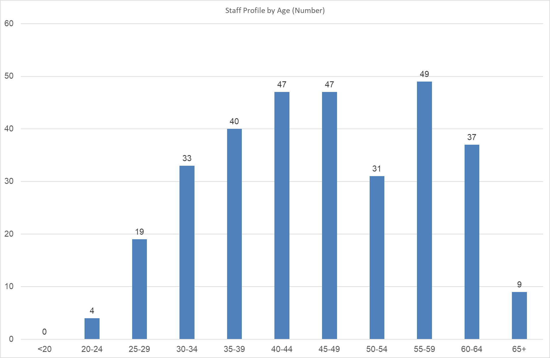

### 7: Staff Age and Gender Profile in Percents

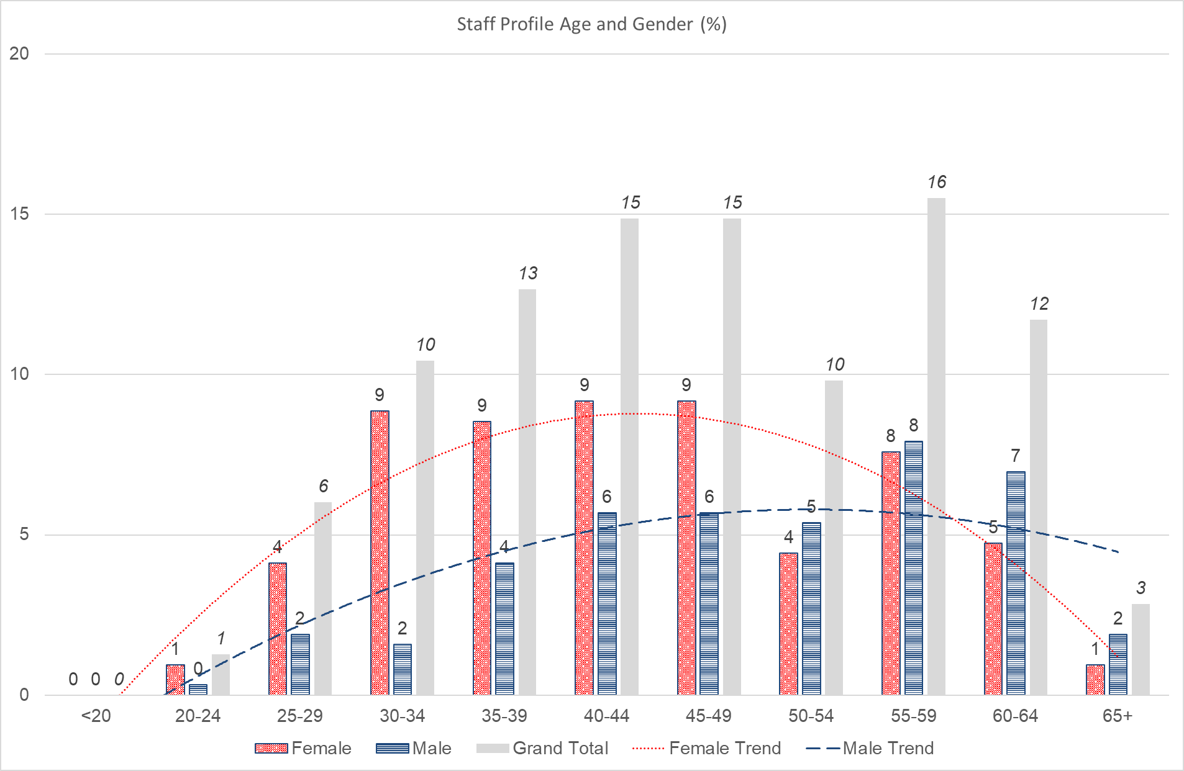

### 8: Staff Age and Gender Profile Numbers

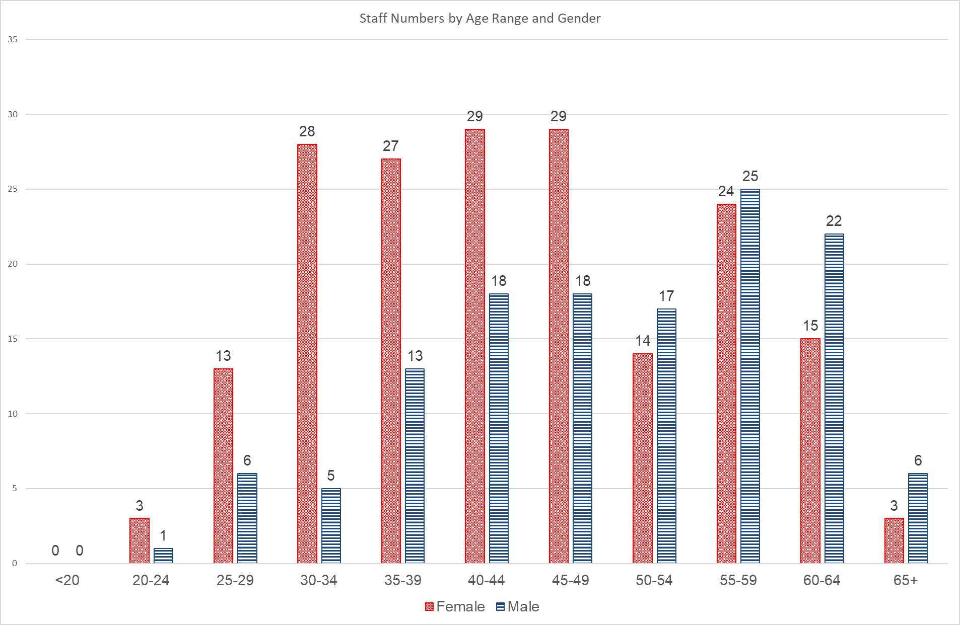

### 9: Ethnicity by Pay Point

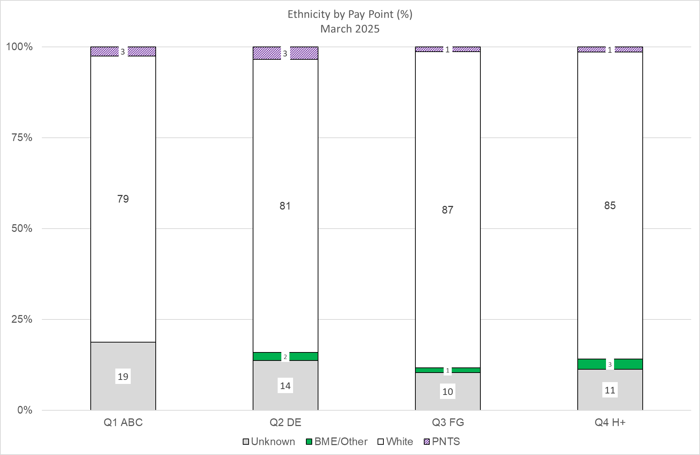

### **10: Nationality by Pay Point**

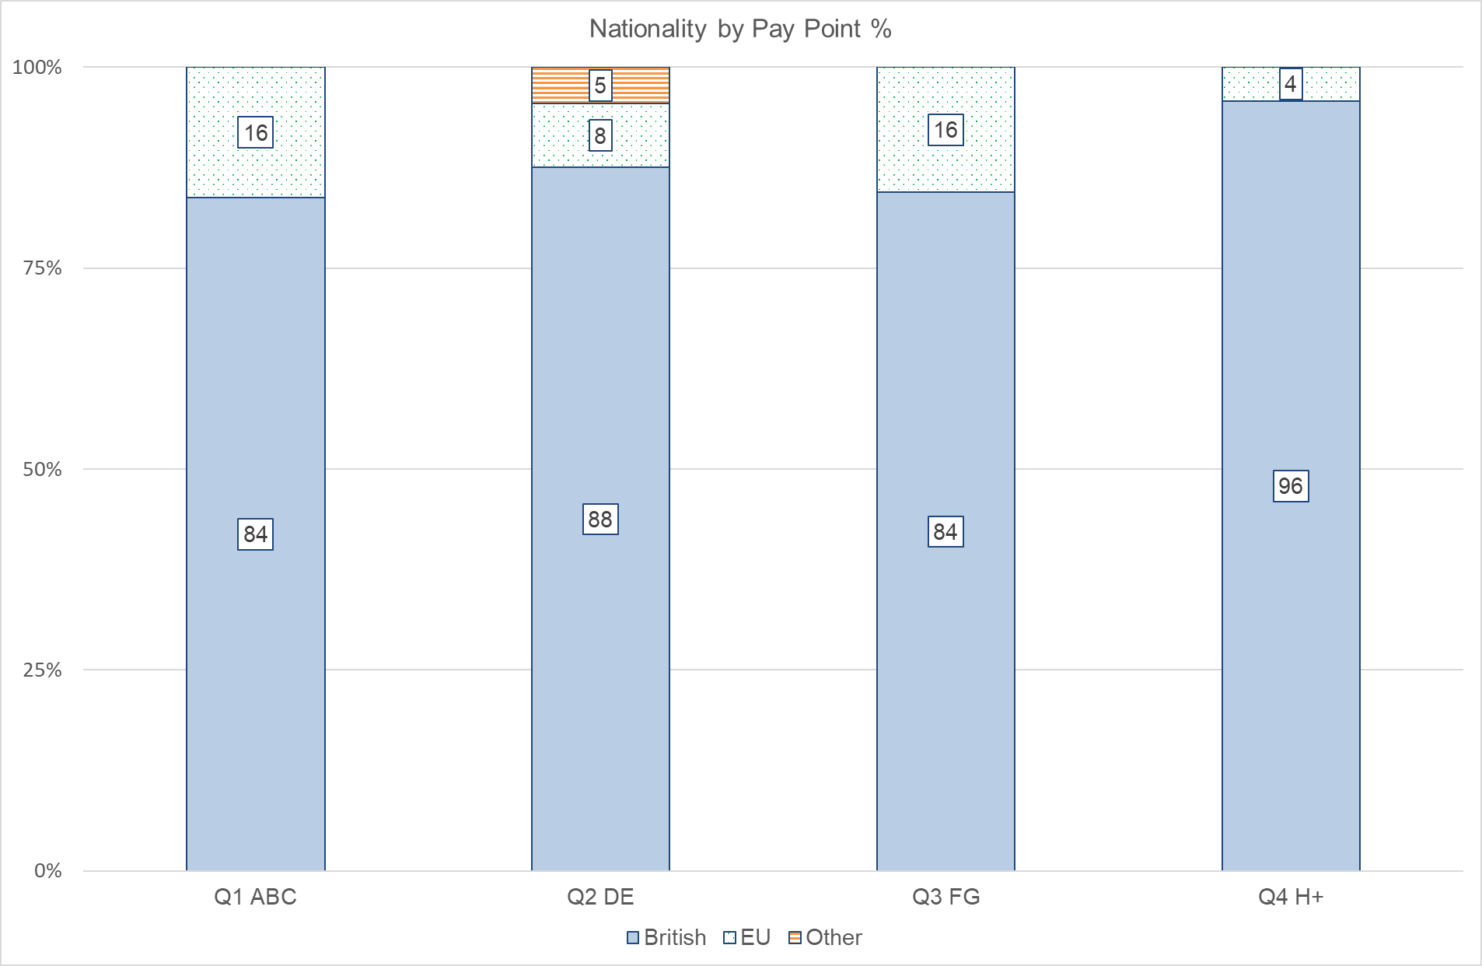

### 11: Religion and Belief by Pay Point

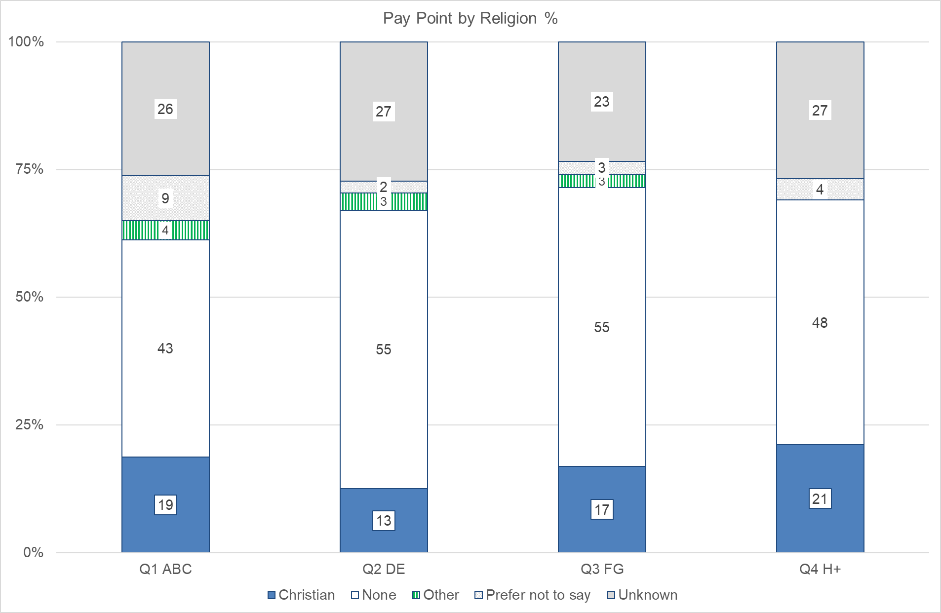

### **12: Sexuality by Pay Point**

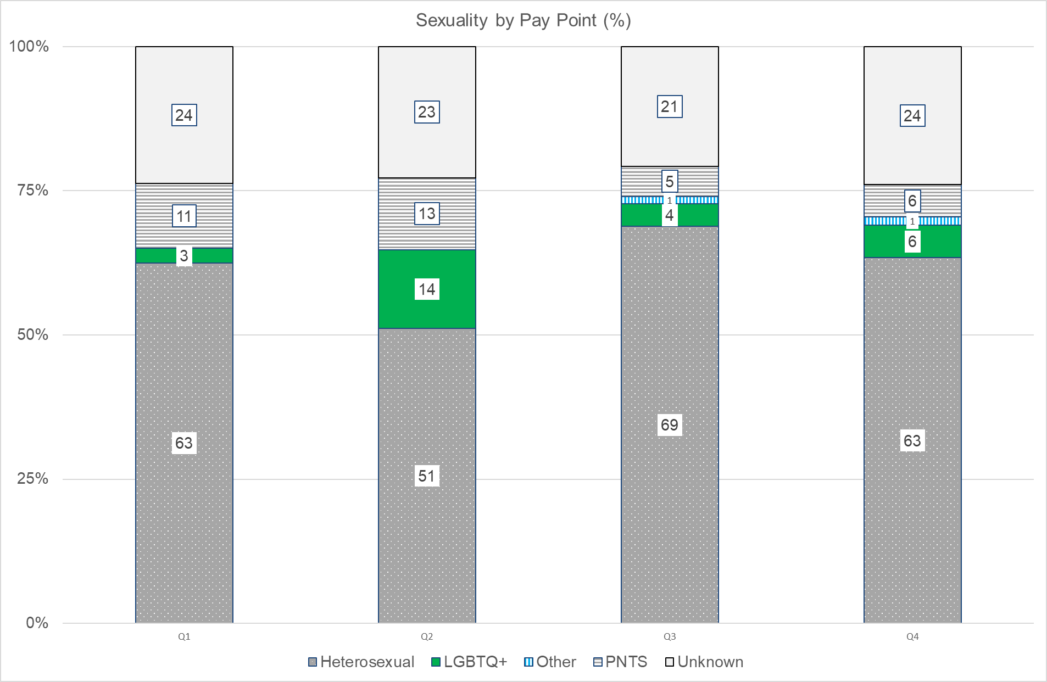

## Appendix 2: Board Data

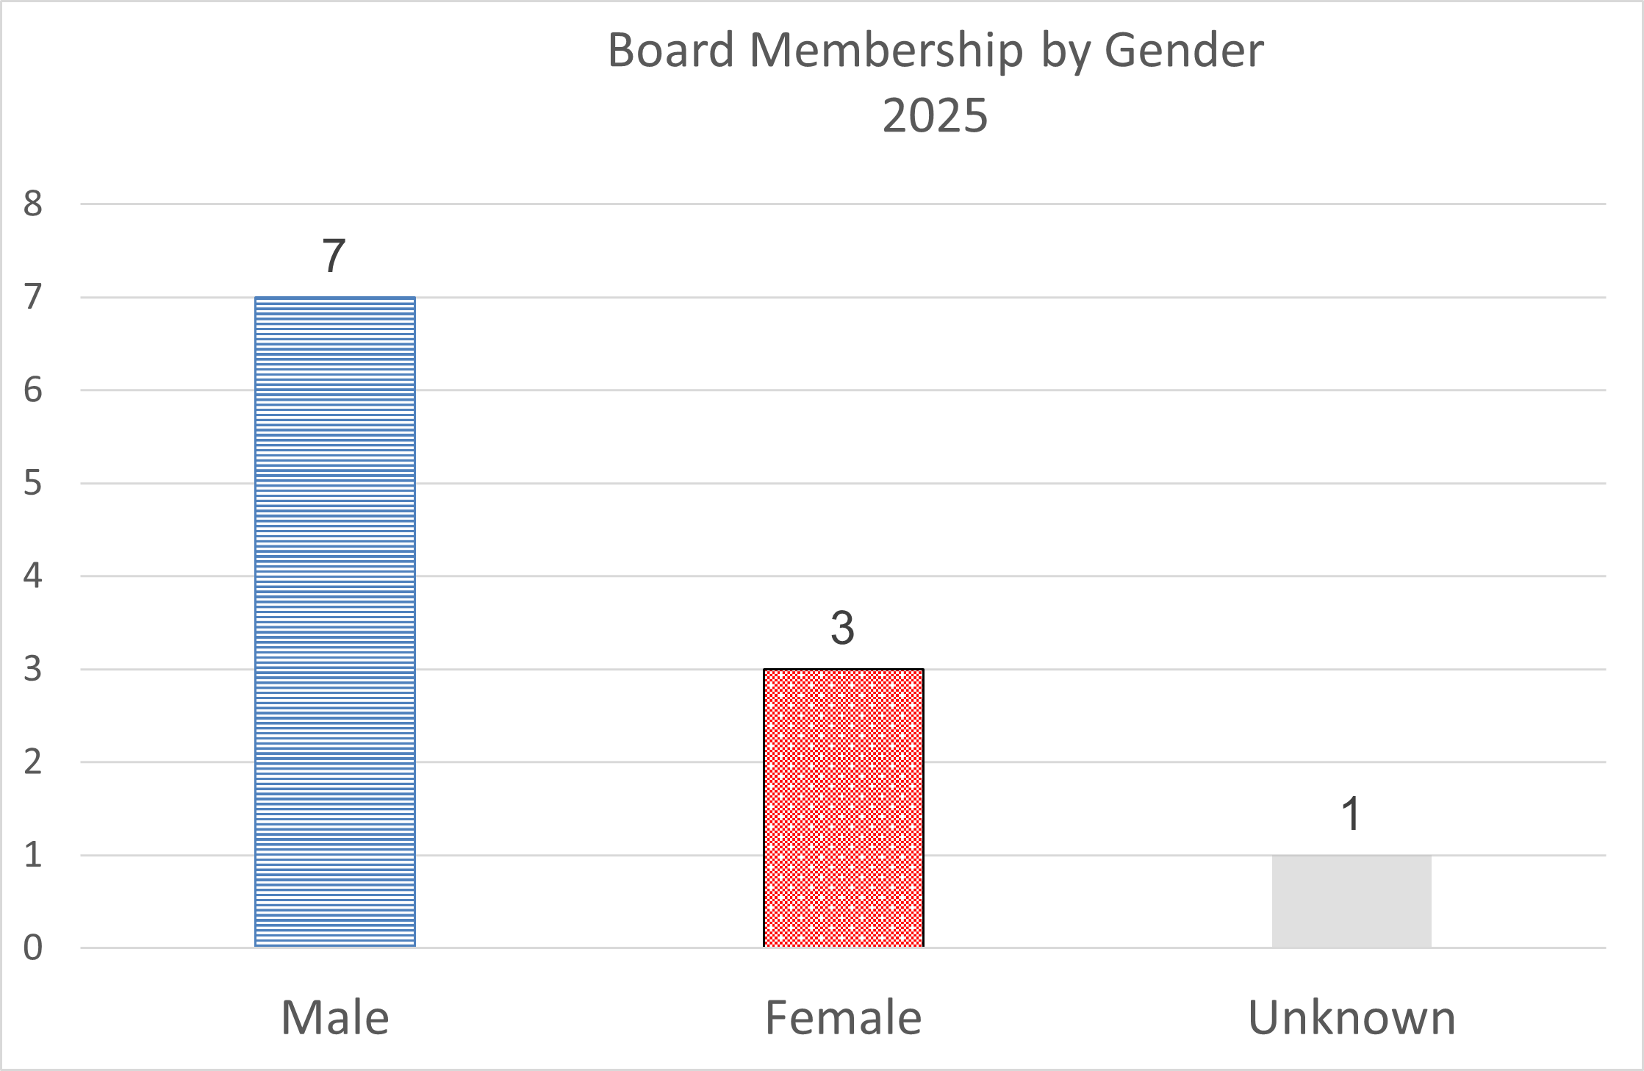

## Appendix 3: Recruitment data

The dataset is made up as follows:

|  |  |  |
| --- | --- | --- |
| Stage | Stage Description | Total |
| Completed Applications | All external applications submitted through the system. | 1898 |
| Interviewed | Candidates who attended an interview | 135 |
| Offered | Candidates offered the post | 34 |
| Hired | Candidates who accepted the post offered | 22 |
| Declined | Candidates who were rejected throughout the process | 1857 |

Note that these numbers will not reconcile as the recruitment process duration spreads across both start and end dates of this reporting period.

The Library implemented a new E-Recruitment Platform last year where an appointment is made conducts the onboarding process. It has just come to light when providing the data that the system does not report on the equalities data of internal applicants as their data is already in the HR System. Therefore, there is a discrepancy in the data under 'Offered' and the data under 'Hired'. This results in some under-reporting of current staff in the data presented below.

It is the intention going forward to address this situation by either discussing with the E-Recruitment provider if there is a fix on this or keeping a record of the equality data of internal applicants to validate the data under 'Hired'.

The information contained within the 'Offered' column is likely to be more indicative of the outcomes.

### Notes on the Charts

The charts break down the data by stages in the recruitment process. Data is presented visually as percentage values to allow comparison across all stages in the process. Data is also given as actual numbers as labels within the chart.

Some charts aggregate data for clarity of display. For example, in the Ethnicity chart responses given as:

|  |  |
| --- | --- |
| * Any other White background | White |
| * British | White |
| * English | White |
| * Gypsy or Irish Traveller | White |
| * Irish | White |
| * Northern Irish | White |
| * Scottish | White |
| * Welsh | White |

Are all represented under the higher-level heading of "White." All mixed or multiple ethnicities are represented as "Mixed or Multiple."

### 1: Disability Overview

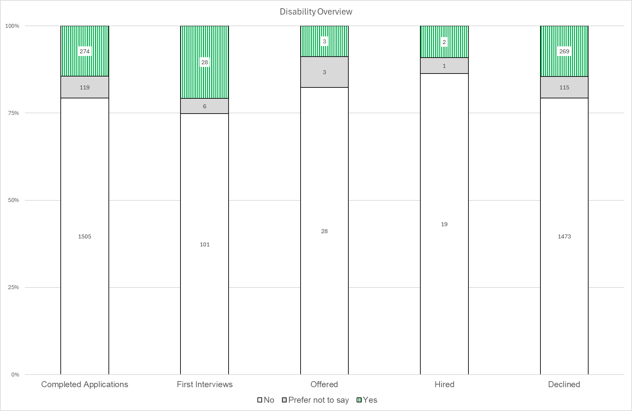

Figure 1 Question: Do you consider yourself to have a disability according to the terms given in the Equality Act 2010?

### 2: Disability detail

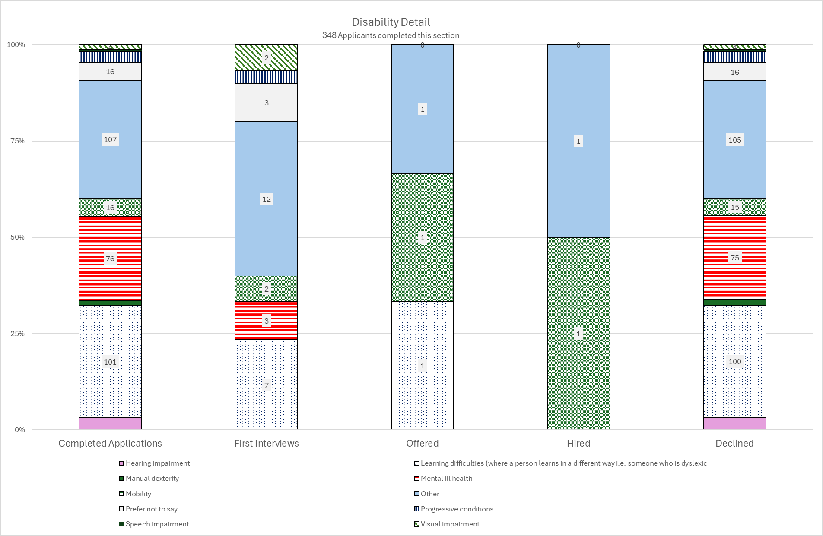

Figure 2 Question: Please indicate the type of impairment(s) which apply to you (all that apply).

### 3: Gender Identity

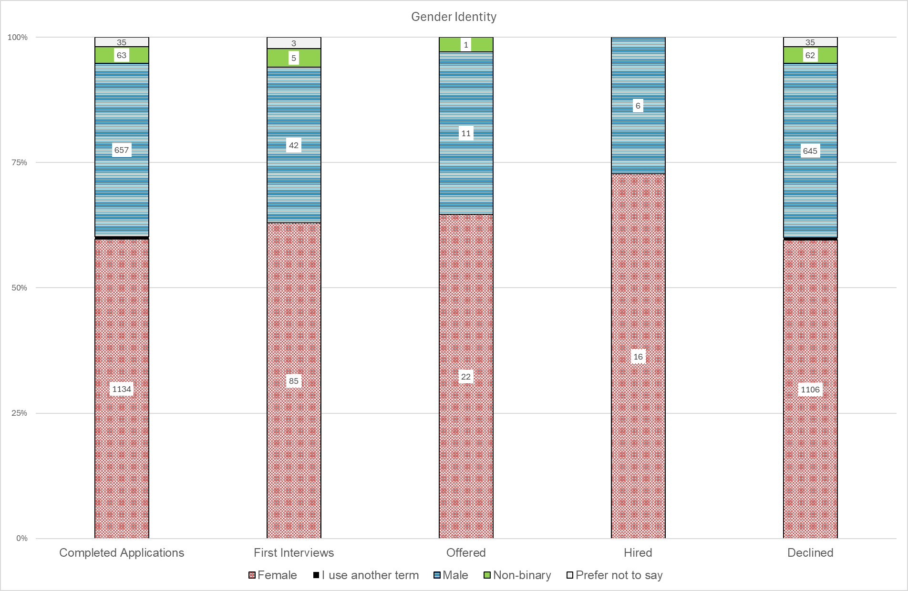

### 4: Gender at Birth

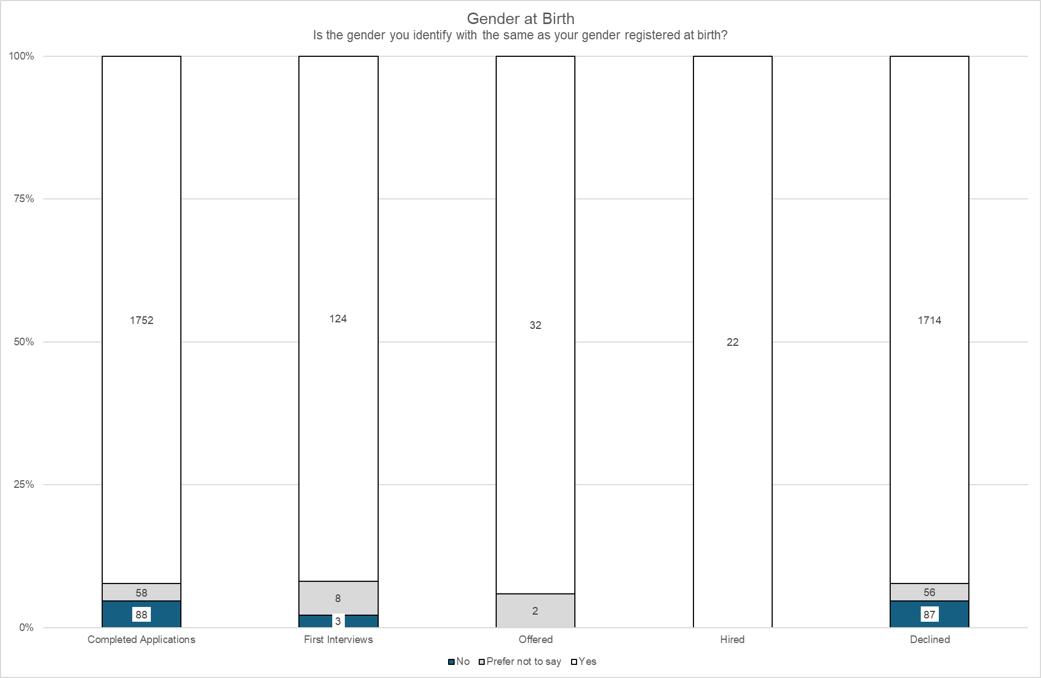

Figure 3 Question: Is the gender you identify with the same as your gender registered at birth?

### 5: Age Range

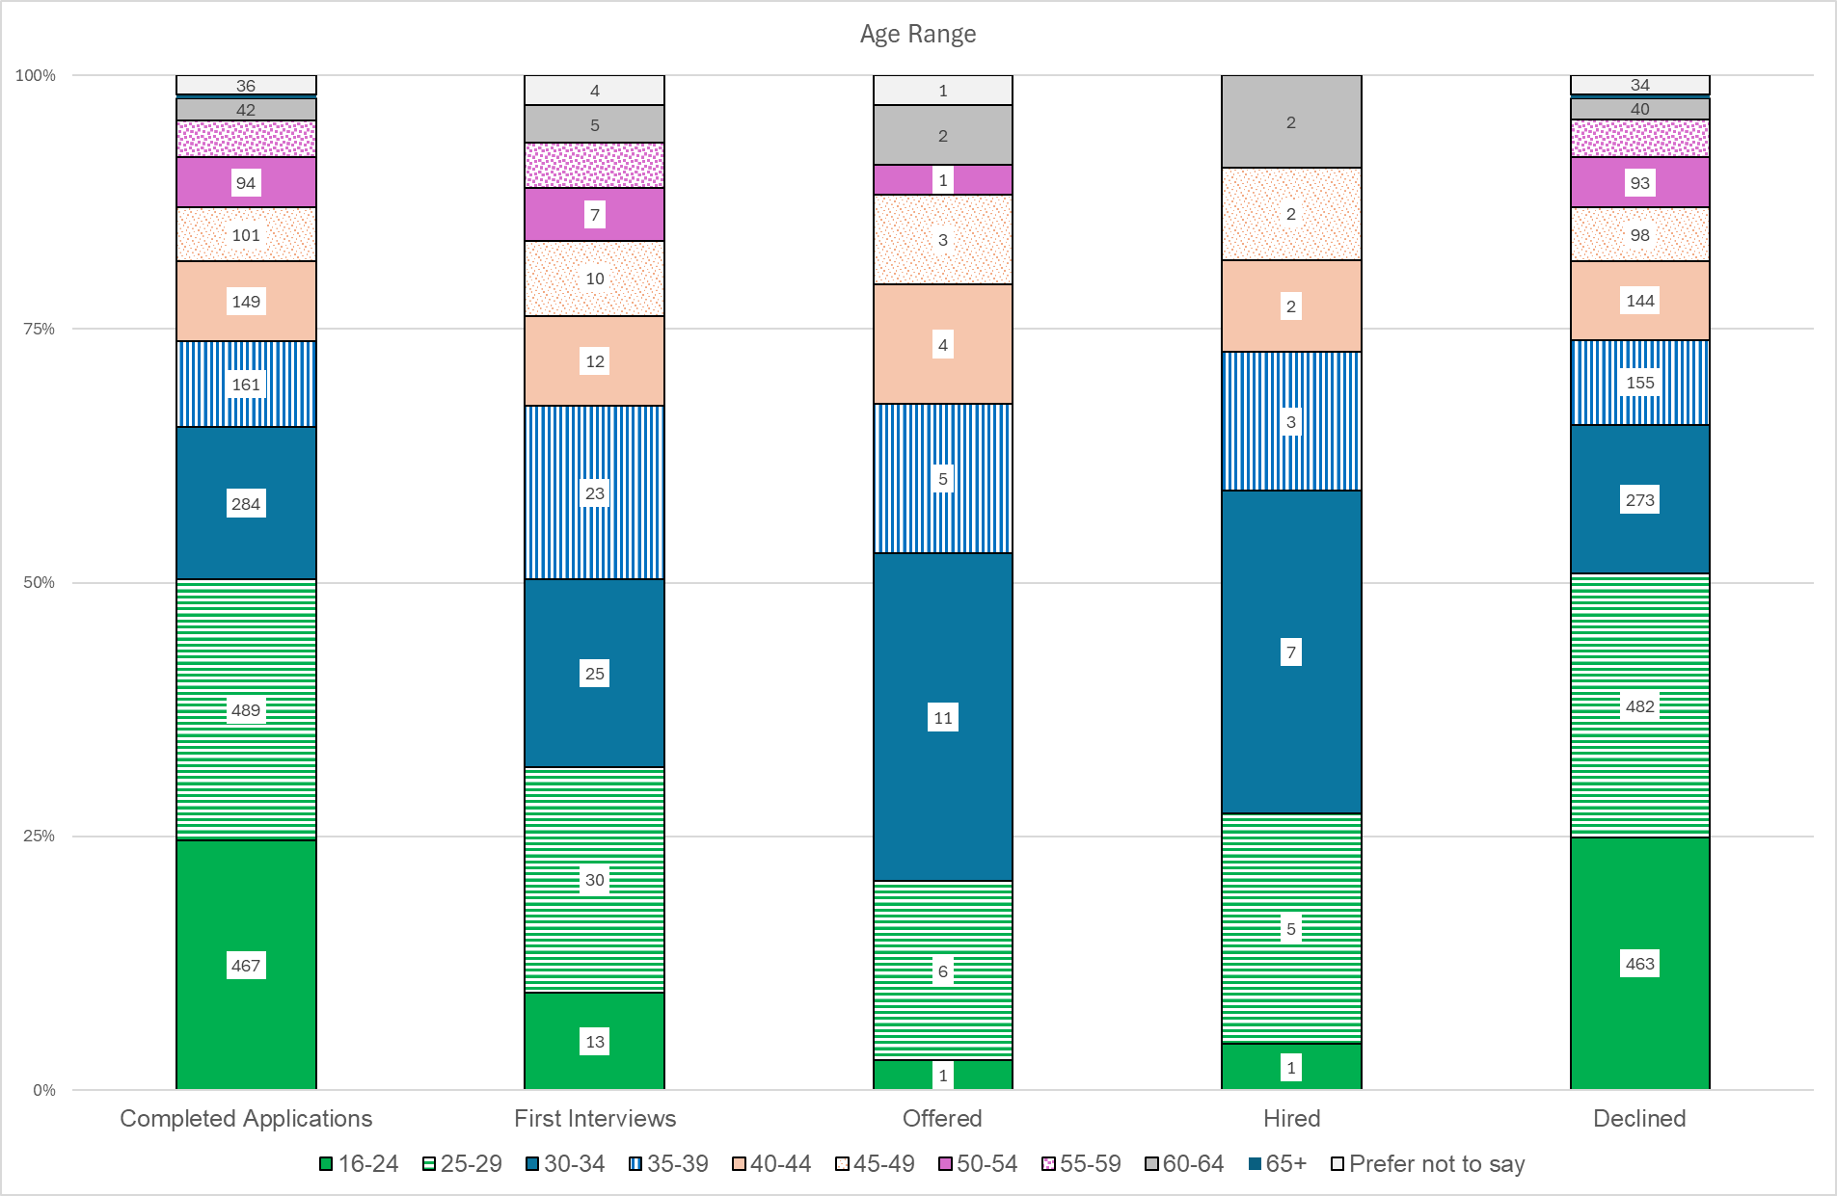

### 6: Ethnicity (Summary)

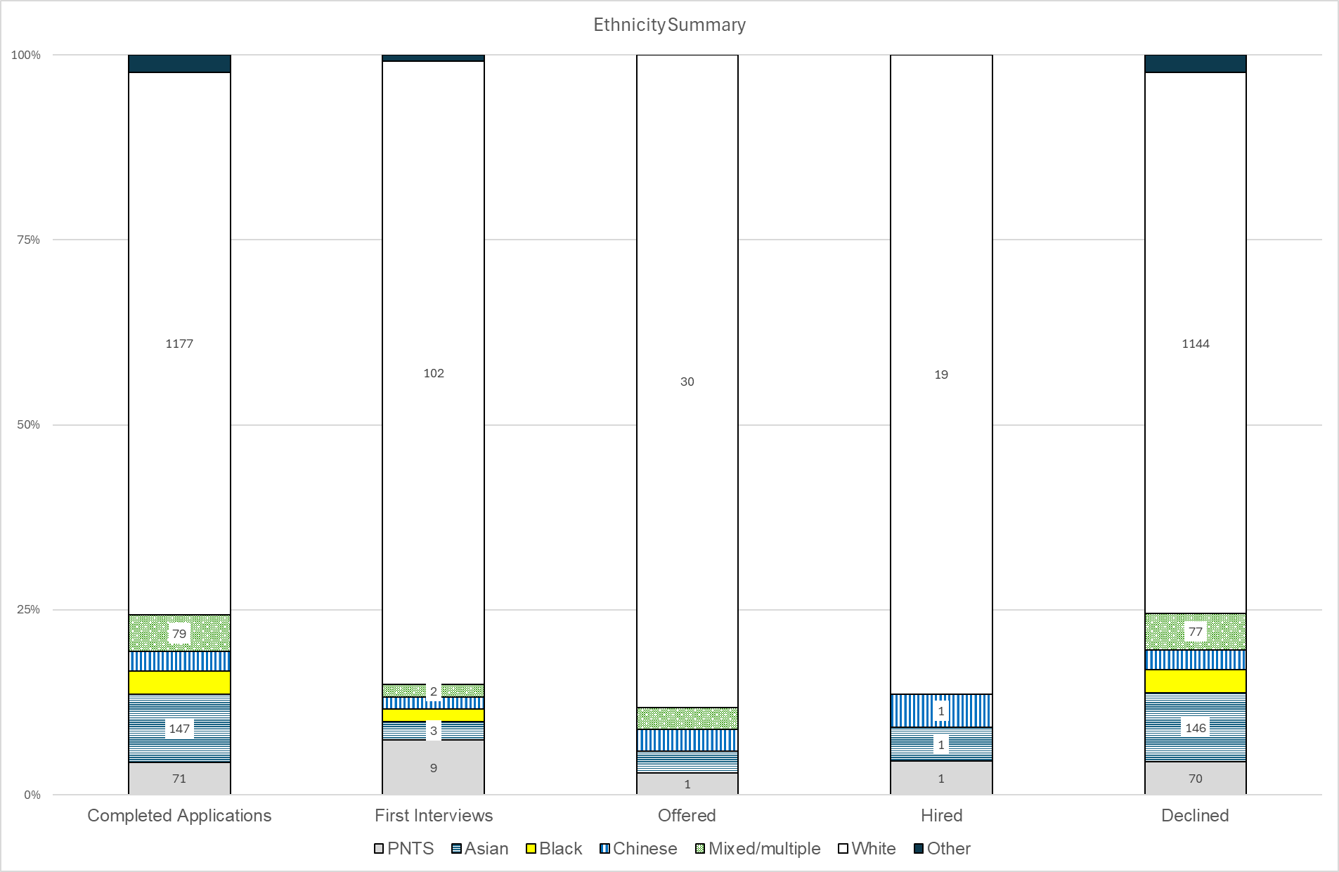

### 7: Religion or Belief

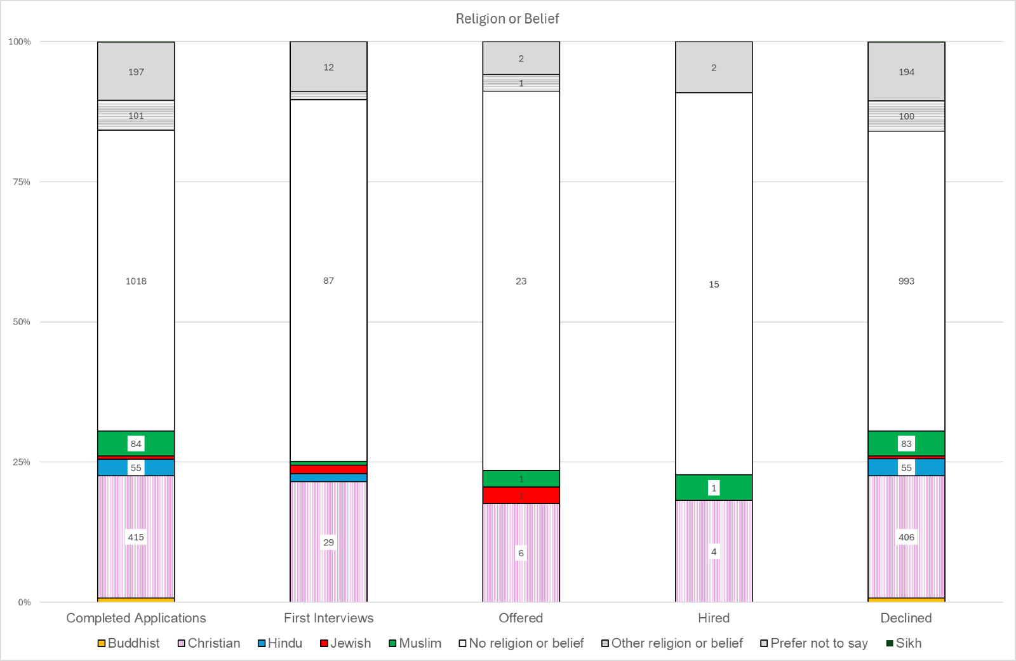

### 8: Sexual Orientation

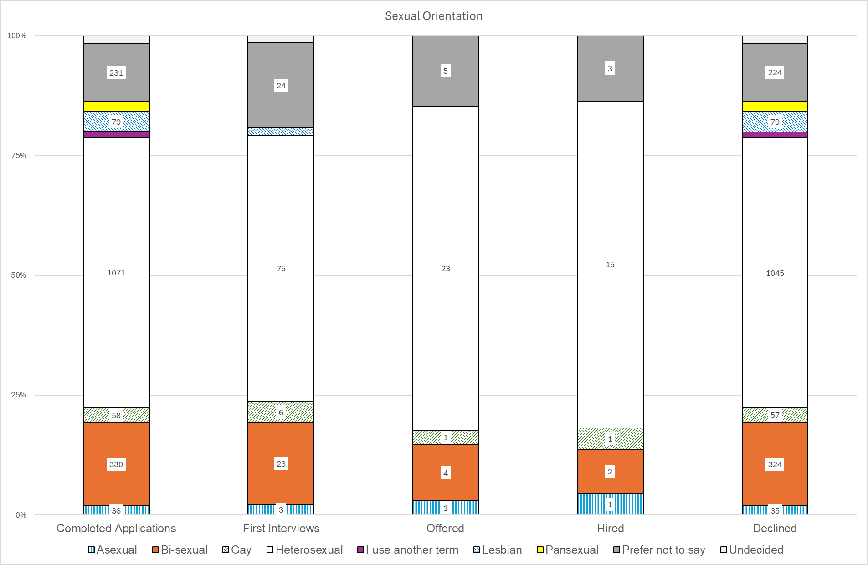

## Appendix 4: Chart Data Tables

### 1: Staff by Gender Data Table

#### A: Staff Numbers

|  |  |  |
| --- | --- | --- |
|  | 2023 | 2025 |
| Female | 179 | 185 |
| Male | 140 | 131 |

#### B: Percentages

|  |  |  |
| --- | --- | --- |
|  | 2023 | 2025 |
| Female | 56 | 59 |
| Male | 44 | 41 |

### 2: Pay Point by Gender Percentage Data Table

|  |  |  |
| --- | --- | --- |
| Pay Point | % Female | % Male |
| A | 69 | 31 |
| B | 25 | 75 |
| C | 42 | 58 |
| D | 71 | 29 |
| E | 77 | 23 |
| F | 48 | 52 |
| G | 64 | 36 |
| H | 60 | 40 |
| I | 56 | 44 |
| J | 75 | 25 |
| K | 50 | 50 |
| L | 0 | 100 |
| PC | 100 | 0 |
| Grand Total | 59 | 41 |

### 3: Pay Point by Gender Numbers Data Table

|  |  |  |  |
| --- | --- | --- | --- |
| Pay Point | Female | Male | Total |
| Q1 ABC | 35 | 45 | 80 |
| Q2 DE | 66 | 22 | 88 |
| Q3 FG | 42 | 35 | 77 |
| Q4 H+ | 42 | 29 | 71 |
| Totals | 185 | 131 | 316 |

### 4: Full/Part Time by Gender Data Table

|  |  |  |  |
| --- | --- | --- | --- |
|  | Female | Male | Grand Total |
| Full Time | 115 | 107 | 222 |
| Part Time | 70 | 24 | 94 |
| Grand Total | 185 | 131 | 316 |

### 5: Disability Percentage by Pay Point Data table

|  |  |  |  |
| --- | --- | --- | --- |
|  | No | Yes | Unknown |
| Q1 | 63 | 16 | 21 |
| Q2 | 77 | 6 | 17 |
| Q3 | 82 | 9 | 9 |
| Q4 | 80 | 7 | 13 |
| Grand Total | 75 | 9 | 15 |

### 6: Staff by Age Range Data Table

|  |  |
| --- | --- |
| Age Range | Total |
| <20 | 0 |
| 20-24 | 4 |
| 25-29 | 19 |
| 30-34 | 33 |
| 35-39 | 40 |
| 40-44 | 47 |
| 45-49 | 47 |
| 50-54 | 31 |
| 55-59 | 49 |
| 60-64 | 37 |
| 65+ | 9 |
| Grand Total | 316 |

### 7: Staff Age Range by Gender Data Table

|  |  |  |
| --- | --- | --- |
|  | Female | Male |
| <20 | 0 | 0 |
| 20-24 | 3 | 1 |
| 25-29 | 13 | 6 |
| 30-34 | 28 | 5 |
| 35-39 | 27 | 13 |
| 40-44 | 29 | 18 |
| 45-49 | 29 | 18 |
| 50-54 | 14 | 17 |
| 55-59 | 24 | 25 |
| 60-64 | 15 | 22 |
| 65+ | 3 | 6 |
| Grand Total | 185 | 131 |

### 8: Ethnicity Percentage by Pay Point Data Table

|  |  |  |  |  |
| --- | --- | --- | --- | --- |
| % | BME/Other | White | PNTS | Unknown |
| Q1 ABC | 0 | 79 | 3 | 19 |
| Q2 DE | 2 | 81 | 3 | 14 |
| Q3 FG | 1 | 87 | 1 | 10 |
| Q4 H+ | 3 | 85 | 1 | 11 |

### 9: Nationality Percentage by Pay Point Data Table

|  |  |  |  |
| --- | --- | --- | --- |
|  | British | EU | Other |
| Q1 ABC | 84 | 16 | 0 |
| Q2 DE | 88 | 8 | 5 |
| Q3 FG | 84 | 16 | 0 |
| Q4 H+ | 96 | 4 | 0 |

### 10: Belief Percentage by Pay Point Data Table

|  |  |  |  |  |  |
| --- | --- | --- | --- | --- | --- |
|  | Christian | None | Other | Prefer not to say | Unknown |
| Q1 ABC | 19 | 43 | 4 | 9 | 26 |
| Q2 DE | 13 | 55 | 3 | 2 | 27 |
| Q3 FG | 17 | 55 | 3 | 3 | 23 |
| Q4 H+ | 21 | 48 | 0 | 4 | 27 |

### 11: Sexual Orientation Percentage by Pay Point Data Table

|  |  |  |  |  |  |
| --- | --- | --- | --- | --- | --- |
|  | Hetero-sexual | LGBTQ+ | Other | PNTS | Unknown |
| Q1 ABC | 63 | 3 | 0 | 11 | 24 |
| Q2 DE | 51 | 14 | 0 | 13 | 23 |
| Q3 FG | 69 | 4 | 1 | 5 | 21 |
| Q4 H+ | 63 | 6 | 1 | 6 | 24 |

## Appendix 5: Recruitment Data Tables

### 1: Disability

|  |  |  |  |  |  |
| --- | --- | --- | --- | --- | --- |
|  | Completed Applications | Interview | Offered | Hired | Declined |
| No | 1505 | 101 | 28 | 19 | 1473 |
| Prefer not to say | 119 | 6 | 3 | 1 | 115 |
| Yes | 274 | 28 | 3 | 2 | 269 |

Table 1 Question: Do you consider yourself to have a disability according to the terms given in the Equality Act 2010?

### 2: Disability Details

|  |  |  |  |  |  |
| --- | --- | --- | --- | --- | --- |
| Answer Option | Completed Applications | Interview | Offered | Hired | Declined |
| Hearing impairment | 11 | 0 | 0 | 0 | 11 |
| Learning difficulties | 101 | 7 | 1 | 0 | 100 |
| Manual dexterity | 5 | 0 | 0 | 0 | 5 |
| Mental ill health | 76 | 3 | 0 | 0 | 75 |
| Mobility | 16 | 2 | 1 | 1 | 15 |
| Other | 107 | 12 | 1 | 1 | 105 |
| Prefer not to say | 16 | 3 | 0 | 0 | 16 |
| Progressive conditions | 10 | 1 | 0 | 0 | 10 |
| Speech impairment | 2 | 0 | 0 | 0 | 2 |
| Visual impairment | 4 | 2 | 0 | 0 | 4 |
| Totals | 348 | 30 | 3 | 2 | 343 |

Table 2 Question: Please indicate the type of impairment(s) which apply to you. If you experience more than one type of impairment, please tick all the types that apply. If your disability does not fit any of these types, please mark Other.

### 3: Gender Identity

|  |  |  |  |  |  |
| --- | --- | --- | --- | --- | --- |
| **Answer Option** | **Completed Applications** | **First Interviews** | **Offered** | **Hired** | **Declined** |
| Female | 1134 | 85 | 22 | 16 | 1106 |
| I use another term | 9 | 0 | 0 | 0 | 9 |
| Male | 657 | 42 | 11 | 6 | 645 |
| Non-binary | 63 | 5 | 1 | 0 | 62 |
| Prefer not to say | 35 | 3 | 0 | 0 | 35 |

### 4: Gender at Birth

|  |  |  |  |  |  |
| --- | --- | --- | --- | --- | --- |
| Answer Option | Completed Applications | Interview | Offered | Hired | Declined |
| No | 88 | 3 | 0 | 0 | 87 |
| Prefer not to say | 58 | 8 | 2 | 0 | 56 |
| Yes | 1752 | 124 | 32 | 22 | 1714 |

Table 3 Question: Is the gender you identify with the same as your gender registered at birth?

### 5: Age

|  |  |  |  |  |  |
| --- | --- | --- | --- | --- | --- |
| Age Range | Completed Applications | Interview | Offered | Hired | Declined |
| 16-24 | 467 | 13 | 1 | 1 | 463 |
| 25-29 | 489 | 30 | 6 | 5 | 482 |
| 30-34 | 284 | 25 | 11 | 7 | 273 |
| 35-39 | 161 | 23 | 5 | 3 | 155 |
| 40-44 | 149 | 12 | 4 | 2 | 144 |
| 45-49 | 101 | 10 | 3 | 2 | 98 |
| 50-54 | 94 | 7 | 1 | 0 | 93 |
| 55-59 | 68 | 6 | 0 | 0 | 68 |
| 60-64 | 42 | 5 | 2 | 2 | 40 |
| 65+ | 7 | 0 | 0 | 0 | 7 |
| Prefer not to say | 36 | 4 | 1 | 0 | 34 |

### 6: Ethnicity

|  |  |  |  |  |  |
| --- | --- | --- | --- | --- | --- |
|  | Completed Applications | Interview | Offered | Hired | Declined |
| Prefer not to Say | 71 | 9 | 1 | 1 | 70 |
| Asian | 147 | 3 | 1 | 1 | 146 |
| Black | 50 | 2 | 0 | 0 | 49 |
| Chinese | 43 | 2 | 1 | 1 | 42 |
| Mixed/multiple | 79 | 2 | 1 | 0 | 77 |
| White | 1177 | 102 | 30 | 19 | 1144 |
| Other | 37 | 1 | 0 | 0 | 37 |

### 7: Religion

|  |  |  |  |  |  |
| --- | --- | --- | --- | --- | --- |
|  | Completed Applications | Interview | Offered | Hired | Declined |
| Buddhist | 14 | 0 | 0 | 0 | 14 |
| Christian | 415 | 29 | 6 | 4 | 406 |
| Hindu | 55 | 2 | 0 | 0 | 55 |
| Jewish | 12 | 2 | 1 | 0 | 10 |
| Muslim | 84 | 1 | 1 | 1 | 83 |
| No religion or belief | 1018 | 87 | 23 | 15 | 993 |
| Other religion or belief | 101 | 2 | 1 | 0 | 100 |
| Prefer not to say | 197 | 12 | 2 | 2 | 194 |
| Sikh | 2 | 0 | 0 | 0 | 2 |

Table 4 Question: What is your religion or belief?

### 8: Sexual Orientation

|  |  |  |  |  |  |
| --- | --- | --- | --- | --- | --- |
|  | Completed Applications | Interview | Offered | Hired | Declined |
| LGBTQ+ | 507 | 31 | 5 | 3 | 500 |
| Heterosexual | 1071 | 75 | 23 | 15 | 1045 |
| Other | 89 | 5 | 1 | 1 | 88 |
| Prefer not to Say | 231 | 24 | 5 | 3 | 224 |